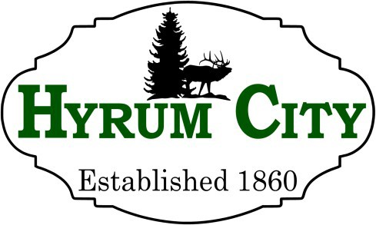
60 West Main Street, Hyrum, Utah 84319 ▪ 435-245-6033
Steve Miller, Mayor Council Members - Rebecca Foulger Michael Nelson NaLyn Nelson Craig L. Rasmussen
Mont Wright

NOTICE OF PUBLIC HEARING

Notice is hereby given that the Hyrum City Planning Commission of Hyrum City, Utah will hold a public hearing Thursday, July 9, 2026 at 6:30 p.m. in the Hyrum City Council Chambers, 60 West Main, Hyrum. The purpose of this hearing is to receive public comment regarding a Short-Term Rental Conditional Use Permit located at 280 South Center Street.

Copies of the proposed amendments are available at the Hyrum City Office, 60
West Main, Hyrum, weekdays between the hours of 8:00 a.m. and 4:30 p.m.,
and on the City's website at www.hyrumcity.gov

_______________________________
Shara Toone
Secretary

Published: State Public Notice Website and Hyrum City Website on June 29, 2026.
Posted: Ridleys Grocery Store, Hyrum City Office, Senior Center, Library, Cache Valley Bank, and Manning Short Stop on June 29, 2026.

