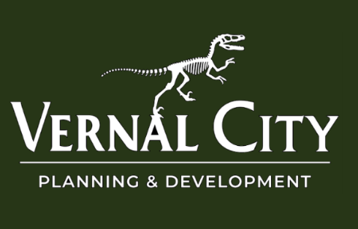

Public Notice
June 29, 2026

VERNAL CITY PUBLIC HEARING
Notice is hereby given that the Vernal City Planning Commission will hold a public hearing on Tuesday, July 14, 2026, at 5:30 p.m. in the Vernal City Council Chambers, located at 374 East Main Street, Vernal, Utah, to consider the following item(s):
- Recommendation to consider amending the Vernal City Planning and Zoning Code, Section 16.06.010 – Administration and Procedures – Ordinance #2026-19
- Recommendation to consider amending the Vernal City Planning and Zoning Code by adding Chapter 16.07 – Amendment to Zoning Map, including Sections 16.07.010, 16.07.020, 16.07.030, 16.07.040, 16.07.050, 16.07.060, 16.07.070, 16.07.080, and 16.07.090 – Ordinance #2026-20
- Recommendation to consider amending the Vernal City Planning and Zoning Code, Section 16.42.080 – R-3 and Section 16.44.080 – R-4 – Special Provisions – Ordinance #2026-21
- Recommendation to consider amending the Vernal City Planning and Zoning Code by amending Section 16.58.110 – Amended Plats, and adding Sections 16.58.112, 16.58.114, 16.58.116, and 16.58.118 – Ordinance #2026-22
- Recommendation to consider amending the Vernal City Planning and Zoning Code, Section 16.16.050 – Proposed Development – Submission of Plans and Documents – Ordinance #2026-23
- Recommendation to consider amending the Vernal City Planning and Zoning Code, Section 16.24.180 – Off-Site Improvements – Ordinance #2026-24
All interested persons are encouraged to attend.
In compliance with the Americans with Disabilities Act, individuals requiring special accommodations should contact Braeden Christofferson at (435) 789-2255 at least five (5) days prior to the hearing.
This notice has been:
- Posted on the Utah Public Notice Website;
- Posted on the Vernal City Website; and
- Posted in conspicuous locations within Vernal City
Posting Date: June 29, 2026
Notice to remain posted through: July 14, 2026

