
JULY 9, 2026
PLANNING COMMISSION
PUBLIC HEARING NOTICE

NOTICE IS HEREBY GIVEN that the Pleasant Grove City Planning Commission will hold a Public Hearing on Thursday, July 9, 2026, at 7:00 p.m. in the Community Room at the Police and Court Building located at 108 S 100 East, Pleasant Grove, Utah, FOR THE FOLLOWING:

Public Hearing: Preliminary Subdivision Plat – Located at approx. 1000 W State St.
(Sam White’s Lane Neighborhood)
Public Hearing to consider the request of Nate Reiner for a 45-lot preliminary condominium subdivision plat, called X Development PG Mixed Use Condominium Plat on approximately 2.954 acres, located at approximately 1000 West State Street in the Commercial Sales-2 (CS-2) Zone. (Administrative Item)

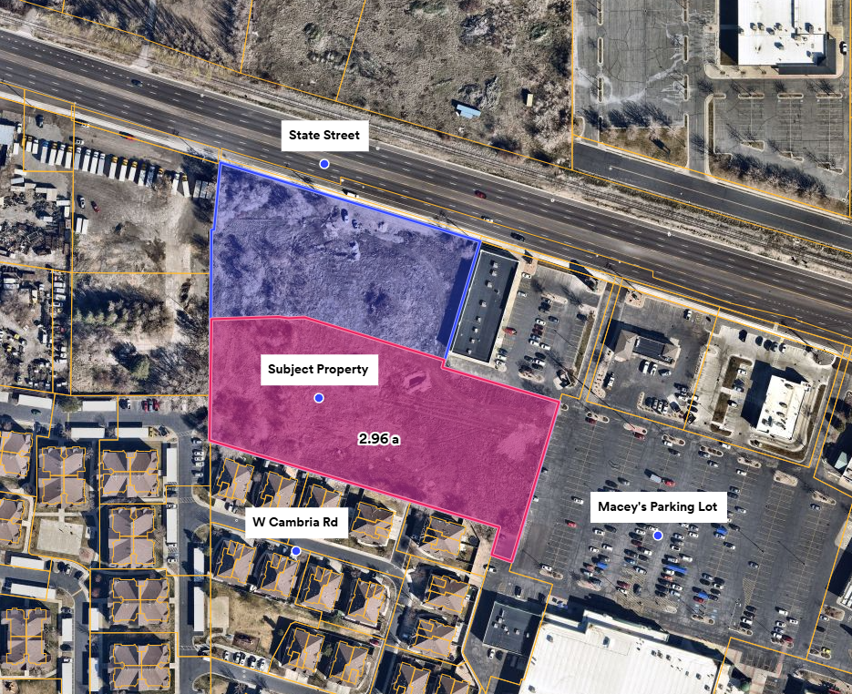

Public Hearing: Site Plan – Located at approx. 224 S Pleasant Grove Blvd
(Sam White’s Lane Neighborhood)
Public Hearing to consider the request of Kartik Patel for a commercial site plan for a commercial building, located at approximately 224 S Pleasant Grove Boulevard in The Grove – Commercial Sales Zone with the Boulevard Mixed Use Overlay. (Administrative Item)

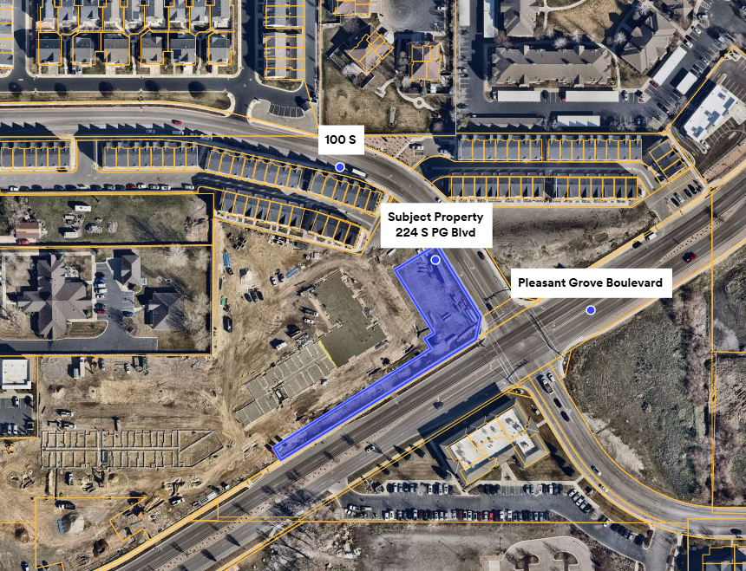

Public Hearing: Rezone – Located at 1270 N 580 E
(Big Spring Neighborhood)
Public Hearing to consider the request of Connor McLeod to add the Residential Agricultural Overlay (RAO) to approximately 2.18 acres of land located at 1270 North 580 East. (Legislative Item)

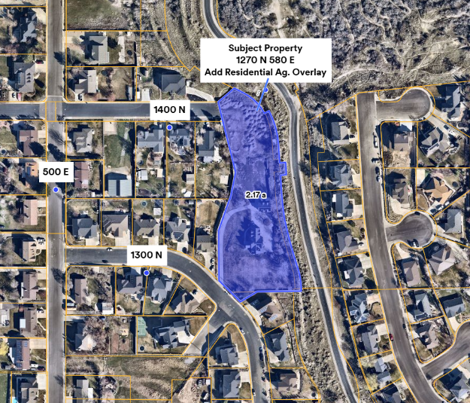

Public Hearing: Code Text Amendment – Section 10-12A-2: Permitted, Conditional, and Accessory Uses in the Business and Manufacturing Park (BMP) Zone
(City Wide)
Public Hearing to consider the request of St. John Properties to amend Section 10-12A-2: Permitted, Conditional, and Accessory Uses in the Business and Manufacturing Park (BMP) Zone, to add Use 6410 (Automobile Repair and Related Services) to the list of permitted uses within the Zone. (Legislative Item)

Public Hearing: Code Text Amendment – Section 10-14-24-3-D: Permitted Uses in The Grove Interchange Subdistrict
(City Wide)
Public Hearing to consider the request of Dallas Curtis to amend City Code Section 10-14-24-3-D: Permitted Uses in The Grove Interchange Subdistrict, to add Use 6295 (Tattooing) to the list of permitted uses within the Zone. (Legislative Item)

For assistance in understanding the above items, you may contact the Community Development Director, Daniel Cárdenas, or City Planner, Jacob Hawkins at (801) 785-6057.

CERTIFICATE OF POSTING:
I certify that the above public hearing notice items were posted in three public places within Pleasant Grove City limits and on the State (http://pmn.utah.gov) and City (www.pgcityutah.gov) websites.

Posted by: /s/ Maria Arteaga, Planning & Zoning Assistant
Date: June 1, 2026
Time: 2:00 p.m.
Public Places: City Hall, Library, and Community Room at 108 S 100 East

*Note: In accordance with the Americans with Disabilities Act, Pleasant Grove City will make reasonable accommodation for participation in the meeting. Request assistance by contacting Pleasant Grove City at (801) 785-5045, at least 48 hours prior to the meeting.

