Present: Tony Jolley-online (Information Technology), Hoa Nguyen-online (Council), Megan Hillyard -online (Administrative Services), Talia Butler-online (Public Works), Rashelle Hobbs-online (Recorder), Sheila Srivastava-online (Treasurer), Chris Stavros-online (Assessor), Robert Sampson-online (Community Services), Rosa Rivera-online (Sheriff), Brad Park-online (Surveyor), Lisa Ashman-online (District Attorney), Katy Fleury-online (Mayor Administration), Beth Graham-online (Human Services), Chris Harding-online (Auditor)
Representation Absent: Clerk
Staff Present: Tony Jolley-online, Rina Shipley-online, Dean Bullock-online, Hillary Boccagno-online, Lee Wilstead-online, Mark Miller-online, Trevor Hebditch, Kira Moody, Halo Pendragon-online, Cherie Root, Sam Sedivec-online, Valina Eckley-online, Thomas Yeung-online, Mike Bailey-online, Kimball Ball-online
TOPIC | POINTS OF INTEREST
Welcome & Remote Meeting Instructions | Brad Park opened the meeting.  Trevor Hebditch shared the following slide:  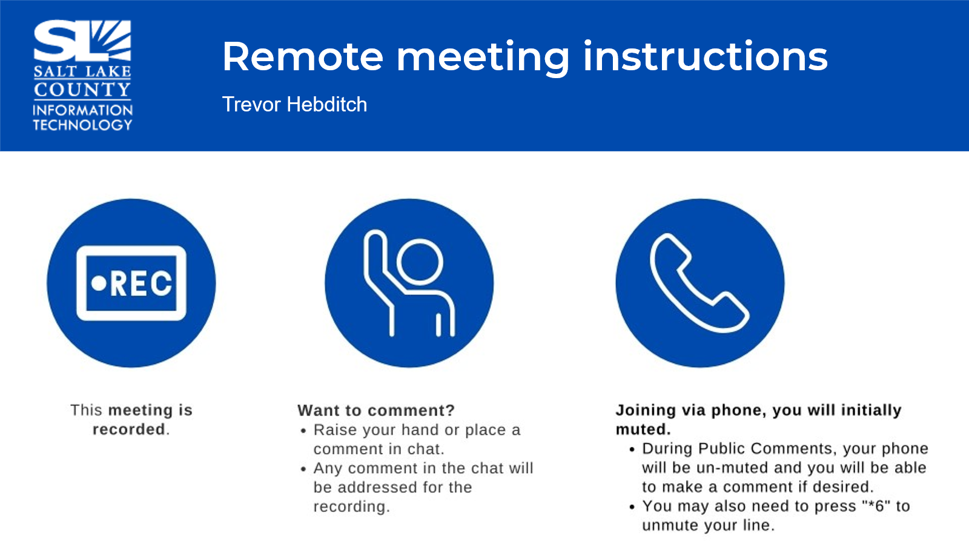
Public Comments | No public comments.
Approval of minutes from March 5, 2026 TAB meeting | - Motion to approve the minutes by Chris Stavros. Rashelle Hobbs seconds the motion.  No discussion.  Motion passed unanimously.
Open & Public Meeting Act (OPMA) Training  (Dianne Orcutt) | Training completed.  Action Item: All who are required but not in attendance will be followed up with by Brad Park and Cherie Root.
Follow-up Items  (Cherie Root) | 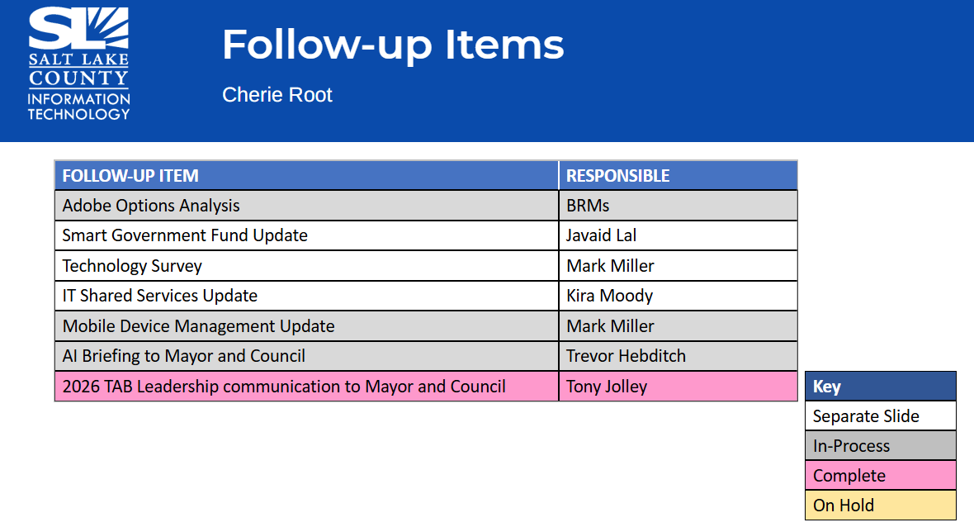
Technology Survey Update  (Mark Miller) | 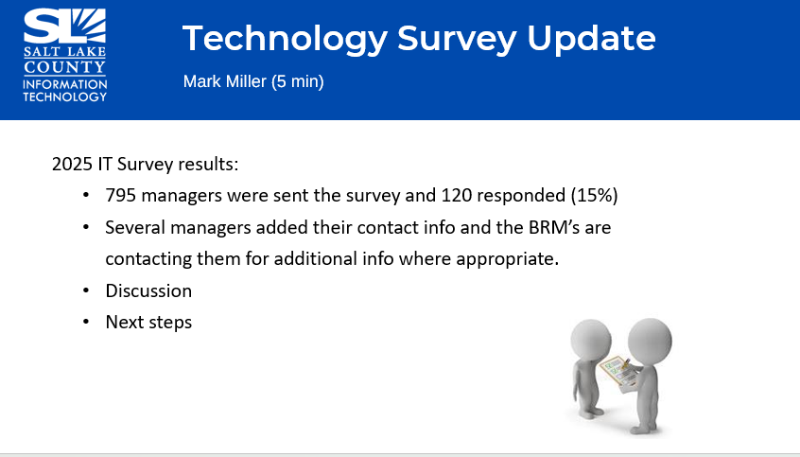  - Service Desk Usage: Routine support requests, such as password resets, are not billed. Engaging the Service Desk enables us to identify broader issues, like VPN outages, more quickly. That improves enterprise stability and responsiveness.  - Expanded Service Desk Hours: Departments expressed interest. IT currently maintains after-hours Webex space for organizations operating outside of reg bus hours. We made sure all respondents are aware of this channel.  - Meeting Environment Reliability: Partners note limited outlets to keep laptops charged in areas like Council Chambers. This presents an opportunity to evaluate integrated power solutions in the GC and Coliseum.  - Devices and Collaboration Tools: Interest in expanded device options and broader adoption of Microsoft Teams. IT cannot support every device type, we can collaborate to define secure, supportable standards that reduce reliance on email and enhance collaboration.  Next Steps: IT will work with our business partners to prioritize feasible solutions that appropriately balance user experience, security, and operational supportability.
IT Shared Services  (Kira Moody)  IT Shared Services cont.  (Kira Moody) | 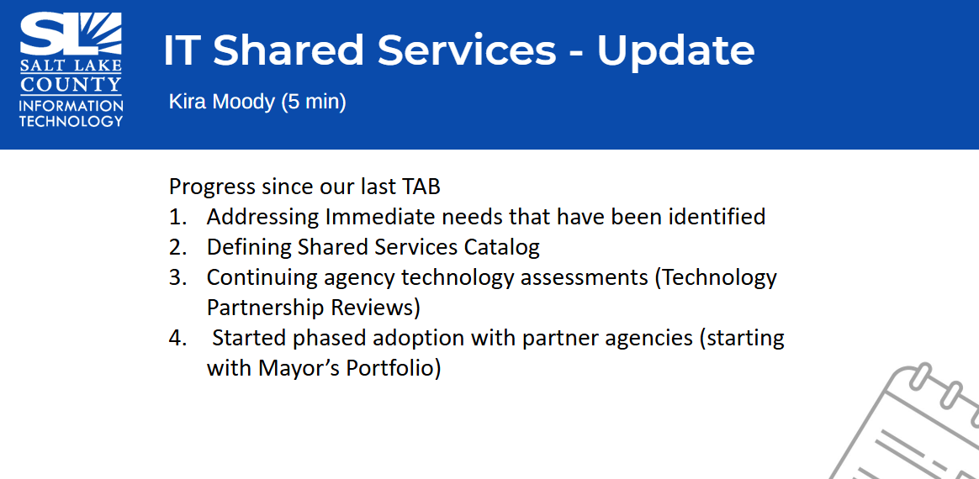  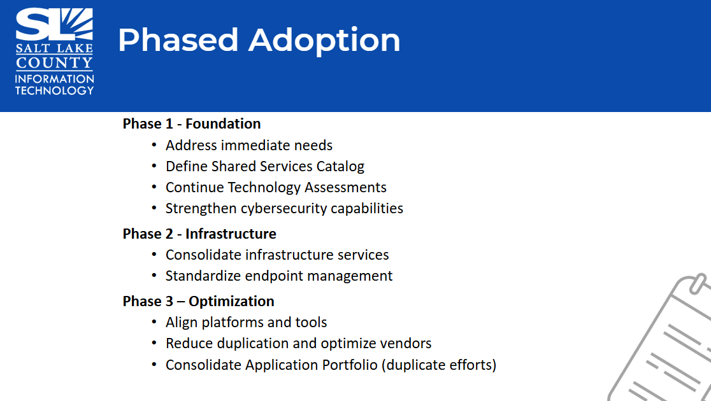  What Agencies Can Expect:  - Introduction Meeting  - Technology Assessment Meetings  - Introduction of Shared Services Catalog  Goal: Provide secure, reliable, and consistent technology across the County.  Action Item: progress update at next TAB meeting
Technology Positions Update  (Nick Loomans) | 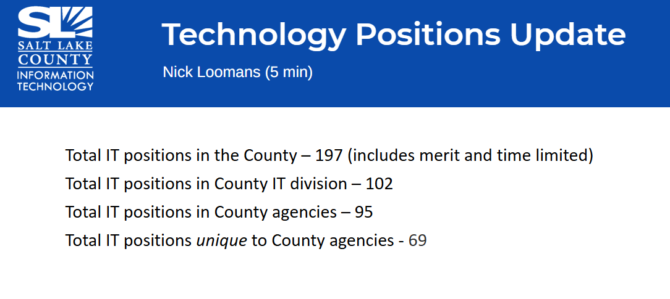
TAB Working Group Milestones  (Tony Jolley) | 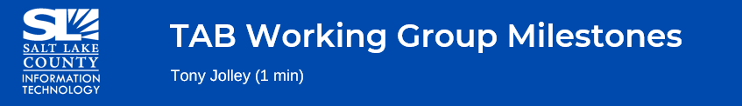  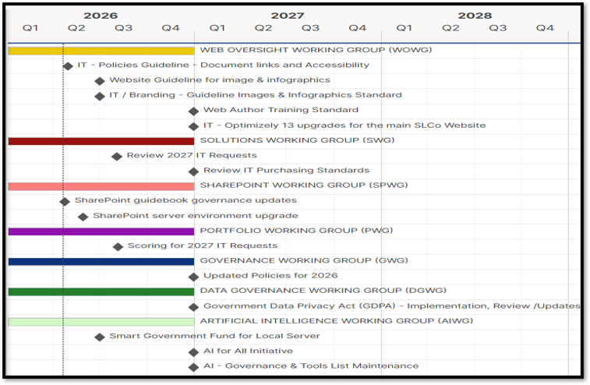
SharePoint Working Group  (Hillary Boccagno) | - Motion to approve the updates to the SharePoint Guidebook by Sheila Srivastava. Chris Stavros seconds the motion.  No discussion.  Motion passed unanimously.
AI Working Group  (Trevor Hebditch)  In depth discussion around County adoption of AI policy, training, and platform. Decision to hold a special “AI TAB Meeting” in May to focus just on AI.  AI Working Group cont.  (Trevor Hebditch)  There are so many tools and IT cannot govern all. The County has unique needs, and careful consideration on the use of AI must be given since we are entrusted with sensitive data.  The AI Working Group is working on a readiness assessment. They are meeting with agencies to thoughtfully consider all steps. | 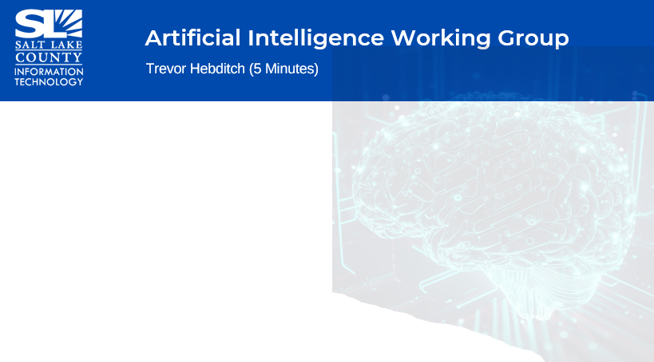  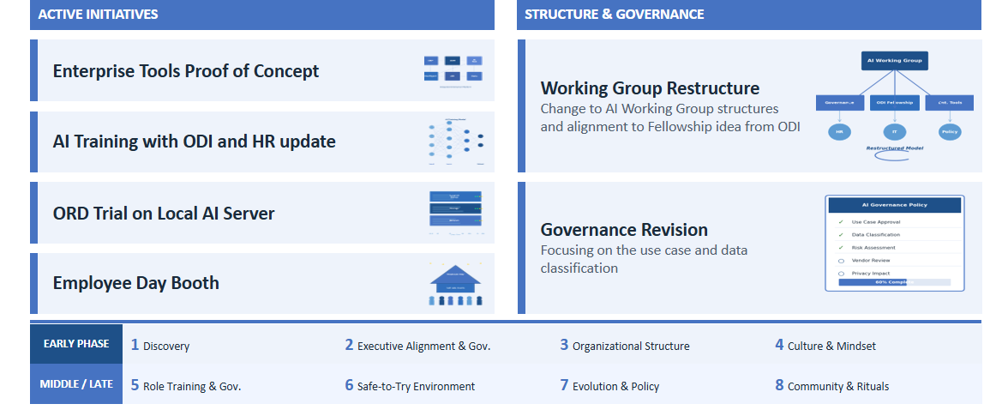  Action Item: schedule additional meeting to discuss AI
Data Governance Working Group  (Javaid Lal)  Data Governance Working Group cont.  (Javaid Lal) | 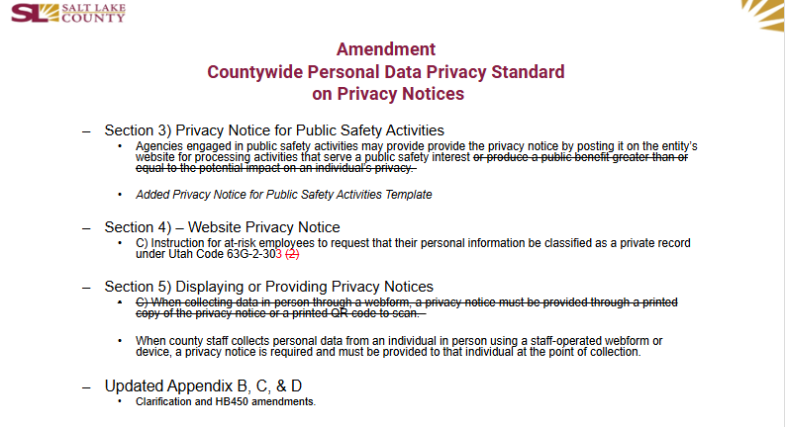  - Motion to approve the updates to the Countywide Personal Data Privacy Standard on Privacy Notices by Megan Hillyard. Chris Stavros seconds the motion.  No discussion.  Motion passed unanimously.  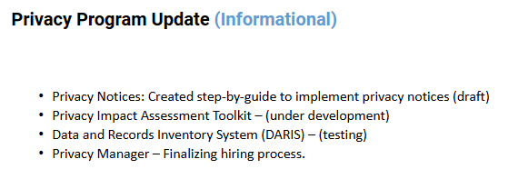
Smart Government Fund Update  (Javaid Lal) | 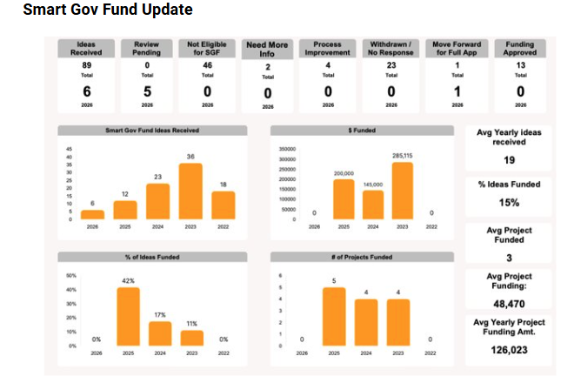  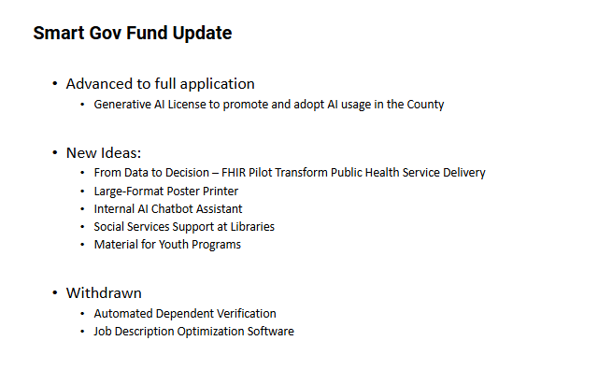
Security Update  (Rina Shipley)  Next Tabletop Exercise will be geared for non-IT teams. FBI will brief those in attendance. Reps from each agency are invited. Contact Rina for details. | 
Communication Items  (Chair & CIO) | Action Item: Brad and Sheila will communicate with the Mayor and Council about the Special TAB Meeting for AI and the tabletop exercise.
Upcoming Meeting Schedule for 2026  (Wendy Ormsby) | 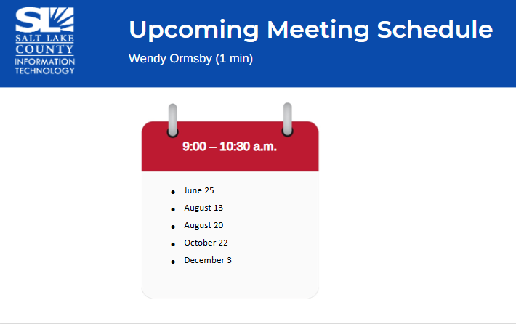
Review Action Items  (Wendy Ormsby)  There are four action items from this meeting.  OPMA training completion  Shared Services Update  Will plan a special AI TAB Meeting. Tony will put together an agenda, and a time will be sent out.  Let Mayor & Council know re: Tabletop & AI TAB meetings. | 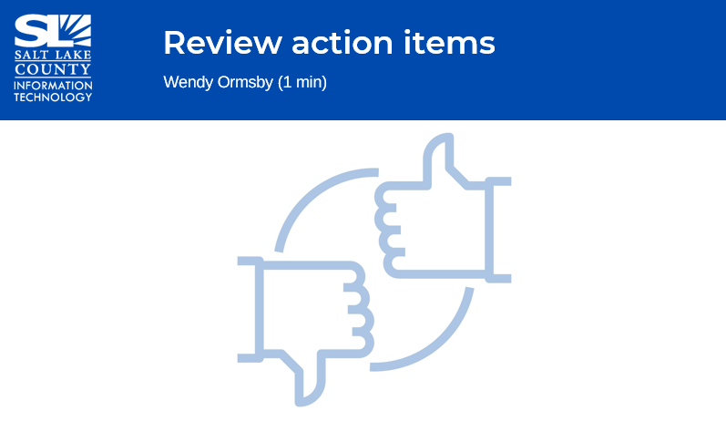
Next TAB meeting:  June 25, 2026 | 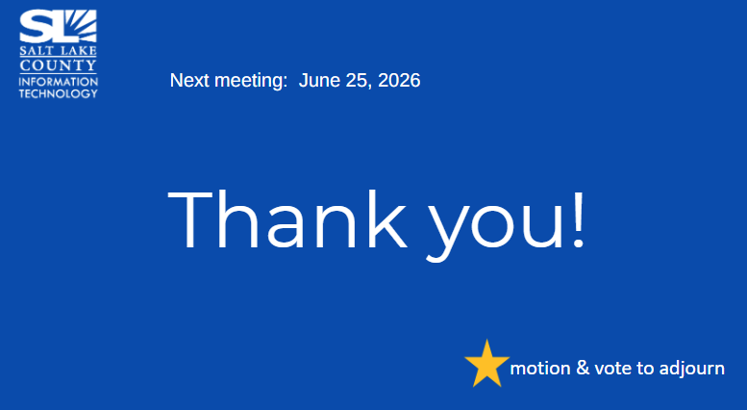
End of Session | Motion to adjourn the meeting by Megan Hillyard. Sheila Srivastava seconds the motion. No objections. Meeting adjourned. So moved.
Submitted by Wendy Ormsby

