Present: Tony Jolley (Information Technology), Megan Hillyard (Administrative Services), Chris Harding (Auditor), Lisa Ashman-online (District Attorney), Hoa Nguyen-online (Council), Talia Butler-online (Public Works), Rashelle Hobbs-online (Recorder), Sheila Srivastava-online (Treasurer), Chris Stavros (Assessor), Robert Sampson-online (Community Services), Carita Lucey-online (Sheriff), Brad Park (Surveyor), Katy Fleury-online (Mayor Administration)
Representation Absent: Clerk, Human Services
Staff Present: Trevor Hebditch, Tony Jolley, Rina Shipley-online, Brandon Allgier-online, Jeff Graham-online, Dean Bullock-online, Hillary Boccagno-online, Cherie Root, Mike Bailey-online, Lei Liu-online, Daniel Rolfe-online, Jake Petersen-online, Teddy Arnold-online, Tony Schleich-online, Corey Hess-online, Emily LaMunyon-online.

TOPIC | POINTS OF INTEREST
Welcome & Remote Meeting Instructions | Brad Park opened the meeting.  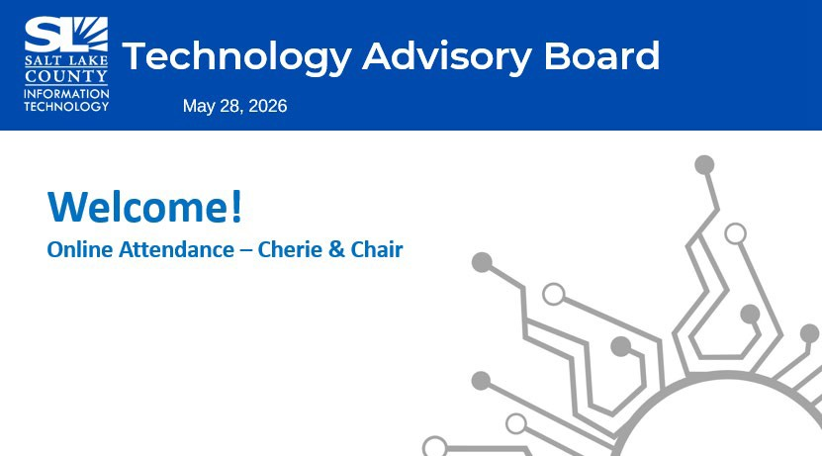  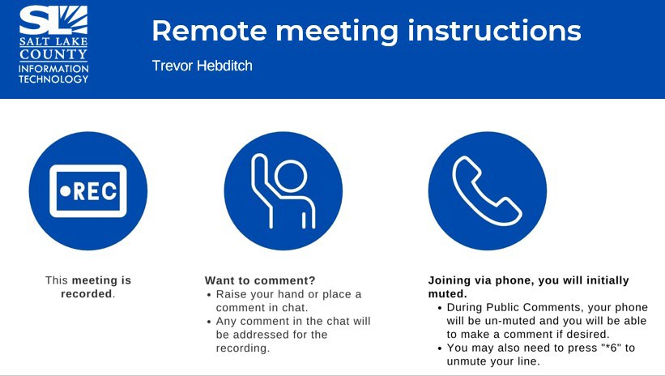
Public Comments  (Brad Park) | No public comments.
Approval of minutes from April 23, 2026 TAB meeting | Motion to approve the minutes by Chris Stavros. Rashelle Hobbs seconds the motion. No discussion.  Motion passed unanimously.

TOPIC | POINTS OF INTEREST
Setting the Context: AI Issues & Opportunities (Trevor Hebditch – Associate Director Enterprise Architecture for Salt Lake County)  A lot of people worked on this and deserve thanks. The AI Working Group helped define policies and standards. Data Privacy WG, members of TAB, other Working Groups, Office of Data Innovation, HR, IT teams….so many people. It was a team effort.  A shining example of cross county collaboration. | 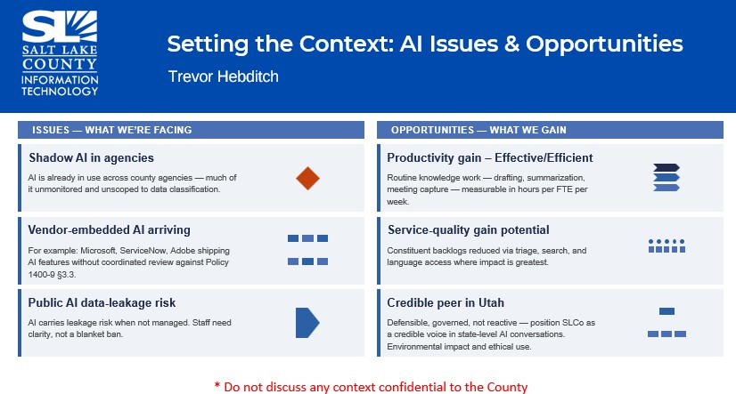  AI is here to stay and if we’re not enabling employees to use it, they’re going to start using it on their own. We can put in place the governance, guidance and policies, but if you don’t know how to  relate them to your job, you’re not really going to know how to use AI responsibly. Our job
 | here is to help educate and train employees to know how to responsibly use AI, enable them,
 | provide them with tools. Those tools should be easier to use and the guidance and mentorship on
 | how to use the tool should be easy to access.
 | Our goal is to enable employees to be more effective and efficient. It’s not about a reduction in
 | force. This is about how to enable people to increase their productivity and bring value to the
 | County.
 | Right now, we know employees are using AI tools, but we want to make sure they use these tools
 | correctly, staying safe and within guidelines to protect data.
Maturity Assessment  (Trevor Hebditch)  The County is a leader in many ways, but we have a lot of growth yet to do in terms of our use of AI and governance around that.  The right aim for a county of our size is to be between 3-4 on this readiness scale, by next year, in terms of our adoption/use of AI. | 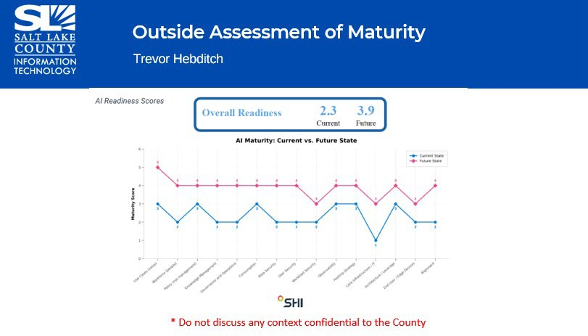

TOPIC | POINTS OF INTEREST
Current State: Foundation & Roadmap (Trevor Hebditch)  Training, what tools are vetted for various jobs, restricted data training, etc. It’s important for us to determine guardrails as soon as possible. | 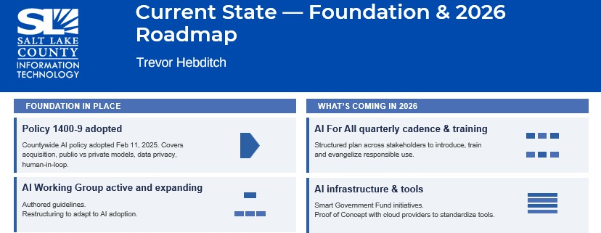
Driving Adoption: HR Partnership & Training  (Sharon Roux)  Our Learning and Development team have built the foundation of a training plan. We will share that with the working group. We need to be on the same page.  Different agencies have different needs. We know there will be broad, multi-party programs for training. | 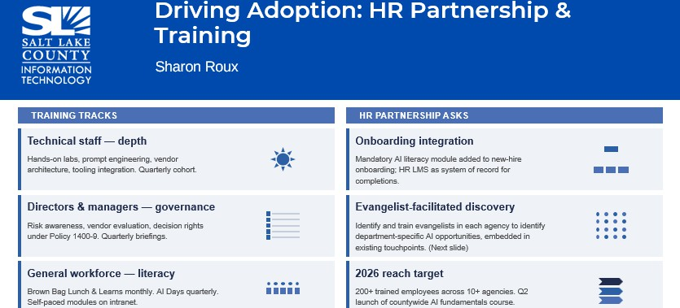
AI Fellowship Program (Trevor Hebditch)  We envision a cohort of experienced people embedded in agencies to scale a program. These evangelists will report back to TAB. We will tweak this program as needed.  We want to create enthusiasm with this, too. | 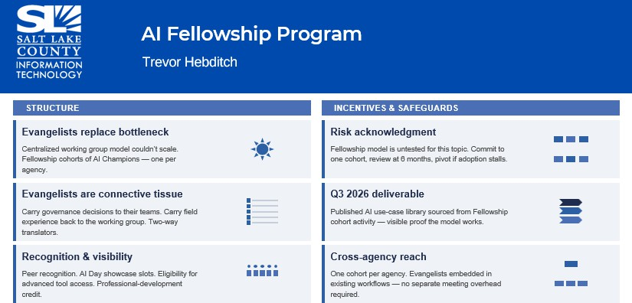

TOPIC | POINTS OF INTEREST
Employee Day AI Booth  (Trevor Hebditch) | 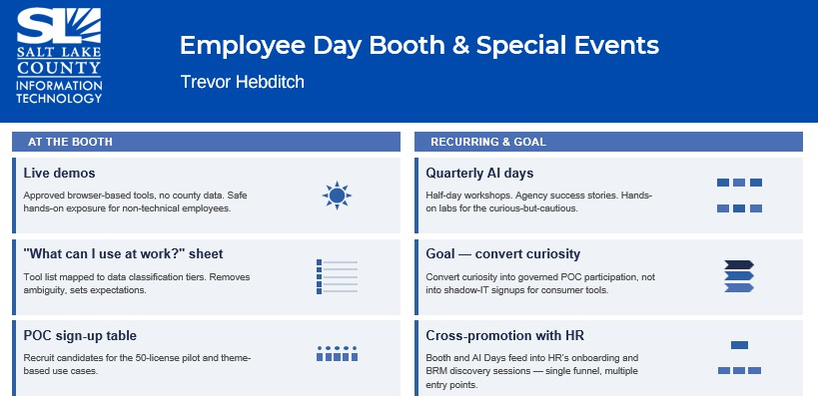
Coordination with Other Groups (Trevor Hebditch)  We can collaborate and learn from other groups, borrow knowledge, and share our experiences as well. We hope to be thought leaders on this, across the state and beyond. We are working on proof-of-concept framework right now. | 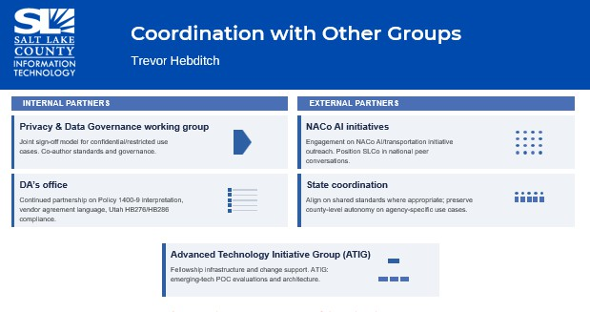

TOPIC | POINTS OF INTEREST
AI Tools & Standards: POC Framework (Trevor Hebditch)  We’ve been given platforms to test for a limited time.  Agents/Agentic AI  (Alex Sherwood)  There is meaningful distinction between AI agents and asking AI a question/chat bots. An agent can research, talk to external systems and make a whole report.  Those higher agency systems have higher risks, benefits and cost.  Productivity gains are real but not guaranteed. Token costs are falling, but it is still a cost to be managed. There is also a risk of skill degradation. It’s important to manage that and be intentional in our use of AI.  AI results are only as good as the data put into it. There must always be a human in the loop, someone that can vet the product’s output. A monitor who knows what the outcome should look like.  Standardized Tools  (Javaid Lal) | 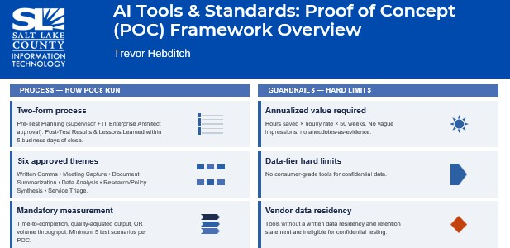  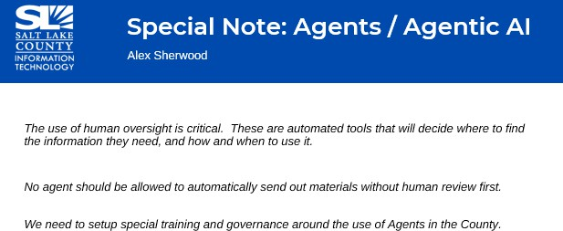  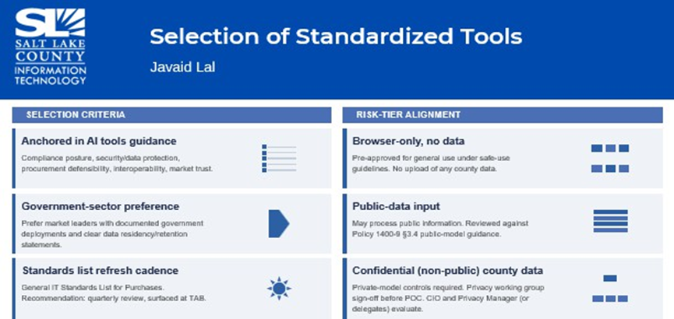

TOPIC | POINTS OF INTEREST
AI Enterprise Level Agreements & Data Governance Direction Support  (Javaid Lal)  The tools we choose should be anchored in our compliance and security requirements. | 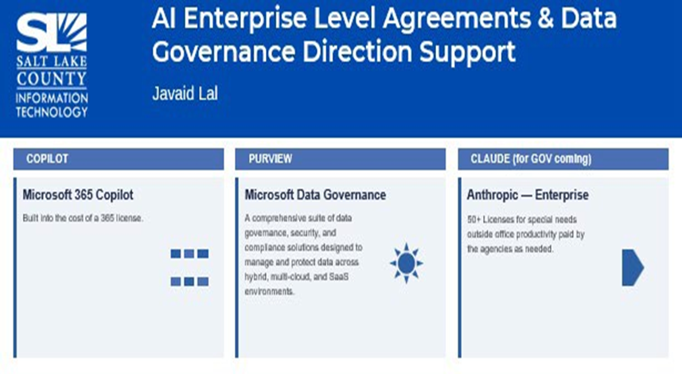  We need to be mindful as we vet these tools of our requirements, security, privacy. We need to refresh our standards and policies on a regular basis, like every 6 months or more, to make sure we keep up with the technology. We need to look at the fine print. We need to make sure our privacy policies are in compliance on a regular basis.  This all gets very complicated and every agency has different needs.
Managing & Monitoring Usage  (Trevor Hebditch)  Different departments will need higher degrees of classification of data.  Those will need appropriate training for their staff and an understanding of the appropriate use of their AI tool. Education at the highest executive levels will be needed to oversee this and the ramifications. | 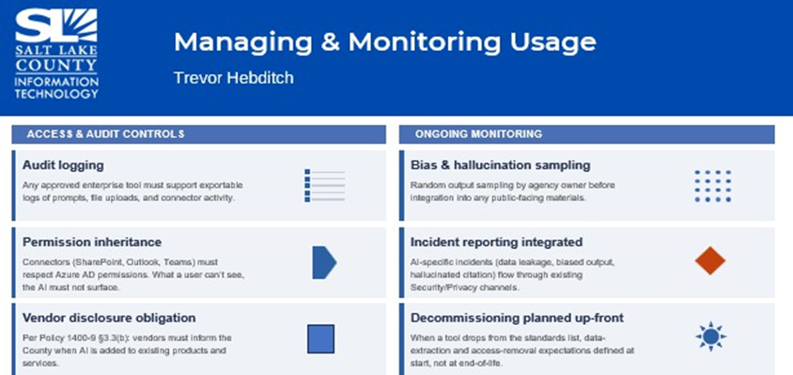

TOPIC | POINTS OF INTEREST
Recommendations & Future Direction: Governance Structure (Trevor Hebditch)  Right now, we have the AI Working Group and TAB for the technology impact side. We need an AI Advisory Committee to steer things from a business impact side. DA, HR, Contracts and Procurement, etc.  Several agencies, working together to oversee this and make sure we are in compliance and policies stay up to date. | 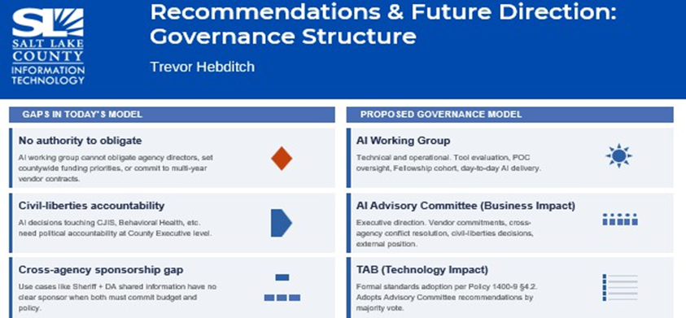
AI Advisory Committee & Chief Administrative Officer (CAO) for AI (Trevor Hebditch)  Many entities have a CAO to oversee the use of AI.  Dedicated support to the County would be our recommendation. | 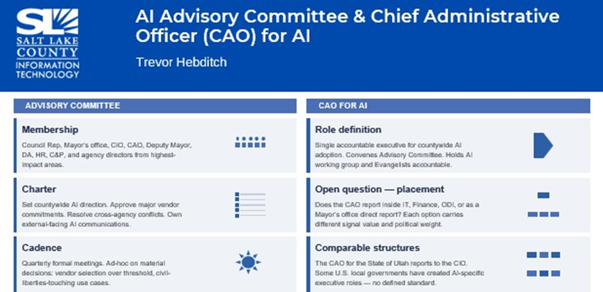

TOPIC | POINTS OF INTEREST
Direction  (Tony Jolley)  Motion & Vote | 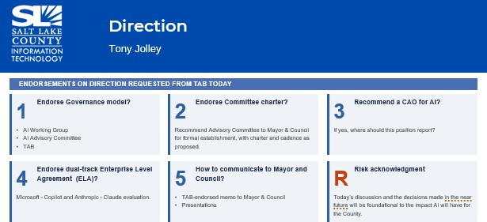
Direction  (Tony Jolley)  Motion & Vote | Motion to approve recommended direction by Megan Hillyard. Sheila Srivastava seconds the motion. No discussion.  Motion passed unanimously.
Other Business | None
Communication Items  (Chair & CIO) | AI Presentation to Mayor and Council

TOPIC | POINTS OF INTEREST
Upcoming Meetings | 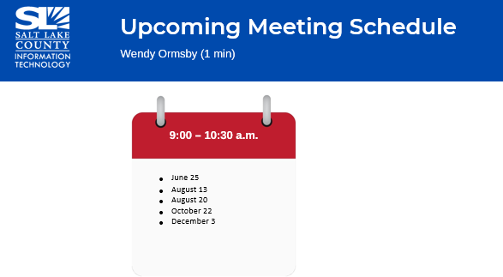
Action Items  (Wendy Ormsby) | 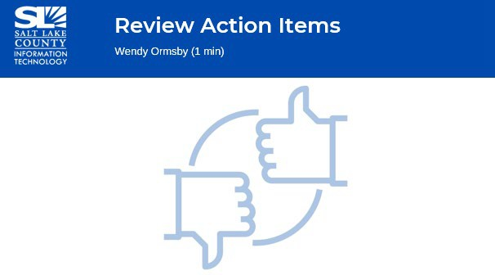
Action Items  (Wendy Ormsby) | - Draft email all County re: policy, use, framework, etc. for AI.  - Survey re: AI use/data (HR—training related questions in survey).  - Explore CAO—bring back topic at TAB re: budget deliberations.  - Talk environmental impact at later TAB meeting. (Brock Damjanovich to present.)  - Present to Mayor and Council, July or August. (Also, talk CAO for importance.)  - HR will survey market and job description for CAO.
End of Session
Submitted by Wendy Ormsby

