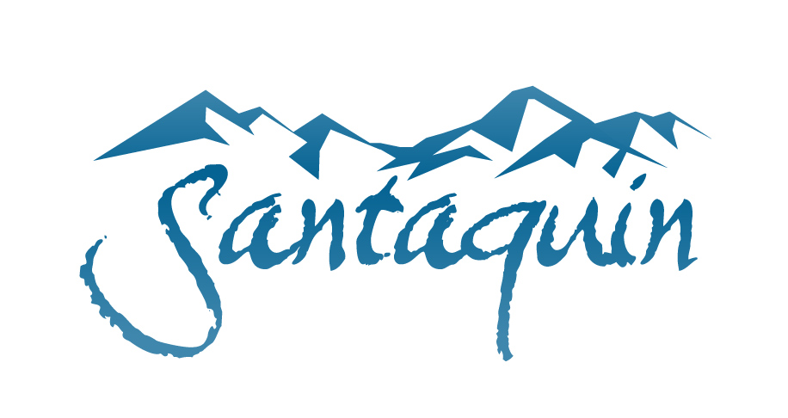
NOTICE OF PUBLIC HEARING (CDRA)
FY 2025-2026 BUDGET AMENDMENT

Notice is given that the Community Development & Renewal Agency of Santaquin City (“CDRA”) will hold a Public Hearing on June 30, 2026, at approximately 5:00 PM at Santaquin City Hall, 110 S. Center St. Santaquin, UT 84655.
The public is invited to participate in person or view electronically through the following website address: https://www.youtube.com/@santaquincity
The purpose of this Public Hearing is to receive public input for the consideration of the CDRA Board:
- Community Development & Renewal Agency of Santaquin City: FY 2025-2026 Budget Amendment #1
The documents associated with this hearing will be available for inspection on the City website at www.santaquin.gov , no later than June 26, 2026.

Certificate of Posting
The undersigned duly appointed City Recorder for the municipality of Santaquin City hereby certifies that a copy of the foregoing notice may be found at www.santaquin.gov in three physical locations (Santaquin City Hall, Zions Bank, Santaquin Post Office), and on the State of Utah’s Public Notice Website, https://www.utah.gov/pmn/index.html. A copy of the notice may also be requested by calling (801)754-1904.

Dated this 19th day of June 2026.

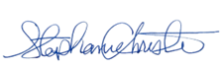
By:
Stephanie Christensen, City Recorder

