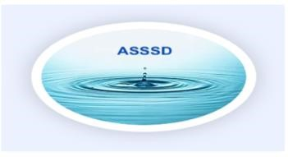
Angell Springs Special Services District
Public Monthly Board Meeting
AGENDA
https://us02web.zoom.us/j/6797857976?pwd+TitlSWE2NEJwYmtBclFZK1VySUd6dz09
(go to JOIN A MEETING) Meeting ID: 679 785 7976 Password: water
June 18, 2026, 6:00 PM, (Springs Building IS ASSSD BUILDING)

ATTENDEES: Chairman: Greg Maranto - Vice Chairman/ CCC Administrator: Tony Hundal
Treasurer: Diane Hundal - Water Master: Shawn Bain Waterboard Clerk: Stephanie Ward
Board Member: Jean Wojtyla Guests:
VOTE: Approval needed for May 21, 2026 Meeting Minutes
ACTION ITEMS:
- Greg-
1. Conservancy District Progress / Community Action
2. Emergency Response Plan
3. Sanitary Survey w/ Shawn
4. Policy on disciplinary action
5. Voting criteria
- Shawn-
1. Sanitary Survey w/ Greg
2. Maintenance budget
- Tony –
1. Website Progress
2. Water Usage
- Jean-
1. Sam.gov
2. Storage Areas
3. My Utah Trust
- Stephanie-
1. Customer Contact list
2. Late fees
- Diane-
  - Impact & Stand by Fees
2. Provide Financial Reports
1.Standard Financial (Last meeting to current meeting)
2. Operational Budget (1/1/2026 to current)
3. Invoice Register (Last meeting + 1 day to current meeting)

