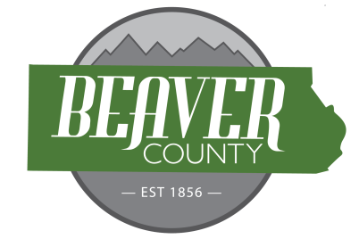
NOTICE AND AGENDA OF A PUBLIC MEETING
June 16, 2026 PUBLIC MEETING OF THE
BOARD OF COUNTY COMMISSIONERS OF
BEAVER COUNTY, UTAH

PUBLIC NOTICE is hereby given that the Beaver County Commissioners of
Beaver County, Utah, will hold a regular Meeting on June 16, 2026 at the place
and time set forth below to consider the agenda item(s) hereinafter set forth.

MEETING PLACE: Beaver County Administration Building 105 East Center Street, Beaver, Utah.
MEETING TIME: 10:00 AM

10:00 AM
Open Meeting Commissioner Hollingshead
Call to order Commissioner Hollingshead
- Prayer offered by Commissioner Brandon Yardley
- Pledge of Allegiance led by Chloee Anderson
New Business
10:05: Approve Bills
10:10: Consider the URS Pickup for Public Safety
10:15: UAC Agreement
10:20: Memorandum of Understanding for PLPCO
10:25: Ratify New Hire
10:30: Grant Funding Check in
10:40: Five County AOG
11:15: Invasive Species Mitigation Grant Agreement
11:20: Utah Forge Update
11:35: Side-by-side Funding Agreement
11:40: Public Hearing- Sale of Real Property
12:00: Meeting Adjourned

(To be discussed when/as time permits)

- Old Business
IDC Grant Renewal
- Commission Updates

BEAVER COUNTY COMMISSION CHAIRMAN
Any other business properly brought before the Board.
Dated the 16 day of June, 2026

