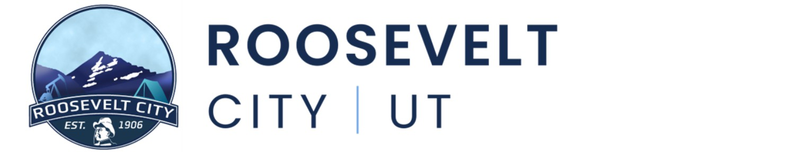

June 16th, 2026
Notice is hereby given that the Roosevelt City Council will hold their regularly scheduled meeting on Tuesday June 16th, 2026, at the Roosevelt Municipal Building located at 255 S State Street, Roosevelt, UT. The meeting shall begin promptly at 5:30pm.
- CALL TO ORDER
- ROLL CALL
- OPENING CEREMONY
Prayer and Pledge of Allegiance
- APPROVAL OF PREVIOUS MINUTES
  - APPROVAL OF PREVIOUS MINUTES, SIERRA WISENER
Meeting Minutes from 6.2.26
Attachments
    - Meeting Minutes CC 6.2.26.pdf
- PUBLIC COMMENT PERIOD
Three (3) minute time limit per speaker. If you would like to make a comment, but are unable to attend the meeting, please consider emailing your comment to citycouncil@rooseveltcity.com.
- COMMITTEE APPOINTMENTS
  - MOSQUITO ABATEMENT APPOINTMENT
  - APR APPOINTMENT
- PUBLIC HEARING(S)
  - FY26 BUDGET REOPEN
- ACTION ITEMS
  - FY26 BUDGET REOPEN, ZEKE ATWOOD
  - OUTDOOR RECREATION GRANT, ZEKE ATWOOD
  - ADOPTION OF FY27 TAX RATE, ZEKE ATWOOD
  - ZONE CHANGE FOR LANCE DENVER, DREW ESCHLER
  - K & K SANITATION CONTRACT RENEWAL, GRANT CHARLES
  - AIRPORT EMPLOYEE CONTRACT, GRANT CHARLES
  - SIDEWALK BID AWARD UPDATE, KIRBY WOLFINJER
  - GOLF COURSE CAFÉ CONTRACT, GRANT CHARLES
  - UTAH WILDFIRE RESOURCE MOU, RYAN CLAYBURN
  - COOPERATIVE WILDFIRE SYSTEM AGREEMENT, RYAN CLAYBURN
  - NEW COPIER LEASE AGREEMENT, BROCK ARNOLD
- EXPENDITURE APPROVAL & FINANCIAL REVIEW
- CITY MANAGER REPORT
- COMMITTEE REPORTS
- ITEMS FOR FUTURE DISCUSSION
- CLOSED SESSION
As for the purposes listed in Utah Code 52-4-205
- ADJOURN

Further information can be obtained by contacting Sierra Wisener at (435) 401-8198 In compliance with the Americans with Disabilities Act, individuals needing special accommodations (including auxiliary communicative aids and services) during these hearings should notify Sierra Wisener at 255 South State Street, Roosevelt, Utah, 84066, at least three days prior to the hearing to be attended.

