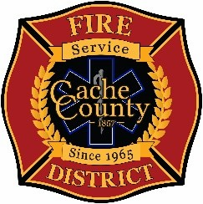
CACHE COUNTY FIRE DISTRICT
BOARD OF TRUSTEES
Kathryn Beus – Board Chair George Daines – Trustee
David Erickson – Trustee Steve Miller – Trustee
Lyndsay Peterson – Trustee Aaron Rudie – Trustee
Larry Jacobsen - Trustee

BOARD OF TRUSTEES MEETING
June 11, 2026
12:00pm

AGENDA
The Cache County Fire District Board will meet Thursday, June 11, 2026, commencing at 12:00 p.m. in the Cache County Historic Courthouse, Council Conference Room, 199 North Main Logan, Utah 84321.
- CALL TO ORDER:
- ITEMS OF BUSINESS
  - Approval of Agenda – June 11, 2026
  - Approval of Minutes – May 20, 2026
- DISCUSSION:
A. Discussion and Guidance Regarding District Board Governance
B. Discussion on Proposed Amendment and Restatement of Board of Trustees Bylaws

- NEXT MEETING – TBD
- ADJOURN

In compliance with the Americans with Disabilities Act, individuals needing special accommodations (including auxiliary communicative aids and services) during this meeting should notify Janeen Allen, at 755-1850 at least three working days prior to the meeting.

