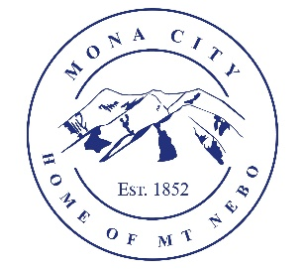
Mona City
435-623-4913
www.monautah.gov
20 West Center Street, Mona, Utah

Mona City Council Meeting Agenda
Tuesday, June 9, 2026
Mona City Building – 20 West Center
7:00 p.m.

Pledge
Prayer
Approval of May 26, 2026, Work Session Minutes
Approval of May 26, 2026, City Council Meeting Minutes
Action Items
- Approval of $8,245 for lining of two manholes near sewer plant
- Approval $16,000 for the preparation of Mona City 40-Year Water Right Plan by Sunrise Engineering
Land Use:
- Cory Ballow – 455 East Platt Lane – Accessory Building with utilities
Secretary
Finance
- Approval of finances
- Adopt Certified Tax Rate
- Set public hearing for June 23rd for amendment of 2025-2026 Budget & 2026-2027 Final Budget
Recorder
Gas & Water & Roads
Sewer
Council Reports
Public Comment
Adjournment

CERTIFICATE OF POSTING
This agenda is hereby properly advertised on this 8th day of June, 2026, by posting copies in the following places: the Mona City Office, on the Mona City website at monautah.gov, at the United States Post Office Mona City Branch, and on the Utah Public Notice Website at www.utah.gov/pmn/index.html.

___________________________________
Alicia Hills, Mona City Recorder

Upon Request, in compliance with the Americans with Disabilities Act, reasonable accommodations for individuals with disabilities will be provided. For assistance, please call 435-623-4913.

