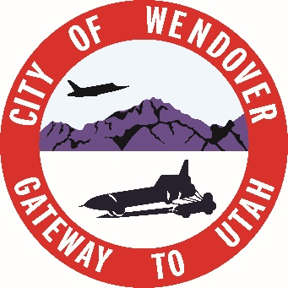
PHONE # 435-665-7771
FAX #435-665-2523

920 E Wendover Blvd
P.O Box 430
Wendover, Ut 84083

BUDGET PUBLIC HEARING #4

DATE: June 17th, 2026
TIME: 5:00pm
PLACE: WENDOVER CITY TOOELE COUNTY COMPLEX BLDG
920 EAST WENDOVER BLVD.

- PROPERTY TAX RATE APPROVAL
- APPROVE TO TRANFER ANY REVENUES OVER 35%
- APPROVAL OF FINAL BUDGET 2026-2027

INCOMPLIANCE WITH THE AMERICAN WITH DISABILITIES ACT, INDIVIDUALS NEEDING SPECIAL ACCOMMODATIONS (INCLUDING AUXILIARY COMMUNICATIVE AIDS AND SERVICES) DURING THESE MEETINGS SHOULD NOTIFY SASHA PALAFOX AT THE WENDOVER TOOELE COUNTY COMPLEX AT 920 EAST WENDOVER BLVD. (435 665 7771). AT LEAST THREE DAYS PRIOR TO THE MEETING TO BE ATTENDED.

POSTED: June 8, 2026
WENDOVER UTAH CITY OFFICES, WENDOVER UTAH
- WENDOVER POST OFFICE, WENDOVER UTAH
- THE WENDOVER TIMES, WENDOVER UTAH
- UTAH PUBLIC MEETING WEBSITE

THE CITY OF WENDOVER, UTAH IS AN EQUAL OPPORTUNITY PROVIDER AND EMPLOYER

