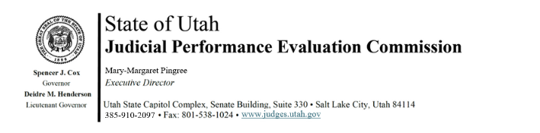
Tuesday, June 9, 2026
9 am – 11 am
Hybrid Meeting: Senate Building, Suite 330, CCJJ Large Conference Room

9:00 a.m. Welcome Bridget Romano
Approval of Minutes – April 28, 2026

9:05 a.m. Announcements Mary-Margaret Pingree

9:15 a.m. 2026 Retention Evaluations - Reconsiderations Chris Russell
Closed Session

9:30 a.m. Off Year Priorities Mary-Margaret Pingree
Madison Klein

9:45 a.m. Voter Outreach - Budget Discussion Mary-Margaret Pingree
Madison Klein

10:00 a.m. Courtroom Observer Spotlight Julie Spilker

10:30 a.m. Commissioner Feedback Madison Klein

11:00 a.m. Adjourn

Next Meeting: Tuesday, August 4, 2026
9:00 a.m. – 1 p.m.
Senate Building, CCJJ Large Conference Room

