



Site Plan Review
Meeting Date June 10, 2026, 6 pm 1528 Sunset Road, Lake Point, UT 84074
Applicant Justin Jones (Civil Science)
Property Owner Shiv Patel
Request Commercial Site Plan Review
Property Address 1685 East Saddleback Blvd, Lake Point Utah 84074
Parcel 13-032-0-0004
Acreage 2.4 acres
Zone Commercial Highway
Prepared by Jamie Olson
Presented by Jamie Olson

Scope of Decision- This is a administrative matter to be decided by the land use authority Lake Point City Council upon receiving a recommendation from the Planning and Zoning Commission and a review from the DRT Committee.
Planning and Zoning recommended the approval of this Site Plan application on June 1, 2026.
Request Summary
- The applicant requests a Site Plan Review for a commercial building, for a Marriott Fairfield Hotel. The proposed development is a 97-room dual-brand Marriott hotel featuring Fairfield Inn and TownePlace Suites, designed to serve both short-term and extended-stay guests. The property will target high-traffic transient demand, including business travelers, tourists, and pass-through interstate traffic. Additionally, the hotel will cater to government and military personnel, as well as visitors to nearby recreational and racing venues. The dual-brand model allows for flexible accommodations, enhancing occupancy across multiple demand segments.
- The Zoning is CH- Commercial Highway and is an allowed use under Chapter 13.5.2. through 13.5.3.
- Building Stories- 4 stories and 97 rooms
- Building square footage-
  - 1st floor - 16,008 SQ. FT.
  - 2nd floor - 13,821 SQ. FT.
  - 3rd floor - 13,657 SQ. FT.
  - 4th floor - 13,657 SQ. FT.
- Building Wall Height- 55 feet (Max 56.6 feet)
- Parking Stalls
  - ACCESSIBLE PARKING SPACES AVAILABLE: 4
  - TRADITIONAL PARKING SPACE AVAILABLE: 83
  - TOTAL PARKING SPACES AVAILABLE: 87
  - REQUIRED PARKING SPACES: 87
- Land Use Table
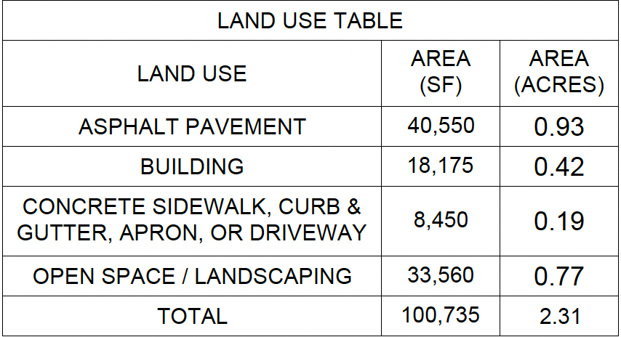
- Project History
  - This project concept was initiated before Lake Point was a city while under Tooele County. The owner had done research under Tooele code and the use would have been allowed under county zoning code. No applications were submitted under the county.
  - After the application was submitted to Lake Point, there was a code amendment requested to allow for a reduction in parking stall width requirements. Because of the limited size of the parcel, the previously adopted width of 10 feet, reduced the amount of desired and appropriate parking stalls. The Commission and Council amended the Supplemental Regulations code on parking minimum width to 9 feet, in December of 2024.

Special Approvals

Building Height Increase- The zoning code permits a maximum building height of 40 feet; however, a height increase may be considered when appropriate mitigating factors and site-specific justifications are present. The proposed increase is necessary to accommodate the hotel design and intended use while maintaining a functional site layout. Potential impacts associated with increased height, including fire access and public safety considerations, have been evaluated. The North Tooele Fire District has indicated plans to acquire a ladder truck prior to project completion, which would improve emergency response capabilities for multi-story structures. Based on the project design, site configuration, and available mitigation measures, the requested height increase is supportable.

General Plan Considerations
This application does not go against anything in the Lake Point General Plan adopted in
Ordinance 2024-05 on April 10, 2024.

DRT Committee Review and Resolved Findings
- Building Official approved and any comments or corrections made
  - No concerns, complete plan review will be done during building permit process.
- Engineering approved and any comments or corrections made
  - The main corrections noted by the engineer. All were addressed
    - Adjustments to match the geotechnical study recommendations.
    - Landscaping adjustments that involved site triangle, irrigation location and trees in the utility easement.
    - Asphalt slope
    - UNEV petroleum pipeline easement approval (Holly Energy)(Sinclair)
    - KUCC aqueduct easement approval (RioTinto)
- Fire Marshal approved and any comments or corrections made
  - Fire code was extensively discussed on this project in regard to the building height and mitigating life saving measures and the lack of current fire apparatus to fight a fire
- Staff approved and any comments or corrections
  - No concerns
- Any public feedback
  - Non reported
- Traffic Report not needed
- Geotechnical Study independently provided by applicant for this parcel by Landmark Testing and Engineering 04-13-2021
- Land Survey Provided
- Complies with proposed use under current zoning -state ordinance and use

Development Review Team (DRT) Approvals

The following departments have reviewed the site plan application which provides the subject for this staff report, and it has been found to be appropriate for review by the Lake Point City Planning Commission and/or City Council.

Fire Marshal (Buck Peck)
Recorder (Jamie Olson)
Engineering (Dan Fechner)
Building Official (Kelly Brown)
Rocky Mountain Power (Lisa B)
Enbridge (Lexi Vigil)
Lake Point Improvement District (Brendan Thorpe)
Oquirrh Mountain Water Company (Keith Fryer)

Recommendation

Based on the findings and conclusion listed in this report, and recommendation from Planning and Zoning, staff recommends the City Council review the request and approve the Site Plan Review Application for applicant Justin Jones.

Supporting Document

Parcel Location

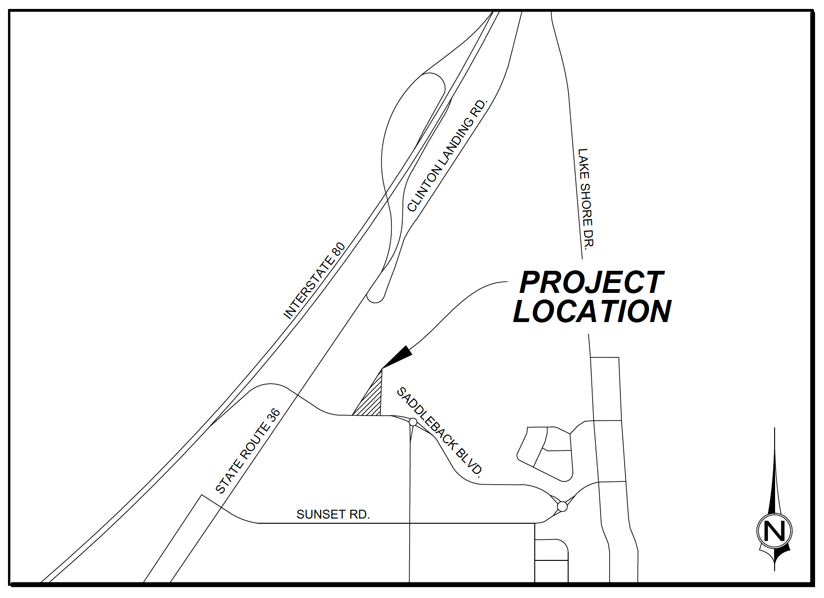

Site Plan of Building

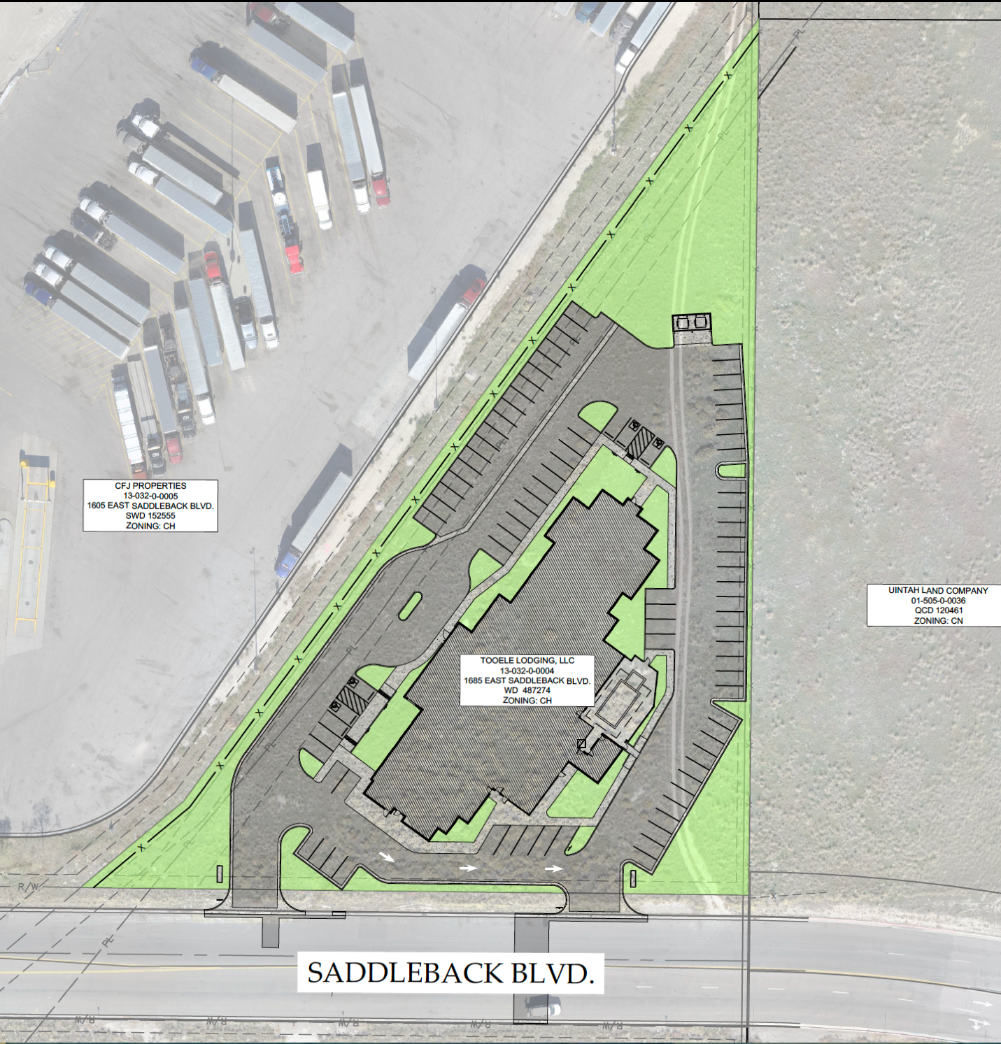

Landscaping Plan

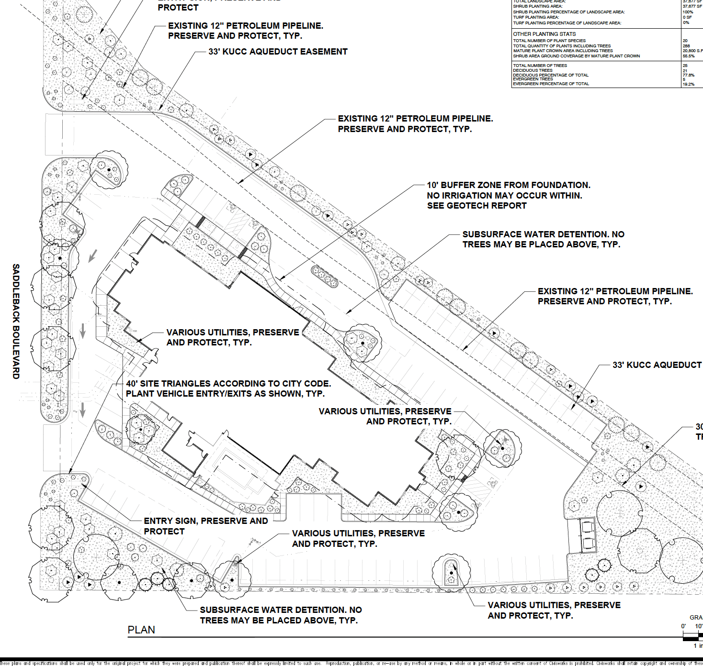

Photometric Plan
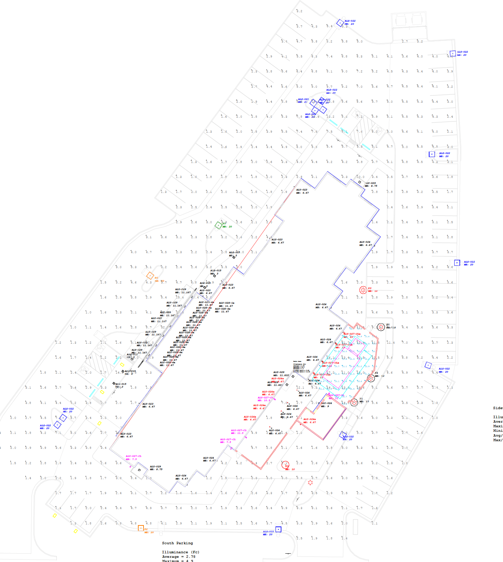

Signs
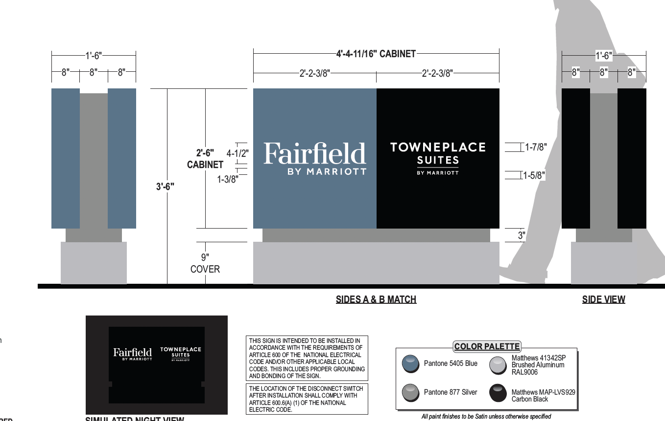

Building Cross Sections
