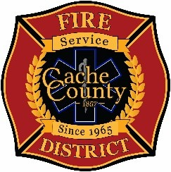
CACHE COUNTY FIRE DISTRICT
BOARD OF TRUSTEES
Kathryn Beus – Board Chair George Daines – Trustee
David Erickson – Trustee Steve Miller – Trustee
Lyndsay Peterson – Trustee Aaron Rudie – Trustee
Larry Jacobsen - Trustee

BOARD OF TRUSTEES WORKSHOP AGENDA
June 2, 2026
7:00pm
The Cache County Fire District Board will meet Monday, June 2, 2026, commencing at 7:00 p.m. in the Cache County Council Chambers, 179 North Main Logan, Utah 84321.
- CALL TO ORDER:
- WORKSHOP DISCUSSION
-The intent of the workshop is to provide an opportunity for fire chiefs, firefighters, and other responders from across the county to share their thoughts, concerns, and perspectives with the Board regarding the proposed direction of funding and service delivery.

- ADJOURN

In compliance with the Americans with Disabilities Act, individuals needing special accommodations (including auxiliary communicative aids and services) during this meeting should notify Janeen Allen, at 755-1850 at least three working days prior to the meeting.

