WRITTEN AGREEMENT

This WRITTEN AGREEMENT (this “Agreement”) is entered into this May 29, 2026 (the “Effective Date”), between CACHE COUNTY, UTAH, a political subdivision duly organized and validly existing under the laws of the State of Utah (the “Local Entity”) and PACE LOAN GROUP, LLC a Delaware limited liability company (including its designee, successors and assigns, the “Lender”).

R E C I T A L S:

- Pursuant to the Commercial Property Assessed Clean Energy Act, Title 11 Chapter 42a, Utah Code Annotated 1953, as amended (the “Act”), the Local Entity’s executive or administrator may authorize the designation of an energy assessment area and the levying of an assessment within such energy assessment area to facilitate the financing and/or refinancing of the costs of acquiring, constructing and installing certain energy efficiency upgrades and/or renewable energy systems and related improvements (collectively, the “Improvements”) owned by Utah Flour Milling, LLC, a Delaware limited liability company (the “Borrower”) and assign to a third-party lender the Local Entity’s rights in its energy assessment lien.
- The undersigned executive or administrator of the Local Entity hereby determines that its legislative body has authorized the Local Entity to designate an energy assessment area and levy an assessment against a property anticipated to be benefited by the Improvements to finance the costs of said Improvements.
- The undersigned executive or administrator of the Local Entity now desires to designate the energy assessment area, to levy said assessments and, pursuant to Section 11-42a-302 of the Act, to assign to the Lender the Local Entity’s rights in the energy assessment lien all in accordance with this Agreement.
NOW, THEREFORE, in consideration of the premises stated herein, the designation of the Energy Assessment Area (as defined below), and other good and valuable consideration, the receipt and sufficiency of which are hereby acknowledged, the Parties hereto hereby agree as follows:

Requirements for Designation of Energy Assessment Area. Pursuant to Section 11-42a-202 of the Act, the Borrower has provided to the Local Entity the documents attached hereto as Exhibit A, and represents to the Local Entity that the documents attached hereto as Exhibit A provide evidence showing:

the written consent from each person or institution holding a lien on the Borrower’s property or confirmation that such liens will be released at the time the Lender makes a loan to the Borrower for the purpose of financing the Improvements;

evidence that there are no delinquent taxes, special assessments, or water or sewer charges on the Borrower’s property;

evidence that the property is not subject to a trust deed or other lien on which there is a recorded notice of default, foreclosure, or delinquency, that has not been cured;

evidence that there are no involuntary liens, including a lien on the Borrower’s property, or on the proceeds of a contract relating to the Borrower’s property, for services, labor, or materials furnished in connection with the construction or improvement of the Borrower’s property; and

the written consent of the Borrower to the Local Entity’s designation of the Energy Assessment Area, levying of the assessment, and creation of the Assessment Lien (as defined below) on the Borrower’s property.

Designation of Energy Assessment Area. Pursuant to Section 11-42a-201 of the Act, the Local Entity hereby designates a voluntary energy assessment area that shall be known as the “Greenfield Milling C-PACE Assessment Area” (the “Energy Assessment Area”). The legal description and tax identification number of the Energy Assessment Area is set forth in Exhibit B and Exhibit C attached hereto.

Levy of Assessment. Pursuant to Section 11-42a-201 of the Act, the Local Entity hereby authorizes the levy of an assessment against all or any portion of the parcels of property identified on Exhibit B attached hereto in an aggregate principal amount not to exceed $15,000,000 (the “Assessment Lien”) which shall bear interest at an interest rate not to exceed 9.00% per annum and shall mature on or prior to May 29, 2056. The final terms of the Assessment Lien shall be as set forth in a loan agreement between the Lender and the Borrower (the “Loan Agreement”) and shall be deemed approved by the Local Entity provided that the final aggregate principal amount, the final interest rate and the maturity date of the assessment levied do not exceed the parameters set forth in this Section 3. Per Section 11-42a-204 of the Act, the assessments will not exceed in the aggregate the sum of: (a) the contract price or estimated contract price of the Improvements; (b) overhead costs not to exceed fifteen percent (15%) of the sum of the contract price or estimated contract price; (c) an amount for contingencies of not more than ten percent (10%) of the sum of the contract price or estimated contract price; (d) capitalized interest; and (e) an amount sufficient to fund a reserve fund. If Lender and the Borrower fail to agree on the Loan Agreement, or do not close the financing for any other reason, then the Lender’s sole obligation hereunder shall be the release of the Assessment Lien.
Pursuant to Section 11-42a-201(2) of the Act, the Local Entity will, as soon as practicable following the Effective Date hereof, give notice of the execution of this Agreement by posting a copy of this Agreement (i) on the Utah Public Notice website, (ii) on the Local Entity’s official website, and (iii) in a public location within the jurisdictional boundaries of the Local Entity for a period of at least twenty-one (21) days.
In addition, pursuant to Section 11-42a-201(4) of the Act, the Lender will cause to be filed with the Cache County Recorder a notice of assessment interest (the “Notice of Assessment Interest”) with respect to this Agreement, stating that the Local Entity has an assessment interest in the Energy Assessment Area describing the Energy Assessment Area by legal description and tax identification number, and containing any other information required by Section 11-42a-201 of the Act. The Lender shall file the Notice of Assessment Interest within five (5) days after the Effective Date of this Agreement.
The Local Entity will not include the assessment on the property tax notices, bill for the assessment, or otherwise collect the assessments or any part thereof in the manner in which property taxes are collected. The Local Entity will not set up an assessment fund. The Lender will be responsible for enforcement of the energy assessment lien through judicial foreclosure, or in the manner provided in Title 57, Chapter 1, Conveyances, as though the property were the subject of a trust deed. The Lender is responsible for the limitations on the face of the bond being stated as required under Section 11-42a-402(1) of the Act. The Lender is responsible for the lawful levy of assessments and the faithful accounting, collection, settlement, and payment of assessments as required under Section 11-42a-402(2) of the Act. The Lender is responsible for refunding assessment bonds as required under Section 11-42a-403 of the Act.

Assignment of Assessment Lien. Pursuant to Section 11-42a-302 of the Act, the Local Entity hereby assigns to the Lender all its rights and interests in the Assessment Lien, including but not limited to the rights and powers of the Local Entity at law or in equity to enforce the Assessment Lien, including those set forth in Sections 11-42a-303 (other than those set forth in Section 11-42a-303(2) of the Act) and 11-42a-304 of the Act.

Requirements for Written Agreement. In connection with the assignment of the Assessment Lien to the Lender as set forth herein and pursuant to Section 11-42a-302(2)(b), the Lender agrees that:

It shall be subject to an audit by the auditor of the State of Utah (the “State”) regarding the Assessment Lien;

It shall submit to the Local Entity monthly reports, including information regarding payments received by the Lender in connection with the Assessment Lien;

The Local Entity shall in no event be liable for any actions taken by the Lender in connection with Assessment Lien; and

The Local Entity is not liable to pay the assessment, and in no event shall be liable for the Assessment Lien or the assessment, and the financing in connection with this Agreement is not an obligation of the Local Entity or a charge against the Local Entity’s general credit or taxing power.

Local Entity Approval of Improvements. The Local Entity hereby authorizes and approves the Improvements listed on Exhibit D attached hereto as improvements which may be financed and/or refinanced under the Act. Nothing in this Agreement shall be deemed an approval of the Improvements by the Local Entities’ building department, planning department, engineering department, health department, or fire district.

Written Agreement. This Agreement shall constitute the written agreement pursuant to Section 11-42a-104 and Section 11-42a-302(1)(b) of the Act.

Representations and Warranties of the County. The Local Entity represents and warrants that:

It is a political subdivision duly organized and validly existing under the laws of the State of Utah;

the execution and delivery of this Agreement by the Local Entity does not materially conflict with, violate, or constitute on the part of the Local Entity a material breach or violation of any of the terms and provisions of, or constitute a material default under any Local Entity law, administrative rule or regulation, decree, order, or judgment; any known corporate restriction or any bond, debenture, note, mortgage, indenture, agreement, or other instrument to which the Local Entity is party or by which the Local Entity is or may be bound or to which any of the Local Entity’s property or assets is or may be subject; or the creation and governing instruments of the Local Entity;

there is no action, suit, proceeding, inquiry, or investigation at law or in equity, with merit, by or before any court or public board or body to which the Local Entity is a party, or threatened against the Local Entity wherein an unfavorable decision, ruling, or finding would adversely affect the validity or enforceability or the execution and delivery by the Local Entity of this Agreement; and

this Agreement (i) does not conflict with or create a material breach or default under any existing law or regulation of the Local Entity, or any known order, or agreement to which the Local Entity is subject, and (ii) after expiration of the 30-day statute of repose (or challenge period) under Section 11-42a-104 of the Act, will, to the best knowledge of the Local Entity, be a legal, valid, and binding obligation of the Local Entity enforceable in accordance with its terms, subject only to applicable bankruptcy, insolvency, or other similar laws generally affecting creditors’ rights and by the application of equitable principles and by the exercise of judicial discretion in appropriate cases.

Representations and Warranties of Lender; Release and Indemnification.

The Lender represents and warrants that:

(i) The Lender is validly organized and existing under the laws of Minnesota;

(ii) Assuming the due authorization, execution and delivery by the Local Entity, this Agreement constitutes a valid and binding obligation of the Lender, enforceable in accordance with its terms, except as enforcement may be limited by bankruptcy, insolvency, reorganization, moratorium and other similar laws affecting creditors’ rights and by the application of equitable principles and by the exercise of judicial discretion in appropriate cases;

(iii) The execution and delivery of this Agreement by the Lender does not materially conflict with, violate, or constitute on the part of the Lender a material breach or violation of any of the terms and provisions of, or constitute a material default under (A) any existing constitution, law, or administrative rule or regulation, decree, order, or judgment; (B) any corporate restriction or any bond, debenture, note, mortgage, indenture, agreement, or other instrument to which the Lender is a party or by which the Lender is or may be bound or to which any of the Lender’s property or assets is or may be subject; or (C) the creation and governing instruments of the Lender; and

(iv) There is no action, suit, proceeding, inquiry, or investigation at law or in equity, with merit, by or before any court or public board or body to which the Lender is a party, or threatened against the Lender wherein an unfavorable decision, ruling, or finding would adversely affect the validity or enforceability or the execution and delivery by the Lender of this Agreement.

The Lender hereby releases the Local Entity from any possible claim it may have that results from any act or omission of the Local Entity, besides fraud or willful misconduct, with respect to this Agreement, the financing to which it relates, or the designation of the Energy Assessment Area, the levying of the assessment, or the creation of the Assessment Lien.

The Lender shall indemnify and hold harmless the Local Entity from and against any and all losses, liabilities, penalties, fines, damages, and claims, and all related costs and expenses (including attorneys’ fees and disbursements and costs of investigation, litigation, settlement, judgment, interest and penalties) arising from or in connection with any dispute, claim, demand, action, citation, or legal proceeding (i) arising out of or related to the financing of the Improvements, (b) arising out of or related to the enforcement of the assessment and the Assessment Lien, or (c) resulting from any act or omission of the Lender or any act or omission of the Local Entity, besides fraud or willful misconduct, related to the foregoing. The Local Entity may utilize or designate its own attorneys.

Effective Date. Pursuant to Section 11-42a-201(3)(a) of the Act, this Agreement shall take effect as of the Effective Date.

Severability. The invalidity or un-enforceability in particular circumstances of any provision of this Agreement will not extend beyond such provision or circumstances and no other provision hereof will be affected by such invalidity or un-enforceability.

Headings. The headings of the sections of this Agreement are inserted for convenience only and will not affect the meaning or interpretation hereof.

Successors and Assigns. This Agreement shall be binding upon the parties hereto and their successors and assigns. Lender may assign its rights and obligations under this Agreement to any person, firm, corporation, partnership (limited or general) or other entity without the prior written consent of the Local Entity.

Governing Law. This Agreement shall be governed by and construed in accordance with the laws of the State of Utah. Any dispute regarding this Agreement that cannot be resolved by the Parties shall be resolved in a court of competent jurisdiction in Cache County, Utah.

Counterparts. This Agreement may be executed in several counterparts, all or any of which may be treated for all purposes as an original and shall constitute and be one and the same instrument.

IN WITNESS WHEREOF, the Local Entity, by the undersigned, and the Lender have executed this Agreement all as on the date first set forth above.
DATED this May 29, 2026.

CACHE COUNTY, UTAH

By: /s/ N. George Daines
N. George Daines, Cache County Executive

PACE LOAN GROUP, LLC

By: /s/ Bali Kumar
Bali Kumar, Chief Operating Officer

EXHIBIT A – CONSENTS OF LIENHOLDER AND BORROWER – on file with Gilmore & Bell, P.C.
EXHIBIT B – LEGAL DESCRIPTION
EXHIBIT C – TAX IDENTIFICATION NUMBER
EXHIBIT D – C-PACE IMPROVEMENTS TO BE FINANCED

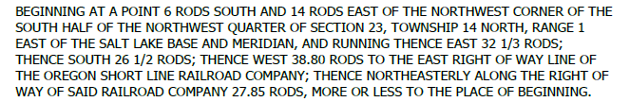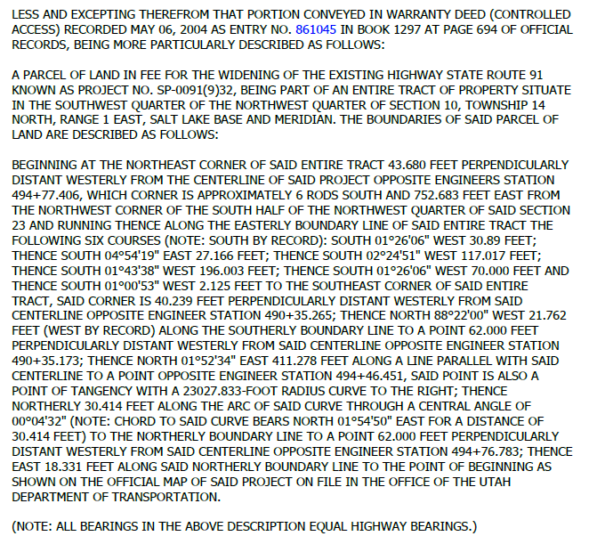
Tax Identification Number: 09-042-0010
