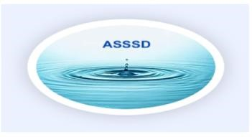
2026 ASSSD BOARD MEETING SCHEDULE
All meetings held at the Angell Springs building. If there is a change of location, there will be a notification.

JANUARY – CANCELED (Washington County Commissioner request)
MARCH 4TH WEDNESDAY 5:30 PM (was to accommodate commissioner schedule.)
MAY 21ST THURSDAY 6PM (Board decided needed monthly meetings)
JUNE 18TH THURSDAY 6PM
JULY 16TH THURSDAY 6PM
AUGUST 20TH THURSDAY 6PM
SEPTEMBER 17TH THURSDAY 6PM
OCTOBER 15TH THURSDAY 6PM
NOVEMBER 19TH THURSDAY 6PM
DECEMBER 17TH THURSDAY 6PM

