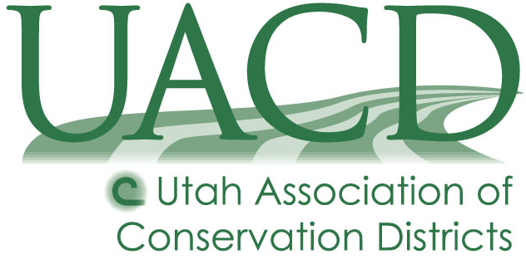

Salt Lake Conservation District
1152 Windfield Court
West Jordan, UT 84088

Meeting Location
Jordan Valley Water Conservation District
Education Building
8275 S 1300 W
West Jordan, UT 84088
Or as announced in the agenda

Board Meeting Schedule for FY27
Thursday, July 9, 2026, 1:00 P.M.
Thursday, August 13, 2026, 1:00 P.M.
Thursday, September 3, 2026, 1:00 P.M.
Thursday, October 8, 2026, 1:00 P.M.
Thursday, November 12, 2026, 1:00 P.M.
Thursday, December 10, 2026, 1:00 P.M.
Thursday, January 14, 2027, 1:00 P.M.
Thursday, February 11, 2027, 1:00 P.M.
Thursday, March 11, 2027, 1:00 P.M.
Thursday, April 8, 2027, 1:00 P.M.
Thursday, May 13, 2027, 1:00 P.M.
Thursday, June 10, 2027, 1:00 P.M.

Approved at the May 14 2026, Board Meeting of the Salt Lake Conservation District

