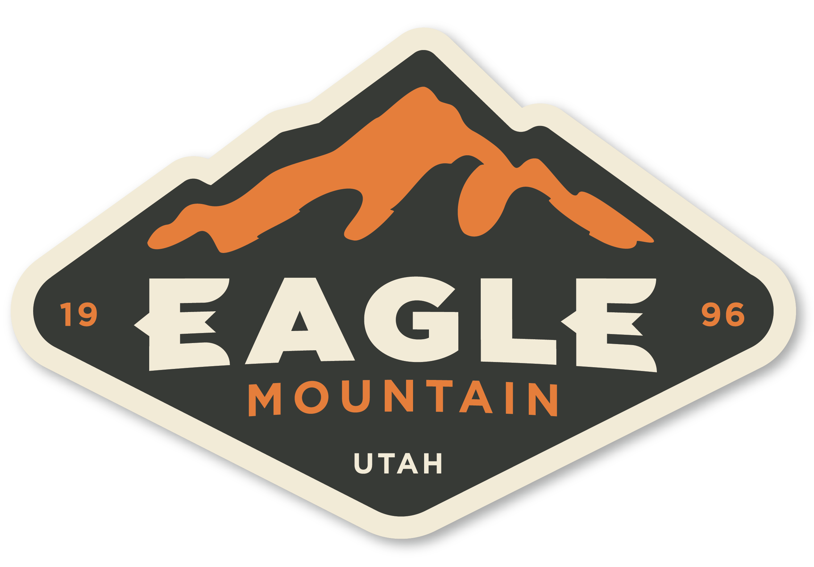 |  |  | EAGLE MOUNTAIN  Planning Commission MEETING  May 26, 2026, 5:30 PM  Eagle Mountain City Council Chambers  1650 East Stagecoach Run, Eagle Mountain, Utah 84005

5:30 PM – PLANNING COMMISSION WORK SESSION

1. | DISCUSSION ITEMS

 | 1.A. | TRAINING - Impact Fees

 | 1.B. | AGENDA REVIEW

6:30 PM PLANNING COMMISSION POLICY SESSION

2. | CALL TO ORDER

3. | PLEDGE OF ALLEGIANCE

4. | DECLARATION OF CONFLICTS OF INTEREST

5. | MINUTES

 | 5.A. | May 12, 2026 Planning Commission Minutes

6. | STATUS REPORT

7. | ACTION AND ADVISORY ITEMS

 | 7.A. | VARIANCE - Pony Express Business Park

8. | DISCUSSION ITEMS

9. | AGENDA REVIEW

10. | NEXT SCHEDULED MEETING

11. | ADJOURNMENT

THE PUBLIC IS INVITED TO PARTICIPATE IN PUBLIC MEETINGS FOR ALL AGENDAS.
In accordance with the Americans with Disabilities Act, Eagle Mountain City will make reasonable accommodations for participation in all Public Meetings and Work Sessions. Please call the City Recorder’s Office at least 3 working days prior to the meeting at 801-789-6611. This meeting may be held telephonically to allow a member of the public body to participate. This agenda is subject to change with a minimum 24-hour notice.

