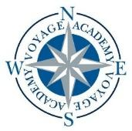
Voyage Academy

2026–2027 Board of Directors Meeting Calendar

The following dates represent the tentative schedule for Voyage Academy Board of Directors meetings for the 2026–2027 school year. Please note that dates are subject to change, and additional meetings may be scheduled as needed. All meetings will be publicly noticed on the Utah Public Meeting Notice website at least 24 hours in advance.
Scheduled Meeting Dates
- August 18 at 6:00 PM – VOA Board Room
- October 22 at 6:00 PM – VOA Board Room
- January 21 at 6:00 PM – VOA Board Room
- March 18 at 6:00 PM – VOA Board Room
- May 20 at 6:00 PM – VOA Board Room

Meeting Location
Meetings are generally held at:
1891 N 1500 W
Clinton, UT 84015
Meetings may also be conducted electronically (with the above address serving as the anchor location) or at an alternate location, as designated by the Board of Directors.

