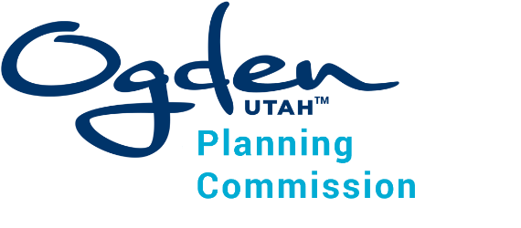
Planning Commission
Work Session Agenda
May 20, 2026 – 5:30p.m.
Room 310, Third Floor
2549 Washington Boulevard, Ogden, Utah 84401

The meeting will also be held electronically:
https://us02web.zoom.us/j/88441486504
1-346-248-7799, Meeting ID: 884 4148 6504 Password 685679

- Zone Ogden Update
- Plan Ogden Update

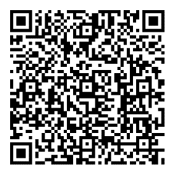
To view the agenda and packet for this meeting, scan the
QR code with
your smartphone.

In compliance with the Americans with Disabilities Act, persons needing auxiliary communicative aids and services for this meeting should contact the Management Services Department at 801-629-8701 (TTY/TDD: 711 or 888-735-5906) or by email: accessibility@ogdencity.com at least 48 hours in advance of the meeting.
CERTIFICATE OF POSTING
The undersigned, duly appointed City Recorder, does hereby certify that the above notice and/or agenda was posted in accordance with Utah State Code on this 15th day of May, 2026. Tracy Hansen, MMC/CRA, Ogden City Recorder

