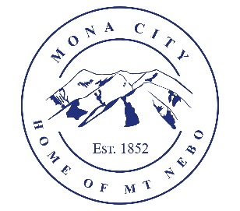
Mona City
435-623-4913
www.monacity.gov
20 West Center Street Mona, Utah

City Council Public Hearing Notice
Tuesday, April 28, 2026
7:00 pm (City Council Room, 20 W. Center St.)

Notice is hereby given that the Mona City Council will hold a public hearing on Tuesday, April 28, 2026, at 7:00 p.m. in the Mona City Council Chambers located at 20 West Center Street, Mona City. The purpose of this hearing is for the following:

- Update to Mona City Fee Schedule: Change Sewer Impact Fee Schedule from $5,500.00 to $6,454.00 on new builds.

CERTIFICATE OF POSTING

This agenda is hereby properly advertised this 20th day of April 2026 by posting copies at the following places: the Mona City Office, at the United States Post Office Mona City Branch, on the Mona City website at monautah.gov, and on the Utah Public Notice Website at www.utah.gov/pmn/index.html.

________________________________________
Alicia Hills, Mona City Recorder

Upon Request, in compliance with the Americans with Disabilities Act, reasonable accommodations for individuals with disabilities will be provided. For assistance, please call 623-4913.

