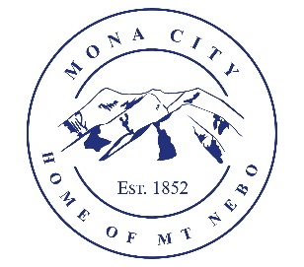
Mona City
435-623-4913
www.monautah.gov
20 West Center Street, Mona, Utah

Mona City Council Meeting Agenda
Tuesday, April 28, 2026
Mona City Building – 20 West Center
7:00 p.m.

Pledge
Prayer
Approval of April 14, 2026, Work Session Minutes
Approval of April 14, 2026, City Council Meeting Minutes
Public Hearing
- Update to Mona City Fee Schedule: Increase sewer impact fee from $5,500.00 to $6,454.00 on new builds
Action Items
- Resolution 2026-9: Fee Schedule Update; sewer impact fee increase on new builds
Miscellaneous Items
- Sunrise Engineering – Natural Gas Impact Fee Analysis
R6 Community Advisor Shay Morrison
Finance
- Approval of Finances
- 2026 Preliminary Budget Proposal
- Set Public Hearing Date for 2026-27 FY Budget Presentation
Recorder
- Stop signs at 100 North 400 East
- Centracom service project on May 5th
Gas & Water & Roads
Sewer
Council Reports
Public Comment
Adjournment

CERTIFICATE OF POSTING
This agenda is hereby properly advertised on this 27th day of April, 2026, by posting copies in the following places: the Mona City Office, on the Mona City website at monautah.gov, at the United States Post Office Mona City Branch, and on the Utah Public Notice Website at www.utah.gov/pmn/index.html.

___________________________________
Alicia Hills, Mona City Recorder
Upon Request, in compliance with the Americans with Disabilities Act, reasonable accommodations for individuals with disabilities will be provided. For assistance, please call 435-623-4913.

