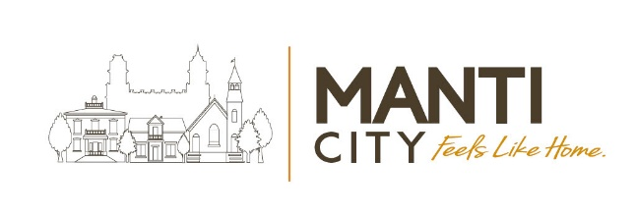
Council Meeting Agenda
Manti City Building • 50 South Main Street
May 13, 2026 – 6:30 p.m.

Call to order & Welcoming: ☐Mayor Mary Wintch
Roll Call of City Council Members (Attendance):
☐Meagan Johnson ☐Mary Pipes ☐AJ Mower ☐Jen Christiansen ☐Brian Francois

6:00 PM - Council Work Meeting

6:30 PM - Council Meeting Agenda Items:

- Declaration of conflicts of personal interest with any agenda item:

- Approval of recent Council Meeting Minutes: April 15, 2026

- Approval of Payment Report (Bills): 4/17/2026-4/30/2026 and 5/1-2026-5/15/2026

- Yoga Group Request: Carol Tibbs and others

- Accessory Dwelling Unit (ADU) Ordinance Review and Approval:

- Short-Term Rental (STR) Ordinance Review and Approval:

- Miss Manti Pageant Report: A huge Thank You to Kaylie Bailey!

- Freedom Fireside Request:

- Cemetery Ordinance Public Hearing:

- “Proposed” FY 2026-27 Budget: First Draft Review

- Fee Schedule Review:

- Continuing Business:

  - Annexation/Subdivision Moratorium (expires July 21, 2026)
  - Cemetery Ordinance Update
  - Master Plan (General Plan) Update
  - Veterans’ Memorial (Discussion scheduled for June 3, 2026 prior to construction.)
  - Quarry Hill Park & Trails Development
  - America250 Utah
  - Economic Development

- Councilmember Reports:
Brian Francois
Jen Christiansen
AJ Mower
Mary Pipes
Meagan Johnson

- Administration Reports (City Manager): Jason Brown

- Public Comment (two minutes per each comment):

- Mayor Comments: Mayor Wintch

- Motion to convene to a Closed Session (if needed): The Manti City Council may close a portion of their meeting to discuss the character, professional competence, conduct, or other factors of an individual per Utah Code 52-4-205(1)(a); or to discuss the purchase, exchange, or lease of real property, or water rights/shares per Utah Code 52-4-205(1)(d) and (e); to hold a strategy session to discuss pending or reasonably imminent litigation per Utah Code 52-4-205(1)(c); discussions regarding security of City devices or systems. ACTION: Any necessary action to be taken as a result of discussions had in the closed session.

- Adjourn:

In Accordance with the Americans with Disabilities Act (ADA) individuals needing special accommodations or interpretive services during this meeting should contact the city office at
435-835-2401 at least (3) working days prior to the meeting.

Certificate of Posting: The undersigned, duly appointed Recorder, does hereby certify that the above notice & agenda was posted and provided to the local media and the posted on the Utah State website.

Matt Gray, City Recorder

