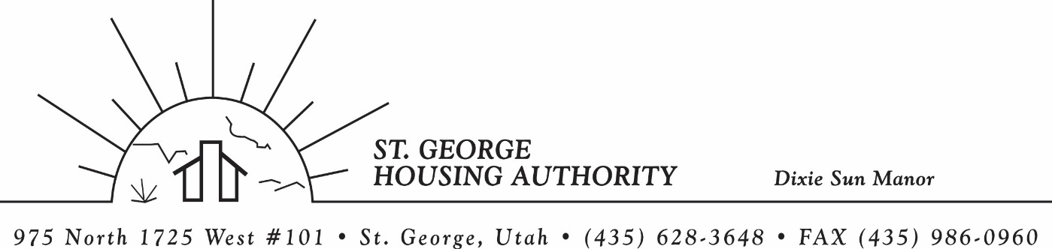
BOARD MEETING
DIXIE SUN MANOR 975 N. 1725 W. # 101
Tuesday April 14, 2026

PRESENT: Mike Barben, Jane Fehrenbacher, Kristopher Pearson, Gloria Shakespeare, Kenny Miller, Greg Whitehead

EXCUSED: Steve Kemp, Daniel Baldwin

MINUTES: Minutes of Board Meeting held March 10, 2026 were reviewed. Motion made by Gloria Shakespeare to approve minutes as reviewed, motion seconded by Greg Whitehead. Motion carried.

Review Housing Assistance Report for April 2026: Mike Barben handed out the HAP reports for April 2026. Board members were able to see the money spent for the months on rental assistance, see the average unit cost, and verify the units leased for the month. The board was also able to ask questions and have a discussion about portability, C of C, VASH, EHV, & Mainstream Vouchers. Each board member present signed off on the HAP payments and month end totals.

Review current 2025-2026 budget: Mike Barben handed the board a copy of the fiscal year 2025-2026 SGHA budget. The board was able to see how the SGHA is doing in the current fiscal year budget. Mike reported that for the most part, SGHA was right on budget, and let the board ask questions on any of the items on the report. The board has asked Mike to provide and present the most recent budget accounts at each board meeting. By providing the current budget monthly, the board can see how the SGHA is keeping up with the current budget throughout the whole year. The board thought it would be great to ask questions and be on top of what the SGHA is doing financially. Greg Whitehead asked Mike if he could break the budget down into separate programs to verify which programs are doing well and which ones are needing help. Mike has now separated the budget into 3 programs so the board can better understand the flow of money in each program.

Approve Health Insurance Premiums 2026-2027 Board Approval: Mike Barben mentioned that it was time for insurance premium renewals for the next fiscal year budget. Mike reported that rates had jumped almost 15% from last year. The board was shocked at the increase and asked Mike to check with the City on their insurance rates with Select Health. Mike agreed to follow up on this and get back to let the board know the difference.

Introduce Kristopher Pearson City Attorney: Mike Barben introduced Kristopher Pearson from the St. George City Attorneys office. Kristopher was filling in for Daniel Baldwin also from the City Attorneys office. Kristopher was happy to be at the board meeting and told us about his job description, where he graduated from law school, and about his family here in St. George. Mike invited Kristopher to the NAHRO Conference and he said he would try to make it. The SGHA board also introduced themselves to Kristopher as well. Great building of relationship of trust.

Utah NAHRO Conference April 21-22: Mike reported that Utah NAHRO conference will be held April 21-22. Mike invited all board members to attend if they would like. Board members are checking their schedules to see if they can attend. It looks like possibly 4-5 board members would like to attend. Mike said the housing authority would pay for the conference. Mike said it is a great conference, and a great way to network and meet other housing authority board members and employees.

Jane Fehrenbacker report on DSM: Jane reported that the community is doing well, reported that DSM is a great place to live. Jane reported that all units are full. Reported on Dixie Sun Manor Easter Pot luck was today at noon. Jane expressed how important it is to have these social activities for DSM tenants. Jane would like to work with Mike Barben to figure out ways to get more tenants involved at these functions. Mike agreed to meet with Jane and discuss.

Kenny Miller/Daniel Baldwin report on Tenant Eviction Reversal: Daniel Baldwin was excused from the meeting so Kenny Miller from the board reported that an eviction was reversed from a tenant at Dixie Sun Manor. Kenny reported that he, Daniel Baldwin and Mike Barben met with the DSM Tenant. Kenny explained all the ins and outs of the eviction and how Kenny with Daniel decided to reverse the eviction. However, the tenant would be on a non-renewal list and possibly non- renewed in January 2027. However, with good behavior and no other infractions, management could recertify for another year. Mike reported that the housing authority would be working closely with Daniel Baldwin add a grievance process that is more specific and easier to follow for future evictions and hearings.

Reports from Board Member & Housing Director: None

Request of a closed meeting to discuss litigation, security, property acquisition or sale, or the character and professional competence or physical or mental health of an individual: None

Motion made by Kenny Miller to close the meeting. Gloria Shakespeare seconded the motion. Motion carried. Meeting adjourned at 10:00 a.m. Next board meeting will be Tuesday May 12, 2026 at 8:30 am.

