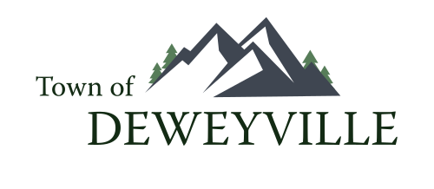
PUBLIC HEARING NOTICE

The Deweyville Town Council will hold a Public Hearing on
Thursday May 28st at 7pm for Truth in Taxation Tax Increase
and our Annual Town Budget instead of May 21st due to notification requirements. The hearing will be held at the
Deweyville Town Hall located at 10870 N Hwy 38, Deweyville,
Utah.

Posted 5/12/26

