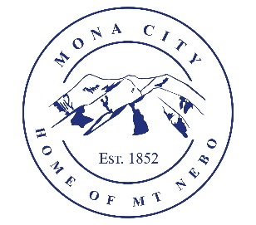
Mona City
435-623-4913
www.monautah.gov
20 West Center Street, Mona, Utah

Mona City Council Meeting Agenda
Tuesday, May 12, 2026
Mona City Building – 20 West Center
7:00 p.m.

Pledge
Prayer
Approval of April 28, 2026, City Council Meeting Minutes
Miscellaneous Items
- Skyler Thomas – Business License Inquiry
- Juab County Sheriff – Announcing Retirement
Finance
- Approval of Finances
Recorder
- Stop sign status
Gas & Water & Roads
Sewer
Council Reports
Public Comment
Adjournment

CERTIFICATE OF POSTING
This agenda is hereby properly advertised on this 11th day of May, 2026, by posting copies in the following places: the Mona City Office, on the Mona City website at monautah.gov, at the United States Post Office Mona City Branch, and on the Utah Public Notice Website at www.utah.gov/pmn/index.html.

___________________________________
Alicia Hills, Mona City Recorder

Upon Request, in compliance with the Americans with Disabilities Act, reasonable accommodations for individuals with disabilities will be provided. For assistance, please call 435-623-4913.

