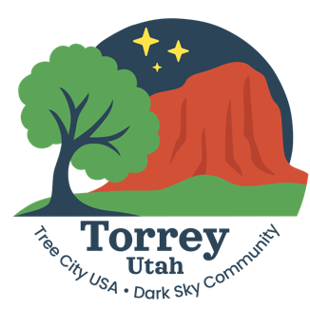

DRAFT AGENDA

Torrey Planning& Zoning Commission Meeting May 21, 2026

1. Call to Order and Roll Call

2. Call for Conflicts

3. Review/approve minutes of the April 30 P&Z meeting

4. P&Z Administration business – Ordinances, CiviclinQ, enforcement

5. Torrey Subdivision Ordinance

6. Building Permit – Ron Moosman storage building

7. Lighting violations – Olga Assyah and Matt Kay

8. Conditional Use Permit – Utah Housing Corporation fourplex

9. Finalize lumen regulations

10. New business

11. Public comments

12. Adjourn

