RESOLUTION NO. 2026-08

A RESOLUTION ADOPTING THE MT. PLEASANT CITY SIDEWALK MANAGEMENT, MAINTENANCE, AND INSPECTION PROGRAM (SMMIP)
WHEREAS Mt. Pleasant City exercises discretion in the inspection, maintenance, and repair of public sidewalks, curb ramps, and pedestrian pathways in accordance with applicable laws, City code, and available resources; and
WHEREAS the City recognizes the importance of maintaining sidewalks in a safe and accessible condition for the public; and
WHEREAS the City desires to implement a proactive and systematic program to identify, prioritize, and address sidewalk maintenance and repair needs; and
WHEREAS the Sidewalk Management, Maintenance, and Inspection Program (SMMIP) establishes procedures for inventory, inspection, maintenance, repair prioritization, and public reporting; and
WHEREAS the program supports compliance with applicable accessibility standards, including ADA requirements, and promotes public safety while recognizing the City’s limited resources; and
WHEREAS the City Council finds that adoption of the SMMIP will assist in reducing liability exposure, improving infrastructure management, and creating a defensible and consistent approach to sidewalk maintenance;
NOW, THEREFORE, BE IT RESOLVED BY THE CITY COUNCIL OF MT. PLEASANT CITY, UTAH:

Section 1. Adoption
The Mt. Pleasant City Sidewalk Management, Maintenance, and Inspection Program (SMMIP), attached hereto as Exhibit A and incorporated herein by reference, is hereby adopted as City policy.

Section 2. Implementation
The Public Works Superintendent, Designated Safety Officer, and other assigned City personnel are authorized and directed to implement and administer the SMMIP.

Section 3. Authority and Discretion
The City retains discretion in scheduling, prioritizing, and funding sidewalk inspections, maintenance, and repairs based on available resources.

Section 4. Amendments
The SMMIP may be reviewed and amended as necessary with City Council approval.

Section 5. Effective Date
This Resolution shall take effect upon adoption.

PASSED AND ADOPTED this ___ day of __________, 2026.
________________________________
Michael T. Olsen, Mayor
ATTEST:
________________________________
City Recorder

VOTE:
Council Member Russell Keisel Yea ___ Nay ___ Absent ___
Council Member Jakob Howcroft Yea ___ Nay ___ Absent ___
Council Member Rondy Black Yea ___ Nay ___ Absent ___
Council Member Lynn Beesley Yea ___ Nay ___ Absent ___
Council Member Cade Beck Yea ___ Nay ___ Absent ___

Exhibit A

Mt. Pleasant City Sidewalk Management, Maintenance & Inspection Program (SMMIP)
Last Edit 5/5/26
Table of Contents:
Introduction | 2
Purpose | 2
Program Objectives | 2
Program Scope | 2
Inspection Program Components | 3
- Asset Inventory | 3
- Inspection Program | 3
- Sidewalk and Gutter Defects Criteria | 4
- Maintenance & Repair | 7
- City Repair Responsibilities &Prioritization | 8
- Repair Tracking System | 8
- Public Reporting & Response | 9
Legal & Risk Management | 9
Review & Modification of Policy | 9
Conclusion | 9
Appendix A: Engineering & Accessibility Standards (link) | 10

INTRODUCTION
The City of Mt. Pleasant, Utah, has approximately 9.3 mile of public sidewalks. Public sidewalks may vary in age and in quality of condition. Not every mere inequality or irregularity on the surface rises to the level of a defect. The City recognizes that some sidewalk conditions can create unreasonable hazards for pedestrians and other sidewalk users.
The City does not have unlimited employee or financial resources and cannot reasonably replace all sidewalks needing replacement or repair within the same year that the sidewalk is identified as needing replacement and/or repair. Sidewalk replacement and/or repair can be costly.
Comprehensive sidewalk Inspections are expensive and require the use of limited city personnel and other resources. Under appropriate circumstances, some or all of the cost of sidewalk replacement may be passed on to the adjacent property owner.
Accordingly, the City must exercise both discretion and professional judgment in determining whether and when sidewalks need to be replaced or repaired. The City expects that its agents, employees, city officials, and other assigned personnel will exercise discretion in identifying conditions requiring replacement and/or repair, in the scheduling of replacement and/or repair, and in establishing priorities for replacement and/or repair.

PURPOSE
The purpose of the Sidewalk Management, Maintenance, and Inspection Program (SMMIP) is to establish a proactive, systematic, and defensible approach to ensuring sidewalks are safe, accessible, and compliant with applicable standards. This program reduces liability exposure, improves public safety, supports ADA compliance, and extends the life of sidewalk infrastructure.

PROGRAM OBJECTIVES
This SMMIP is designed to:
- Identify and correct sidewalk hazards to prevent injury
- Maintain compliance with current ADA, PROWAG, APWA, and local accessibility requirements
- Reduce slip, trip, and fall claims and associated legal exposure
- Prioritize maintenance funding using data-based decision making
- Create defensible inspection records and repair histories
- Improve walkability, mobility, and public confidence

DEFINED RESPONSIBILITIES
This program applies to all sidewalks, curb ramps, pedestrian pathways, crosswalks, and pedestrian-related concrete infrastructure owned, operated, or maintained by the organization, including:
- Public rights-of-way
- Parks and public facilities
- Parking lots and internal pedestrian routes
- Trails and shared-use paths
Property Owner/Tenant Responsibility: Property owners are responsible for maintaining sidewalks adjacent to their properties, including:
  - It is unlawful for the owner, occupant, lessor or agent of any property, abutting on any paved sidewalk, to fail to remove, or cause to be removed from such paved sidewalk, all hail, snow or sleet falling thereon within a reasonable time after such snow, hail or sleet has fallen; provided, that in the case of a storm between the hours of five o'clock (5:00) P.M. and six o'clock (6:00) A.M. in the morning, such sidewalks shall be cleaned before nine o'clock (9:00) A.M. the morning following such storm. (City Code 7.02.150 SNOW REMOVAL FROM SIDEWALKS.)
  - Keeping sidewalks clear of debris, overgrown vegetation, and other obstructions.
  - Reporting damage or safety hazards to the City for evaluation and potential repair assistance.
The Primary responsibility rests with the property owner or tenant, with Mt. Pleasant City assuming a secondary level of responsibility.
City Responsibility: The purpose of this policy is to establish clear guidelines for the maintenance of sidewalks within the City of Mt. Pleasant. Mt. Pleasant City will be responsible for maintenance to ensure pedestrian safety, accessibility, and clearing sidewalks in the following areas:
  - Sidewalks along state routes within city limits.
  - Sidewalks surrounding public parks and city-owned buildings.
Disclaimer: Curb adjacent to state- maintained roads shall not be the responsibility of Mt. Pleasant City.

INSPECTION PROGRAM COMPONENTS
1. Asset Inventory
All sidewalks and pedestrian assets should be mapped and inventoried using GIS or an equivalent asset management system. Each segment should include:
- Location
- Length and width
- Surface type
- Age (if known)
- Adjacent land use
- ADA features (ramps, landings, detectable warnings)
New sidewalks and gutters will follow established engineering and accessibility standards including:
- ADA, APWA, and PROWAG requirements
- Local sidewalk design standards
(Can be found in Appendix A: Engineering and Accessibility Standards)
2. Inspection Program
The Public Works Superintendent, the Designated Safety Officer, and/or other assigned city personnel shall establish procedures for regular sidewalk inspection. Those procedures will include:
- An initial city-wide sidewalk survey to be completed within 6 months that this policy is adopted.
- A schedule for routine sidewalk inspections.
- A complaint system whereby sidewalks are inspected after the City receives a complaint about a sidewalk.
Sidewalks will be inspected on a defined cycle based on risk level:
Area Type | Inspection Frequency
Business district and high pedestrian volume | Annually
Residential neighborhoods | Every 2–3 years
Low-use or rural areas | Every 3–5 years
After major storms or construction | As needed

Inspections will document:
- Vertical displacement (lips, cracks, heaving)
- Surface defects (spalling, potholes, broken panels)
- ADA compliance (cross slope, running slope, ramp condition)
- Obstructions (vegetation, poles, utility conflicts)
- Drainage, puddling, and ponding
- Utility access covers, water meter and manhole covers
3. Sidewalk and Gutter Defects Criteria
Sidewalk and gutter defects refer to any sidewalk or gutter anomaly causing or potentially causing a safety risk or functionality issue. Defects are identified through inspections as well as individuals informing the organization of the issue. Each defect is inspected and the information is recorded.
Each sidewalk segment will be assigned a condition and risk score based on:
    - Sidewalk location and amount of pedestrian traffic
    - The nature and severity of the condition needing replacement or repair
    - Public safety
    - ADA impact/non-compliance
    - Whether or to what extent the cost of repair can be recovered from adjacent property owners.
    - Schedules of independent contractors and work necessary to prepare bid specifications if work is to be performed by independent contractors or the availability of employees, equipment and other resources for sidewalk replacement or repair.
    - History of prior accidents or complaints
    - The City’s budget for replacement or repair of sidewalks
    - Proximity of sidewalk identified as needing replacement or repair to other sidewalks also needing replacement or repair
    - Cost vs. benefit

The following are the criteria the City of Mt. Pleasant uses to determine if a sidewalk is deficient and is in need of repair or replacement:
Type: | Summary: | Description: | Pictures:
CA | Cracked | Cracked in 3 pieces or less.  Cracks are wider than ¼ inch but less than ¾ in wide.  Slab is level. | 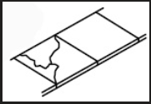
CB | Cracked | Cracked in 3 pieces or less.  Cracks are wider than ¼ inch but less than ¾ in wide.  Slab is not level
CC | Cracked | 4 or more pieces.  Has cracks exceeding 3/4 inch wide in panel.  Has shifted more than 1 inch.  Any gap is greater than 2 inches.  Prohibits the sidewalk from functioning as designed.  Opening in between sidewalk slabs greater than 2” in width, or those caused by the absence of a fragmented section of sidewalk exceeding 2” in width | 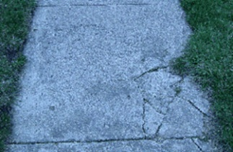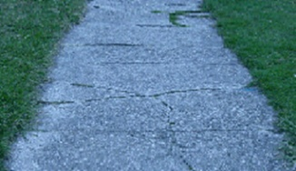  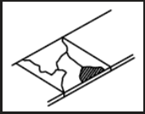
D | Drainage | Low - Small area puddle.  Moderate - Water puddles to the road surface.  High- Water puddles onto the road or approach causing damage or ice buildup or water backup.  Extreme- Water puddles onto the road or sidewalk causing damage, flooding or ice build up. | 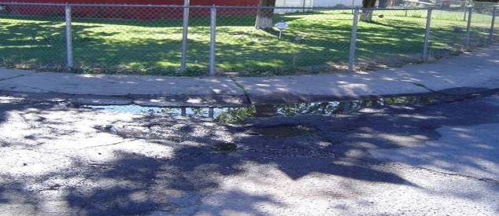
G | Gaps | Opening in between sidewalk slabs greater than 2” in width, or those caused by the absence of a fragmented section of sidewalk exceeding 2” in width. | 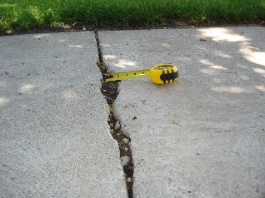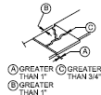
L | Level | Displaced ¾ inch or more vertically at any point at in the panel.  The vertical misalignment along any part of the seam between two slabs. Or between sections of a cracked slab, of 1/2 inch or more, or deemed hazardous by engineering judgment.  Any sidewalk panels that have lifted to a peak or sunken such that the slab or portion of a slab deviates from the average line of the sidewalk surface level at a ratio of more than 1” per foot.  The cross slope (width) of the sidewalk exceeds more than one foot per inch.  Any individual slab or portion of a slab shall not slope either toward the street of the adjoining property at a ration of more than 5/8 inch per foot (1:20) | 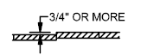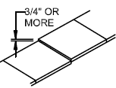  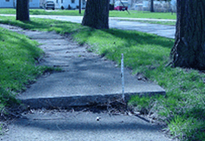  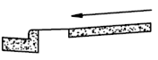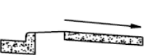  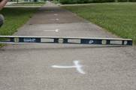
M | Missing | Missing a full slab.  Missing a full depth piece.  Spalling covering 75% or more of surface.  Has a spalled area deeper than one inch. | 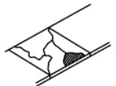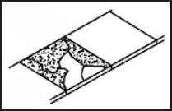
PT | Tree Root Damage | Any deficiencies in a slab or part of a slab that are deemed to be caused by tree roots from a tree in the city right of way. | 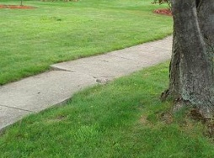
PU | Public Utility Damage | Any deficiencies in a slab or part of a slab that are deemed to be caused by public infrastructure (sewer and water mains, sewer manholes, catch basins, ... etc.). | 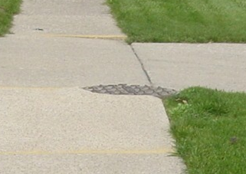
SD | Settling/ Depression/ Concave | Depressed more than 3 inches from the normal line of grade.  The vertical misalignment along any part of the seam between two slabs, or between sections of a cracked slab, of 1/2" or more, or deemed hazardous by engineering judgment | 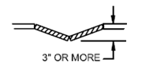  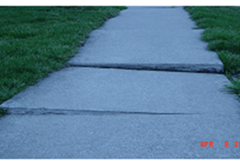
SC | Settling/ Upward Depression /Convex | Is raised more than 3 inches from the normal line of grade.  The vertical misalignment along any part of the seam between two slabs, or between sections of a cracked slab, of 1/2" or more, or deemed hazardous by engineering judgment | 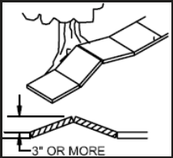
SP | Spalling | Low - Minimal shallow, random flaking.  Moderate- Up to 25% of the slab is spalling. Exposed aggregate, ½” recesses.  High - Up to 50% of the slab is spalling. Exposed aggregate, >1/2” recesses.  Extreme - Over 50% of the slab is spalling and exposed. | 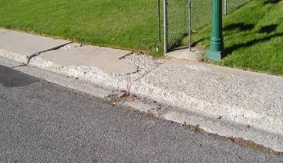
If a section of sidewalk meets any of the High Priority criteria, it will be marked with yellow safety paint denoting the sidewalk deficiency.
Please Note:
- Damage deemed to be caused by public infrastructure will be the responsibility of the City of Mt Pleasant.
- Damage deemed to be caused by private infrastructure will be the responsibility of the property owner.
- Damage deemed to be caused by tree roots from street trees in the right of way will be the responsibility of the City of Mt. Pleasant.
- Street trees in the right of way that are deemed unhealthy or potentially hazardous by the City will be removed and replaced with a new tree suitable for the location.
- Damaged sidewalks caused by trees outside the right of way shall be the property owner’s responsibility to repair or replace.
- The removal and replacement of any trees outside the right of way shall be at the property owner’s discretion and cost.
4. Maintenance & Repair
City employees will be responsible for removing snow from sidewalks that abut city-owned buildings or parking lots. Adjacent property owners, including other public entities are responsible for removing snow and ice from sidewalks that abut their property (see City ordinance No. 7.02.150). The City may, as a public service and for reasons of public safety, remove snow and ice from sidewalks. The Public Works Superintendent, the Designated Safety Officer, and/or other assigned city personnel will identify sidewalks from which the City will remove ice and snow.
Upon completion of the sidewalk inspection, the City shall establish a replacement and repair schedule, which will be approved, denied, or altered by Mt. Pleasant City Council and its members. This schedule is subject to modification based both on sidewalk conditions and the availability of resources for sidewalk replacement and repair. The sidewalk replacement and repair schedule will divide the City into sections or otherwise prioritize replacement of the sidewalks identified as needing replacement or repair so that all sidewalks identified in the initial sidewalk inspection as needing replacement or repair are replaced or repaired as resources become available.
Repairs will follow established engineering and accessibility standards including:
- ADA, APWA and PROWAG requirements
- Local sidewalk design standards
(Specifics can be found in Appendix A: Engineering and Accessibility Standards)
Approved repair methods may include but are not limited to:
- Panel replacement
- Grinding
- Asphalt or concrete patching
- Mud-jacking or slab leveling
- Curb ramp upgrades
5. City Repair Responsibilities & Prioritization
The City will prioritize sidewalk repairs based on the following criteria:
- Pedestrian Usage: High-traffic areas near schools, parks, public buildings, and commercial districts.
- Proximity to Public Infrastructure: Sidewalks along major roadways, city-owned buildings, or civic spaces.
- Defect Status: Severe cracks, heaving, missing sections, or trip hazards.
- ADA Compliance: Locations with accessibility barriers for disabled pedestrians.
- Structural Condition: Sidewalks with significant deterioration that pose long-term structural concerns.
- Cost vs. benefit

The City will allocate funds for repairs as they become available, with priority given to critical infrastructure needs.
Priority ratings will fall into:
- High Priority (Immediate Hazard):
Significant vertical displacement (e.g., ≥ 11230. inch), trip hazards, major cracks, holes, or obstructions that pose an imminent risk of injury or ADA non-compliance.
- Medium Priority (Moderate Hazard):
Noticeable deterioration (e.g., ½–1 inch displacement), surface wear, or minor obstructions that could worsen over time.
- Low Priority (Minor/Cosmetic):
Hairline cracks, minor surface issues, or defects that do not currently pose a safety risk.
Property Owner Repair Options:
  - Property owners needing repairs before City funding is available may choose to pay 100% of the repair costs themselves, ensuring that all work follows City standards and ADA compliance.
  - Alternatively, property owners may apply for the 50/50 Sidewalk Repair Program, where the City will cover 50% of the repair costs when funding is available.
  - All repairs, whether funded privately or jointly with the City, must be performed by a licensed contractor or qualified personnel with City approval and meet all APWA Utah chapter engineering and safety standards.
6. Repair Tracking System
All hazards, inspections, and repairs will be tracked in a centralized system that records:
- Date of inspection
- Inspector name
- Condition ratings
- Photos
- Repair type
- Budgeted
- City Council approved/denied
- Funded
- Contractor or crew
- Date of completion
Sidewalk inspection will not become a become a workorder until repair is funded.
7. Public Reporting & Response
A reporting system found on the Mt. Pleasant City website will allow the public to submit sidewalk concerns.
All complaints will be:
- Logged
- Inspected within 24 working business hours
- Assigned a risk level
- Added to report compilation
- Tracked through to resolution

LEGAL & RISK MANAGEMENT INTEGRATION
The City is not liable for injuries resulting from unmaintained sidewalks under the responsibility of private property owners.
The City maintains governmental immunity under Utah law for sidewalk maintenance decisions made within reasonable resource constraints.
This policy complies with ADA requirements to ensure accessible routes for all pedestrians.
This SMMIP creates documented proof of reasonable care by demonstrating:
- Routine inspections
- Timely response to hazards
- Consistent repair standards
- ADA compliance efforts

REVIEW & MODIFICATION OF POLICY
The Public Works Superintendent, the Designated Safety Officer, and other assigned city personnel will keep on file, comments and complaints received regarding this policy. The policy will be reviewed annually by the Designated Safety Officer. Any review will consider comments and complaints since the last review and any other factors affecting the policy or its implementation. Changes will be taken to City Council for approval as needed.

CONCLUSION
A formal Sidewalk Management, Maintenance, and Inspection Program allows the organization to move from reactive repairs to a proactive, data-driven system that protects the public, controls costs, improves accessibility, and reduces legal risk.

APPENDIX A: ENGINEERING AND ACCESSIBILITY STANDARDS
https://www.ada.gov/law-and-regs/design-standards/2010-stds/
https://www.access-board.gov/prowag/
chrome-extension://efaidnbmnnnibpcajpcglclefindmkaj/https://utah.apwa.org/wp-content/uploads/sites/64/2025/03/Final-2025-Document.pdf

