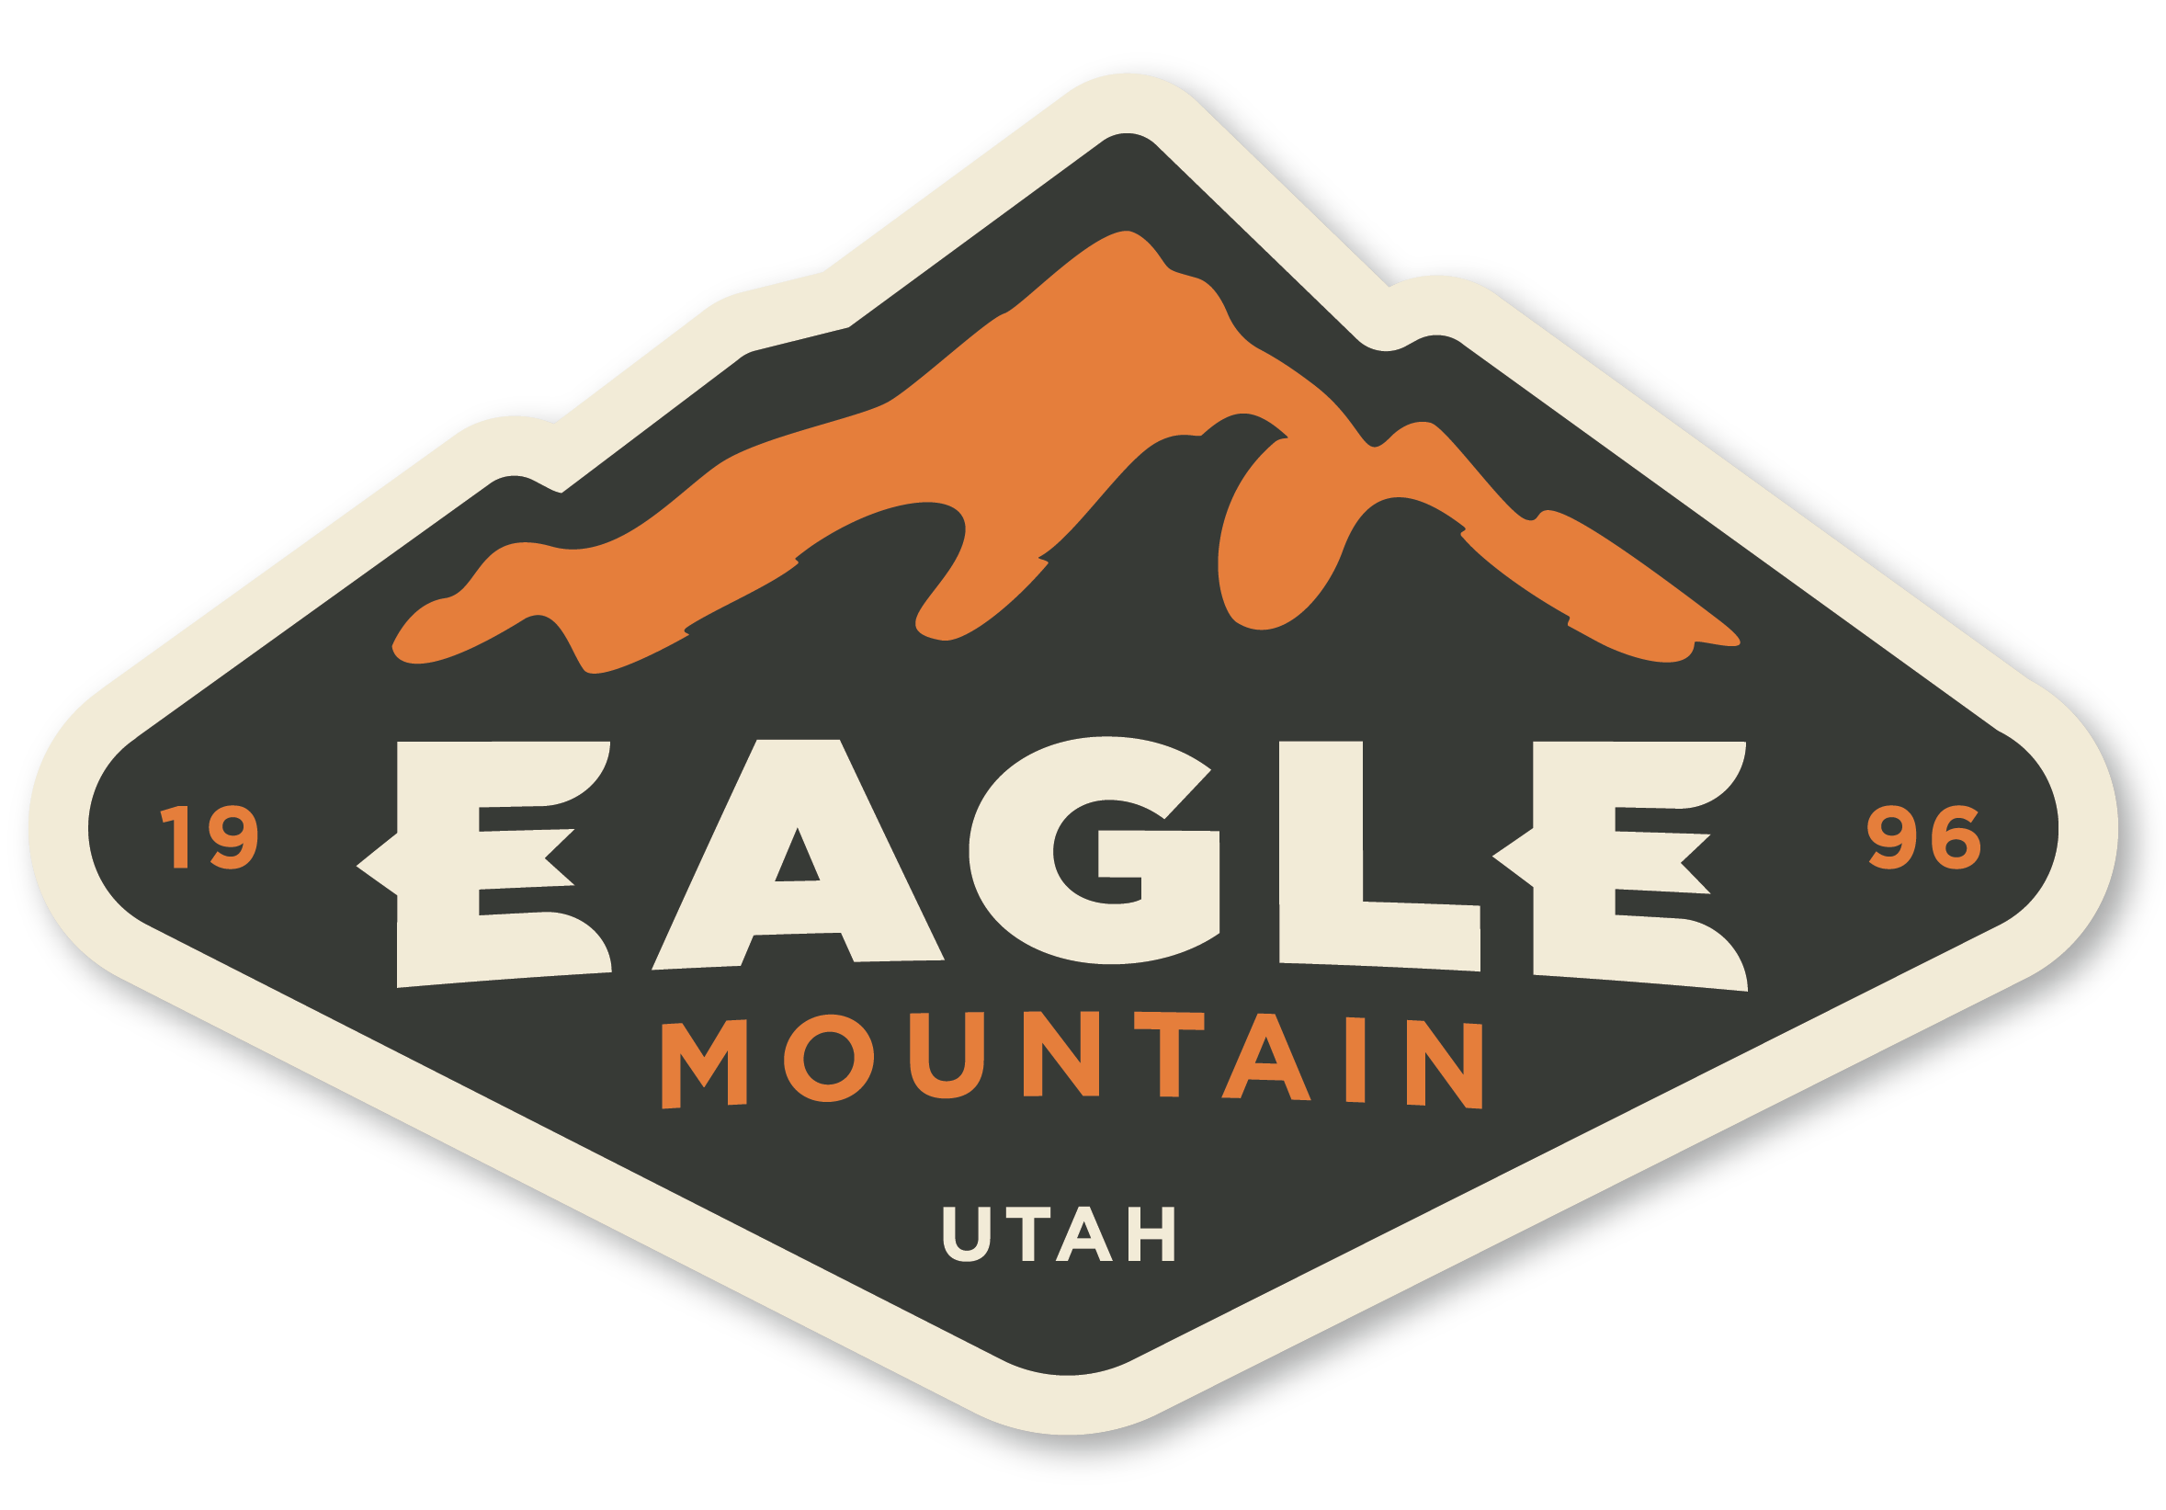 |  |  | EAGLE MOUNTAIN  Planning Commission MEETING  May 12, 2026, 5:30 PM  Eagle Mountain City Council Chambers  1650 East Stagecoach Run, Eagle Mountain, Utah 84005

5:30 PM – PLANNING COMMISSION WORK SESSION

1. | DISCUSSION ITEMS

 | 1.A. | DISCUSSION - Corrigan Farms Rezone

 | 1.B. | DISCUSSION - Deer Run Concept Plan

 | 1.C. | DISCUSSION — Scenic Mountain Area Rezoning of 223 Properties

 | 1.D. | Agenda Review

6:30 PM PLANNING COMMISSION POLICY SESSION

2. | CALL TO ORDER

3. | PLEDGE OF ALLEGIANCE

4. | DECLARATION OF CONFLICTS OF INTEREST

5. | MINUTES

 | 5.A. | April 28, 2026 Planning Commission Minutes

6. | STATUS REPORT

7. | ACTION AND ADVISORY ITEMS

 | 7.A. | PUBLIC HEARING / ACTION ITEM - An Ordinance of Eagle Mountain City, Utah, Amending the Eagle Mountain Municipal Code Chapter 17.64, Alternative Energy Overlay Zone  BACKGROUND: (Presented by Legislative Affairs Director, Evan Berrett) Eagle Mountain City is proposing the creation of an overlay zone known as the Alternative Energy Overlay Zone (AEOZ) which would allow for the development of a variety of types of power generation facilities at approved locations. The AEOZ is not being proposed at this time to be applied to any property and would generally be contemplated for use on request. The AEOZ contains a number of requirements and restrictions regarding power generation facility development including demonstration of approval from state and federal entities as applicable.

 | 7.B. | PUBLIC HEARING / ACTION ITEM - An Ordinance of Eagle Mountain City, Utah, Amending the Eagle Mountain Municipal Code 16.15 Concept Plans.  BACKGROUND: (Presented by Community Development Director, Brandon Larsen) An Ordinance of Eagle Mountain City, Utah, Amending the Eagle Mountain Municipal Code Chapter 16.15 Concept Plans.

 | 7.C. | PUBLIC HEARING / ACTION ITEM - An Ordinance of Eagle Mountain City, Utah, Approving the Overland 5th Amendment to the ARMDA Agreement.  BACKGROUND: (Presented by City Attorney, Marcus Draper) On March 25th, 2026, the City Council approved the 5th Amendment to the Overland ARMDA with Terra Smith’s Eagle Mountain, LLC. Prior to execution of the Amendment the developer determined that it would like to add another party to the agreement, Smith’s Food & Drug Center, Inc. and to request one additional exception to a City development standard in relation to slope requirements for retention basins. The amendment is being sought to make those changes and to correct a clerical error in the agreement that gives the incorrect name of Terra Smith’s Eagle Mountain, LLC.

8. | DISCUSSION ITEMS

9. | AGENDA REVIEW

10. | NEXT SCHEDULED MEETING

11. | ADJOURNMENT

THE PUBLIC IS INVITED TO PARTICIPATE IN PUBLIC MEETINGS FOR ALL AGENDAS.
In accordance with the Americans with Disabilities Act, Eagle Mountain City will make reasonable accommodations for participation in all Public Meetings and Work Sessions. Please call the City Recorder’s Office at least 3 working days prior to the meeting at 801-789-6611. This meeting may be held telephonically to allow a member of the public body to participate. This agenda is subject to change with a minimum 24-hour notice.

