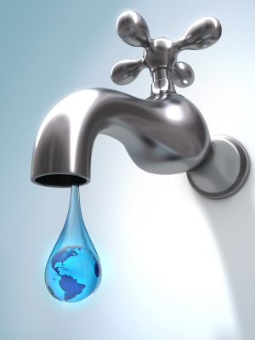
COPPERTON
IMPROVEMENT
DISTRICT
8654 West State Highway Copperton, Utah 84006 (801)255-3411

As you know the State of Utah is in a drought. We want to remind residents of their watering days and other ways to save water. CID suggests watering two times a week.
Monday, Thursday, for Odd Number Houses
Tuesday, Friday for Even Numbered Houses.
Watering days have been set, we ask that there is NO WATERING ON SUNDAYS.
There are a few incentives for residents through Jordan Conservancy District. If you go to their website, you can register and find those incentives. They will ask you for a copy of you latest bill that can be provided by CID. Also, on their website you will find ways to save water with water wise plants and landscaping. Also did you know that replacing your park strip with rock or low maintenance plants can save 5000-8000 gallons of water a year! Have you thought of taking a shorter shower? Keep children away from the garden hose, children have the habit of turning it on then leave it running. A small leak adds up check your home often. Are all your sprinklers working properly, are you watering the road? Small changes can make a difference.
Another great website is utahwatersavers.com they provide tips and water saving cost.
Did you know that having a timer on your sprinkling system can save water? Lowes and Home Depot have timers to buy with rebates.
We ask that we all do our part to save water and be wise in its usage. If you have questions or concerns, please call the office at 801-255-3411.
Please remember NO SUNDAY WATERING, please water before 10:00 am and after 6:00 pm.

