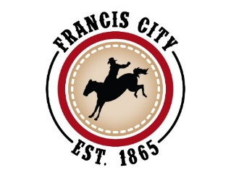
Francis City Council Meeting
Tuesday, November 18, 2025, 6:00 pm
2317 South Spring Hollow Road, Francis, UT

The meeting will be streamed live on the Francis City YouTube channel:
https://www.youtube.com/channel/UC-9wahpEELShvGQZShXGIXg
You can also comment by email to: comments@francisutah.gov
Council Members Attending: Mayor Forman, Councilwoman Shana Fryer,
Councilman Sam Hunter, Councilman Clint Summers, Councilman Clayton Querry
Staff Attending: Deputy Recorder Rae Olson
- Call to Order and Pledge of Allegiance
Mayor Forman called the meeting to order. Pledge of lead by Clint Summers

- Canvass of the 2025 Francis City Municipal General Elections
Resolution No. 2025-08
Verified Results were read and reviewed from the county report.

Council discussed the increased voter turnout and the slim margin between some of the candidates. They discussed the Park City Mayoral race and the need for a recount going on in that area. They concluded that the results in our area that had been verified by the county and appear to be accurate.

Councilman Hunter made a motion to approve the resolution seconded by Clint Summers all voted in favor. Documents to be signed.

Councilwoman Fryer made a motion to adjourn. Seconded by Councilman Summers. All voted in favor, meeting adjourned

_____________________________________ __________________________________
Mayor Jeremie Forman Deputy Recorder RaeLyn Olson

