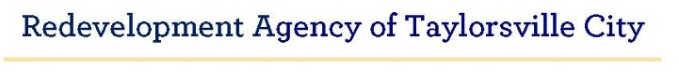
RESOLUTION NO. RDA 26-02 DATE: May 6, 2026
A RESOLUTION OF THE REDEVELOPMENT AGENCY OF TAYLORSVILLE CITY BOARD TENTATIVELY ADOPTING A TENTATIVE BALANCED BUDGET FOR THE FISCAL YEAR BEGINNING JULY 1, 2026, AND ENDING JUNE 30, 2027.

WHEREAS, the Redevelopment Agency of Taylorsville City Board (the "Board") met in a properly noticed meeting on May 6, 2026, to consider, among other things, tentatively adopting a tentative balanced Redevelopment Agency Budget for the fiscal year beginning July 1, 2026 and ending June 30, 2027 ("Tentative Budget"), and
WHEREAS, the Board has determined that tentatively adopting the Tentative Budget with any amendments the Board has directed is in the best interest of the City, its residents and businesses; and
WHEREAS, a public hearing to consider the adoption of the Tentative Budget shall be held at the date, time, and location established in the City of Taylorsville Notice of Public Meetings, a copy of which is attached hereto as Exhibit "B"; and
WHEREAS, the Board desires to tentatively adopt the Tentative Budget as it has been presented to the Board.
NOW, THEREFORE, BE IT RESOLVED that the Redevelopment Agency of Taylorsville City Board hereby tentatively adopts the Tentative Budget as presented to the Board.
PASSED AND APPROVED by the Redevelopment Agency of Taylorsville City Board this _6th_ day of May, 2026.

REDEVELOPMENT AGENCY OF TAYLORSVILLE CITY

_____________________________________
Anna Barbieri, Board Chair
ATTEST:

_________________________
Brittany Kempff, Secretary

EXHIBIT “B”

