OFFICE OF THE BEAVER COUNTY CLERK
2026 PRIMARY ELECTION CERTIFICATION
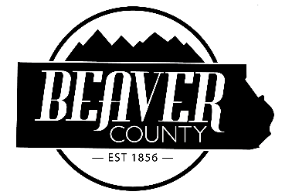
COUNTY COMMISSION A
Candidate Office Party
TAMMY PEARSON Commissioner A Republican
JONATHAN L. CALDWELL Commissioner A Republican

SHERIFF
Candidate Office Party
CODY V BLACK Sheriff Republican
DUNN ALISA JR Sheriff Republican

IN WITNESS WEREOF, I have hereunto
Set my hand and affixed the Seal of Beaver County, this 29th day of April, 2026.
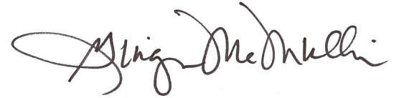
Ginger McMullin
County Clerk/Auditor

