PUBLIC NOTICE:

The Grantsville City Council will hold a Special Work Session on Friday, May 1, 2026 in person at 429 East Main Street, Grantsville UT 84029 and electronically via Zoom beginning at 3:25 pm.

Please note: There will be no public comments or action taken by the Council during this meeting.

The agenda is as follows:
ROLL CALL
AGENDA:
- Training of roles and responsibilities of Legal Department
- Training of roles and responsibilities of City Recorder and Open Public Meetings Act training
- Training of roles and responsibilities of HR/Treasurer Department
- Training of roles and responsibilities of Grant Writer
- Training of roles and responsibilities of Finance Director roles
- Adjourn
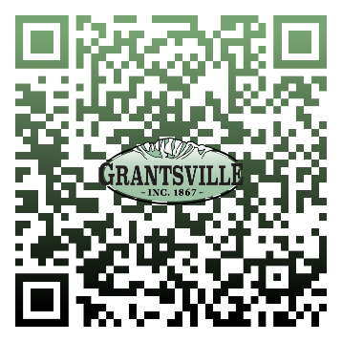
Scan to be directed to the Zoom Meeting
Alicia Fairbourne
City Recorder

Join Zoom Meeting
https://us02web.zoom.us/j/4358843411

By Phone, Dial: 1-253-215-8782

Meeting ID: 435 884 3411

In compliance with the Americans with Disability Act, Grantsville City will accommodate reasonable requests to assist persons with disabilities to participate in meetings. Requests for assistance may be made by calling City Hall at (435) 884-3411 at least three days in advance of a meeting.

CERTIFICATE OF POSTING: This agenda was posted on the Grantsville City Hall Notice Boards, the State Public Notice website at www.utah.gov/pmn/index.html, and the Grantsville City website at www.grantsvilleut.gov.

