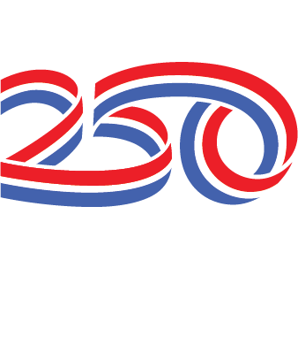

Everyone is invited to a
Community July 4th Planning
For the 250 Year Anniversary
Thursday, April 30, 2026
At Town Hall @ 6:00 pm

Agenda:
June:
Rodeo Queen Contest
Baby Contest

July 3:
1st Night of Rodeo
Dance (Ty Pebley Band has been booked for that)

July 4:
Fun Run
Fireman’s Breakfast
Parade
*Parade, general info
*Float
*Popsicles
Kid Fun Days
*Bounce houses, games, prizes etc.
Rodeos
* Kids Timed Events
* 2nd Night of Rodeo
*Ambulance coverage
* Cook Shack
Sales Tax?
Parking
Other ideas/concerns

