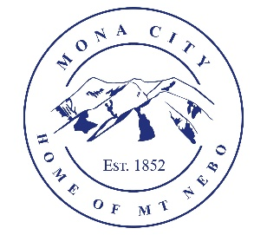
Mona City
435-623-4913
www.monautah.gov
20 West Center Street, Mona, Utah

Mona City Council Meeting Agenda
Tuesday, April 14, 2026
Mona City Building – 20 West Center
7:00 p.m.

Pledge
Prayer
Approval of March 24, 2026, City Council Meeting & Closed Executive
Session Minutes
Action Items
- Ordinance 2026-8: Adoption of the 2024 Edition of the International Wildland-Urban Interface Code
- Troy Linton – Billboard Variance Request
- Kent Davis – East Hill Meadows Subdivision Variance Request
Miscellaneous Items
- Approval of up to $45,000 from Water Fund and General Fund for 200 North Main Street Water Crossing
- Approval of up to $14,000 for firework purchase and bid exception
- Mona Representative for Fire District
- Pickleball court ribbon cutting
- DNR OHV Youth Education Course
Secretary
- Old Baseball Backstop
Finance
- Approval of Finances
- Budget Quarterly Report
Recorder
- Spring Cleanup
- Approval of Civiclinq for Mona City Code
Gas & Water & Roads
Sewer
Council Reports
Public Comment
Adjournment

CERTIFICATE OF POSTING
This agenda is hereby properly advertised on this 13th day of April, 2026, by posting copies in the following places: the Mona City Office, on the Mona City website at monautah.gov, at the United States Post Office Mona City Branch, and on the Utah Public Notice Website at www.utah.gov/pmn/index.html.

___________________________________
Alicia Hills, Mona City Recorder
Upon Request, in compliance with the Americans with Disabilities Act, reasonable accommodations for individuals with disabilities will be provided. For assistance, please call 435-623-4913.

