OPEB Board Meeting
Wednesday, September 18 – 1:30 PM – 2:30 PM
In Person – 2001 S State St, N4-600
WebEx – Electronic Meeting
Meeting video/audio (log in first)

- Roll Call – Darrin Casper
Trustees Present:
Darrin Casper, Deputy Mayor of Finance and Chief Financial Officer
K. Wayne Cushing, County Treasurer
Lori Okino, Fiscal Administrator, Community Services
David Delquadro, Council Fiscal Manager
Other Attendees:
Shanell Beecher, Director of Accounting, Mayor’s Financial Administration
Becky Timothy, Benefits Budget Administrator, Mayor’s Financial Administration
Greg Folta, Director of Finance and Payroll, Mayor’s Financial Administration
Zachary Landcaster, Civil Senior Attorney, District Attorney
NEW Attendees for this Meeting:
Krystalyn Jensen, Internal Services Manager, Mayor’s Financial Administration
Adam Freitas, Utility Accountant, Mayor’s Financial Administration
Jason Williams, President, Moreton Asset Management
Absent:
No members of the public attended.

- Approve Prior Meeting Minutes – Darrin Casper
Meeting minutes from August 10, 2023, were approved.

- Review Annual OPEB Report – Becky Timothy, Shanell Beecher
Motion to accept the final version of the Annual OPEB Report has been approved.
- Update on OPEB Finances – Jason Williams
SLCO OPEB – Q3 2024 Investment Report was shared on screen for viewing. Mr. Williams will take 5-7 minutes for updates on the interest rate, bond markets and equity markets to get the board up to speed from what was talked about last time. It will also help set the table for the recommendations that will be made going forward, particularly if there are additional funds that the board is considering adding to the portfolio. He will cover performance, current allocation and report back to the board on how last year’s $2.7M addition to the portfolio was invested and the progress.
The Cumulative Tightening of Monetary Policy chart shows the speed and magnitude of interest rate increases going back to the 1980’s. This was the fastest and steepest interest rate increase over a considerable amount of time. Since this slide was created, the interest rate has dropped a little. Moreton has been cautious over the last two years because of the economy and interest rates being up so much. He will show how the portfolio benefited on the fixed income side of what they are doing.
The next slide shows a graph that measures the spread between the 3-month T bill and the 10-year Treasury. It’s measuring if the yield curve is steep and how steep it is. The green is considered normal periods of time when short term interest rates are lower than long term interest rates. That tends to be an optimistic view of what’s happening in the economy. The red sections are where the yield curve has inverted, and the orange line was overlayed to show Fed funds policy. Inversions in the treasury market have been good predictors of a recession. If you look back to the 70’s there was a recession every time the yield curve has inverted. We just had a significant inversion particularly over the last 20 years and there is still no recession. The risk-free rate as defined as the 3-month T bill has been over 5% for the last 18 months or so; that represents a 20-year high. This is being shared with the board to indicate some of the decisions that have been made over the last year and a half. We still have an inverted yield curve and still no recession, and now with the Fed cutting today there is potential for the yield curve to un-invert.
The next slide is to give a sense of how steep the inversion is and as you think about the interest rates and the decisions that can be made, it can give a sense of what’s available today in the market. It’s a little lower now because of the surprise cut but until an hour ago you could get over 5% for 3-month T bills, it’s now a little less than 5%. At the 3Y and 5Y rates, those are now pricing in at 3-3.5 percent. There are many investors and market participants that are willing to take a 3.5% longer return based on the outlook of the economy.
The next slide represents the 5-year treasury yield since the $2.7M deposit came in through today. Moreton was able to execute over $8M of what has matured and what the board had added on the longer-term fixed income securities, mostly in the risk-free categories (US Treasuries and CD’s) at rates that were at 4.5% and above. Mr. Cushing asked about the callable issue and if there are any that we might lose. Mr. Williams replied that those were all fixed non-callable and non-variable rates. Mr. Cushing verifies that we took a little less rate to fix them in for multiple years. Mr. Williams confirmed and stated we had a very good year this year mostly due to taking advantage of the higher rates.
The next slide shows that the market was pricing in a quarter percent cut today and it actually cut by half percent. The Implied rate column is the futures market of over under buying selling on short term interest rates. In terms of the market and forecast, we are moving into a falling rate environment now that the Fed feels inflation is more under control. The risk now is more on the job side of the economy.
The next slide is what will drive the recommendations to the board. This slide represents the various debt categories for US consumers (auto loans, student loans, credit cards, mortgages). There was a severe recession in 2008 in terms of delinquencies across the United States. They are starting to see delinquencies coming up again now, a lot of that is driven by the higher rates for the last two years.
The next slide shows what Moreton has been very cognizant of and has adjusted the portfolio already based on this information. The report shows the index weights for the Magnificent 7 Stocks from December 2022 – December 2023. Other companies have been flat to slightly positive in price appreciation. Most of the gains in the OPEB portfolio are heavily concentrated in these seven stocks. These seven added together are almost 30% of the index by themselves. They are putting the new money and adjusting some of the gains in the portfolio into an equally weighted S&P 500 to try to get the concentration risk down.
The next slide represents the results of the portfolio which had a very good year from a returns standpoint. When the interest rates increased so much 18-24 months ago, we reduced some of the exposure in the stock market but because of the gains in the stock market there is a target of a 50/50 split over time. We are about 47% in stock exposure vs 53% in fixed income and bonds. The net un-utilized gain is stocks and bonds. The Cash and Fixed Income Summary the book yield has drifted up significantly and will be beating the estimates that we gave the actuaries based on that movement.
The next slide is a report back to the County showing what was accomplished over the last year to year and a half. It is a trade blotter with the securities that were executed in the portfolio. A total of 8.4M (a little overstated due to rolling T bills) has a reinvestment rate of 5.1% and they were able to get term on several of those. There are 29 maturities. There are a couple of corporate ones, but the majority are US government and US agency backed securities.
The next slide is the GAAP financials page. This is the results year to date showing a net income of just over $1.3M which is a combination of stock market performance and $375,000 in dividends and interest. Mr. Williams states that although this was a very good year, this is not how it will be every year. The book value to start the year was coming in at $16.1M and the total market value is $18.2M. They are taking realized gains and offsetting against any other losses.
The final slide shows the performance standpoint of investment performance vs. benchmark. The trailing 5-year total return, which includes a worldwide pandemic, is coming in at 6.77%, which is about a percent and a quarter above what was anticipated. Noting that the fixed income return has also drifted up to the high 4’s but the total return stock on the entire portfolio as a whole is coming in at 6.7 over a 5-year basis.
Mr. Delquadro states there is an actuary report coming up and it seems you could argue that 6.7 ought to be what the estimated rate of return could be. Mr. Cushing states the biggest risk would be that the market is so high it can’t be sustained for 30 years. Mr. Williams states he would like to give it a couple more years of performance before we give it a longer term because we used a 10-year time frame for the estimates when they worked with the actuarial group, and he has updated that about every two years. He keeps pulling in a prior tenure so this should drift up based on what’s happening.
Mr. Williams said for recommendation of additional funds for the remainder of this year and going into 2025, with the slowdown of the economy and some of the other things that might happen geopolitically, it’s going to be volatile. With the potential for recession, they think the stocks could go on sale, however, they are not on sale now. He recommends letting the stock market drift up over the next 12 months but doing it on a dollar cost average basis on the idea that it’s going to be volatile between now and a year from now as the fed’s trend to cut the rates and some of the geopolitical things on the horizon. He suggests if it is volatile, buying some stocks when they’re on sale but based on how the portfolio is now, he doesn’t suggest making any adjustments now, it would be based on if there’s new money contributed.
Mr. Williams said some of the adjustments they made over the last 18 months were the equal weight S&P 500 to help protect against the big concentration in the max seven, they’ve also added some defensive plays in three categories. They matched some of the gains in the general stock market with a loss from the preferred stock to reduce exposure.

- Fund 995 – Becky Timothy
Mr. Casper asks Ms. Timothy what the balance is in the operating fund, followed by Mr. Cushing who asked if we know how we are doing this year as far as income vs. projected expense.
Ms. Timothy states we are just under $3.5M and the revenue is exceeding expenses. Mr. Casper states the reason for that question is that we could probably provide some cash to be able to take advantage of some of the fire sale prices if they pop up. Becky states the last time we contributed was $2.7M in August of last year (2023), nothing this year. Mr. Casper says we are fairly stable in terms of our revenue expenditures and the minimum reserve is $250,000 so we would be able to review approval of the board to transfer $3M or more. Mr. Williams says they could blend it in over 12 months. Mr. Cushing asks if there are any risks with healthcare costs for next year or anything else we always look at. Mr. Delquadro asks if we know what the state is planning to do with Medicare rates for which Mr. Cushing states there are significant gains the money could be pulled out of if necessary. Mr. Casper says this fund is approximately tracking along the lines that the OPEB problem has been solved, at least from a structural standpoint. Hypothetically, collecting revenues around $7M with out-of-pocket expenses around $4.5M. Mr. Casper states that he thinks transferring $3M still leaves a tremendous buffer in case something happens. He does not want to go backwards on that.
Mr. Delquadro mentions the liability associated with OPEB and the Sheriff’s Enforcement Bureau and asked if we hired someone back from UPD prior to the transfer. If we did, they should not have received OPEB coverage. Mr. Casper states nobody has brought up that policy issue and from his perspective it’s not an issue and they just didn’t get that coverage. Mr. Delquadro states another issue that it’s going to be a tough budget year with no new revenue sources identified, he asks what the pros and cons are of pausing OPEB contributions for 2025 and using it for other county purposes. They discussed the recommended increases from our health consultants and the only people that would get the hit are those that are excessive users of the health system. Mr. Casper states he is hesitant because it took ten years to attain the structural balance of meeting our actuary funds. There is a discussion on possibilities regarding funds and it’s mentioned that Mr. Casper and Mr. Delquadro will discuss things further. Mr. Cushing states it would be prudent to put something into the investment account because it’s available to do so. Mr. Cushing says he’s comfortable moving $3M over to Morton and makes a motion. That leaves $500,000. Ms. Timothy states $3.5M is estimated at year end. Ms. Okino asks for clarification because the discussion was about possible delaying decisions until policy makers can weigh in. She asks if contributing now would it tie their hands. It’s clarified that by contributing now they would be working with $4M instead of $7M. Ms. Okino states she doesn’t want to tie the boards hands if there are funding issues but acknowledges the strides that have been made and doesn’t want to go backwards. She would like to take advantage of possible future investments. Mr. Cushing says it’s just as easy to bring the money back as it is to put it in. Ms. Beecher states the whole reason for this account being a trust account is because it’s only used for expenditures. Mr. Cushing says we would just be moving it from the investment side to the operating side, which is then clarified that it would all still go to allowable expenditures.
Mr. Casper suggests contributing $2.5M, which Mr. Delquadro agrees based on the anticipation of quadrupling the $250 and having the expectation of $1M at the end of the year. Mr. Casper says there are pretty critical issues that need to be funded, not including pay and health insurance. Ms. Timothy shares the balance sheet.
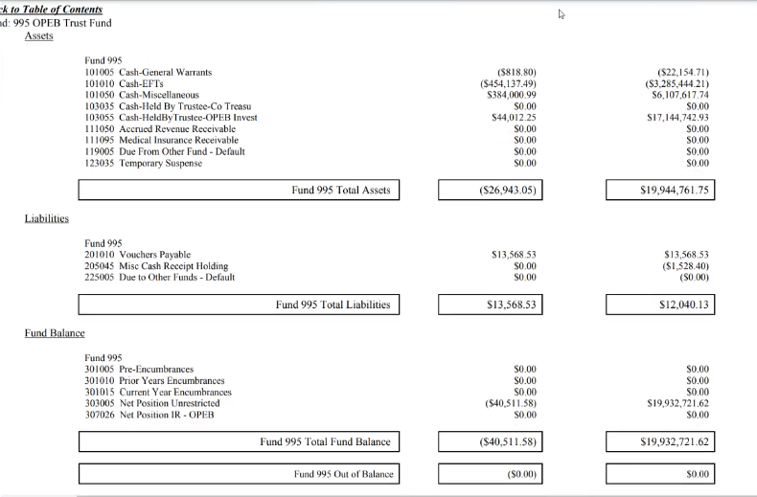
Mr. Casper says he doesn’t want to throw the fund out of balance due to a single year, he states it still may be necessary, but it’s not preferred. Mr. Casper initiates a motion to transfer an amount. Ms. Okino makes a motion to transfer $2.5M to Morton for future investments. The motion passes unanimously.

