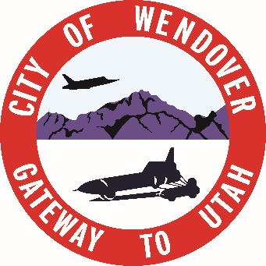
PHONE # 435-665-7771
FAX #435-665-2523

920 E Wendover Blvd
P.O Box 430
Wendover, Ut 84083

BUDGET PUBLIC HEARING #2

DATE: MAY 6th, 2026
TIME: 5:30 PM
PLACE: WENDOVER CITY TOOELE COUNTY COMPLEX BLDG
920 EAST WENDOVER BLVD.

- Budget Work Meeting 2027-2028 Budget

INCOMPLIANCE WITH THE AMERICAN WITH DISABILITIES ACT, INDIVIDUALS NEEDING SPECIAL ACCOMMODATIONS (INCLUDING AUXILIARY COMMUNICATIVE AIDS AND SERVICES) DURING THESE MEETINGS SHOULD NOTIFY SASHA PALAFOX AT THE WENDOVER TOOELE COUNTY COMPLEX AT 920 EAST WENDOVER BLVD. (435 665 7771). AT LEAST THREE DAYS PRIOR TO THE MEETING TO BE ATTENDED.

POSTED: April 28th, 2026
WENDOVER UTAH CITY OFFICES, WENDOVER UTAH
- WENDOVER POST OFFICE, WENDOVER UTAH
- THE WENDOVER TIMES, WENDOVER UTAH
- UTAH PUBLIC MEETING WEBSITE

THE CITY OF WENDOVER, UTAH IS AN EQUAL OPPORTUNITY PROVIDER AND EMPLOYER

