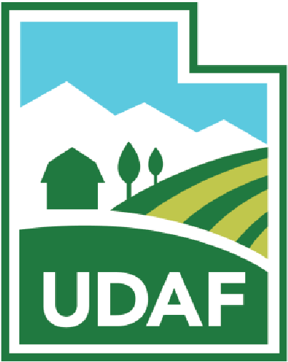
UTAH DEPARTMENT OF AGRICULTURE AND FOOD
State of Utah
Fish Health Policy Board
April 28, 2026
10:30 – 11:30 AM
UDAF offices
Taylorsville, UT
Conference Room #2506

Teleconference link: More phone numbers: https://tel.meet/hox-fote-uyc?pin=9955588022044
Join by phone: (US) +1 856-281-1351‬ PIN: 993 789 974‬#‬‬‬‬‬

This meeting will be conducted in person and via electronic means. Here is the available link to the public for live broadcast and on-demand viewing: https://meet.google.com/hox-fote-uyc

If you do not have access to the Internet, you can join via telephone calling: (US) +1 856-281-1351 and using meeting PIN: 993 789 974‬#‬‬‬‬

AGENDA
- CALL MEETING TO ORDER – WADE CAVENDER, CHAIR.
- PUBLIC COMMENT
- APPROVAL OF THE MINUTES OF THE FHPB: [action Item]
  - January 13, 2026 FHPB meeting (Handout)
- UDWR VARIANCES [action item]
  - Multiple presentations, Randy Oplinger (UDWR Aquatics)
- LLPA VARIANCE [action item]
  - Presentation, Xavier Matheson (UDAF Aquaculture Manager)

- UDAF RULES UPDATE: [discussion item]
  - Presentation, Xavier Matheson (UDAF Aquaculture Manager)

- ANNOUNCEMENTS [discussion item]

- ADJOURN

