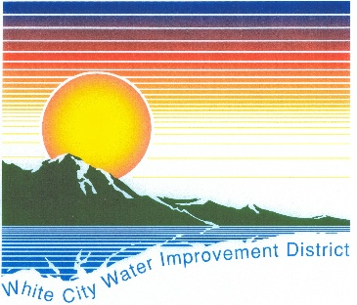
PUBLIC NOTICE
White City Water Improvement District
2026 Election – Notice of Candidacy

Notice is hereby given that the White City Water Improvement District will hold its 2026 General Election on November 3, 2026, to fill the following positions:
(All Seats are four-year terms)
- Treasurer (1 seat)
- Board Member (1 seat)

Declaration of Candidacy Filing Period
The Declaration of Candidacy filing period will open on June 1, 2026, and close on June 7, 2026 (excluding Saturday and Sunday) 8:00 a.m. – 5:00 p.m. Monday - Friday. Because June 7 falls on a weekend, the filing deadline will be extended to Monday, June 8, 2026, at 5:00 p.m.

Candidate Qualifications
To qualify as a candidate for office, an individual must:
- Be a registered voter within the boundaries of the White City Water Improvement District;
- Be a resident of the district for at least 12 consecutive months immediately preceding the date of the election;
- Be a United States citizen;
- Not be a convicted felon, unless the right to hold elective office has been restored;
- File a completed Declaration of Candidacy form during the filing period.
Election Related Links:
Utah State Site: http://vote.utah.gov
S.L. County Clerk: https://slco.org/clerk/elections/
For additional information, candidacy forms, or questions regarding eligibility, please contact the White City Water Improvement District at 801-571-3991.
Published this 23rd day of April, 2026.

