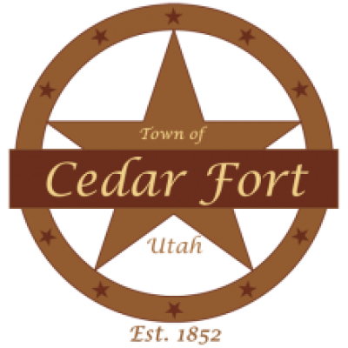
Planning Commission Meeting Agenda

Kent Withers
Bart D. Berry
Cayden Draper
Derek Beck
Lynnette Groff

Town of Cedar Fort
Tuesday, April 14, 2026 @ 7:00 pm
Town Hall, 50 East Center Street, Cedar Fort, UT 84013
CALL TO ORDER
1. Roll Call.
2. Prayer/Thought.
3. Pledge of Allegiance.
REPORTS

PUBLIC COMMENT
Time for Public Input is limited to no more than 2-3 minutes per person. This time has been set aside for the public to express ideas, concerns, and comments for subject matter not listed as public hearing on the agenda.

CONSENT ITEMS
The Commission may approve these items without discussion or public comment and may remove an item to the Business Items for discussion and consideration.
1. Approval of Minutes: Public Hearing March 5, 2026.
2. Approval of Minutes: Regular Meeting March 5, 2026.

BUSINESS ITEMS
The Commission will discuss (without public comment) and may approve the following items:
1. Rezone and conditional use application - Jose Carreno
2. Accessory Building - Marcellus Troy Bronson
3. Zoning map amendment - Mervyn Arnold
4. Discussion and action of property - 510 E Station Rd

ADJOURNMENT

Planning Commission Regular Meeting
Tuesday, April 14 · 7:00 – 9:00pm
Time zone: America/Denver
Google Meet joining info
Video call link: https://meet.google.com/neb-ncug-dte

PLEASE NOTE: The order of items may be subject to change with the order of the Commission. One or more commission members may participate by electronic telecommunication means such as phone, internet, etc. so that they may participate in and be counted as present for all meeting purposes, including the determination that a quorum is present.

In compliance with the Americans with Disabilities Act, individuals needing special accommodations (including auxiliary communicative aids and services) during this meeting should notify the City Recorder (Kandice Johnson) at 801-768-2147 or clerk@cedarfort.gov at least two days prior to the meeting.
Posted ____ day of April 2026 at ________ AM/PM By: _____________________

