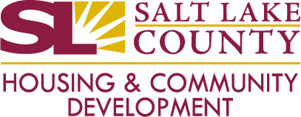

Salt Lake County

Urban County Mayors

PY26 CDBG Funding Recommendations

MEETING AGENDA
April 20th 2026 | 1:00-2:00 PM

Virtual Meeting Link:
https://slco.webex.com/slco/j.php?MTID=mc93c542b64e1f7f883ade2fc89bcf33d

Time | Agenda Item | Person Assigned
1:00 | Welcome, Overview, and Updates | Tallie Viteri
1:15 | Discussion | All
1:45 | Voting and Next Steps | All
1:55 | Urban County Requalification Reminder | Tallie Viteri
2:00 | Adjourn

