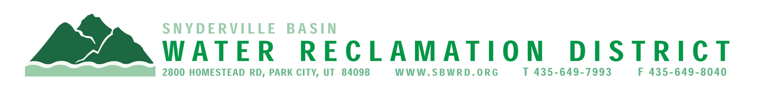
BOARD OF TRUSTEES MEETING

AGENDA

April 20, 2026
** District Office**
5:00 p.m.

** The meeting is open to the public and will also be
conducted electronically using Microsoft Teams**

** For information on how to connect to the meeting, please call 435.649.7993 or email
Dan Olson @ dolson@sbwrd.org by 4:30 p.m. on Monday, April 20, 2026**

I. CALL TO ORDER

II. CONSENT AGENDA
- Approval of Board Meeting Minutes for March 16, 2026
- Final Project Approval
  - Studio Crossing
  - Park City Heights Phase 5
- Escrow Fund Reduction Approval
  - Silver Creek Village Lot 8 – Retain 0%
  - Vista Point at Promontory – Retain 0%
  - Promontory Link’s Edge Subdivision – Retain 0%
  - Sage Hills Estates Subdivision/ The hills Clubhouse – Retain 0%
  - Studio Crossing – Retain 10%
  - Park City Heights Phase 5 – Retain 10%

III. PUBLIC INPUT

IV. APPROVAL OF EXPENDITURES – Bills in the Amount of $1,270,082.43

V. SERVICE AWARDS – Steven Lamb – 10 years
Dustin Lewis – 20 years

VI. SUBDIVISION PROJECTS
Estimated LEA REs Year to Date: # Above Splitter 0; # ECWRF 3.33; # SCWRF 12; Total 15.33
Proposed this Meeting: # Above Splitter 0; # ECWRF 0; # SCWRF 0; Total 0

VII. DISTRICT MANAGER
- Discussion Items – Status of Bond Refinancing
- Information Items
- Financial Statement
- Impact Fee Report

VIII. FUTURE AGENDA ITEMS

- Projects
- Operations
- Finance
- Governmental Matters

IV. ADJOURN

If you are planning to attend this public meeting and, due to a disability, require reasonable accommodation in understanding, participating in or attending the meeting, please notify the District twenty-four or more hours in advance of the meeting, and we will try to provide whatever assistance may be required. Board members may appear telephonically.

