DUCHESNE COUNTY
Community Development Department
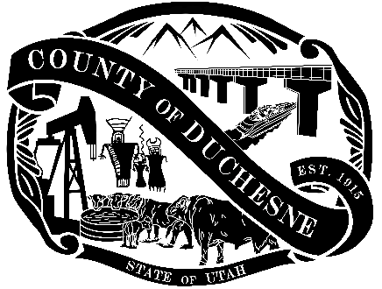
734 N Center Street, P.O. Box 317
Duchesne, UT 84021
Planning Division (435) 738-1152

PUBLIC HEARING NOTICE
Public notice is hereby given that the Duchesne County Commission, acting in lieu of the Duchesne County Board of Adjustment, will meet at 12:00 PM on April 27, 2026, at the Duchesne County Centennial Event Center Conference Room #1 & 2, located at 60 W 400 S, Duchesne, Utah, to conduct a public hearing and consider an appeal by Diana Meacham Davies of the Duchesne County Planning Commission’s decision on April 2, 2026, approving the request by Wells Draw Energy LLC, for a conditional use permit to build and operate a solar power plant in the South Myton Bench area.
For further information, contact the Duchesne County Planning Division at (435) 738-1152. Email comments to planning@duchesne.utah.gov, or mail them to P.O. Box 317, Duchesne, UT 84021. Persons needing special accommodation for this meeting should call the Duchesne County Planning Division at least 3 days in advance of the hearing.

Published: April 22 and 29, 2026 Uintah Basin Standard
Posted: April 15 through May 4, 2026 Duchesne County Administrative Building
Duchesne County website
Utah Public Notice Website

Mike Gottfredson AICP
Deputy Director of Community Development

