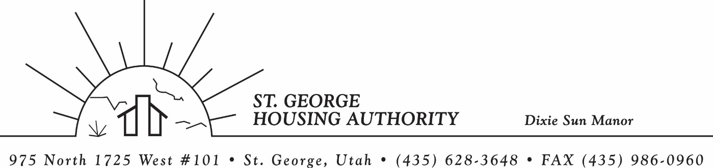
BOARD MEETING
DIXIE SUN MANOR 975 N. 1725 W. # 101
Tuesday February 10, 2026

PRESENT: Mike Barben, Jane Fehrenbacher, Tom Cover, Daniel Baldwin, Gloria Shakespeare, Steve Kemp

EXCUSED: Kenny Miller, Greg Whitehead

MINUTES: Minutes of Board Meeting held February 10, 2025 were reviewed. Motion made by Tom Cover to approve minutes as reviewed, motion seconded by Gloria Shakepeare. Motion carried.

Review Housing Assistance Report for March 2025: Mike Barben handed out the HAP reports for March 2026. Board members were able to see the money spent for the months on rental assistance, see the average unit cost, and verify the units leased for the month. The board was also able to ask questions and have a discussion about portability, C of C, VASH, EHV, & Mainstream Vouchers. Each board member present signed off on the HAP payments and month end totals.

Review current 2025-2026 budget: Mike Barben handed the board a copy of the fiscal year 2025-2026 SGHA budget. The board was able to see how the SGHA is doing in the current fiscal year budget. Mike reported that for the most part, SGHA was right on budget, and let the board ask questions on any of the items on the report. The board has asked Mike to provide and present the most recent budget accounts at each board meeting. By providing the current budget monthly, the board can see how the SGHA is keeping up with the current budget throughout the whole year. The board thought it would be great to ask questions and be on top of what the SGHA is doing financially. Greg Whitehead asked Mike if he could break the budget down into separate programs to verify which programs are doing well and which ones are needing help. Mike has now separated the budget into 3 programs so the board can better understand the flow of money in each program.

Introduce Steve Kemp as new board member from the St. George City Council: Mike Barben turned some time over to Steve Kemp to introduce himself. Steve is on the St. George City Council. Steve told us about himself and his family and also reported on the different responsibilities and boards that he is apart of. It was great getting to know Steve and the SGHA board is excited to have Steve as our newest board member. Steve mentioned that he is committed to helping the Housing Authority grow and find new avenues to possibly develop affordable housing in Washington County.

Utah NAHRO Conference April 21-22: Mike reported that Utah NAHRO conference will be held April 21-22. Mike invited all board members to attend if they would like. Board members are checking their schedules to see if they can attend. It looks like possibly 4-5 board members would like to attend. Mike said the housing authority would pay for the conference. Mike said it is a great conference, and a great way to network and meet other housing authority board members and employees.

Jane Fehrenbacker report on DSM: Jane reported that the community is doing well, reported that DSM is a great place to live. Jane reported that all units are full. Reported on Dixie Sun Manor Valentines Pot luck had only 5 tenants show. Jane would like to work with Mike Barben to figure out ways to get more tenants involved at these functions. Mike agreed to meet with Jane and discuss.

Kenny Miller/Daniel Baldwin report on Tenant Eviction Reversal: Kenny Miller was excused from the meeting so Daniel Baldwin from the City Attorneys office reported that an eviction was reversed from a tenant at Dixie Sun Manor. Daniel reported that he, Kenny Miller and Mike Barben met with the DSM Tenant. Daniel explained all the ins and outs of the eviction and how Kenny with Daniels input decided to reverse the eviction. However, the tenant would be on a non-renewal list and possibly non- renewed in January 2027. However, with good behavior and no other infractions, management could recertify for another year. Mike reported that the housing authority would be working closely with Daniel Baldwin add a grievance process that is more specific and easier to follow for future evictions and hearings.

Reports from Board Member & Housing Director: Tom Cover, a long-time board member informed the SGHA board that he would be stepping down from the board. Tom has served on the board 14-15 years and has been a wonderful asset to the Housing Authority. Tom will be greatly missed and we wish Tom and his sweet wife all the best in their future endeavors. Mike assigned Steve Kemp to discuss with Mayor Jimmie Hughes another candidate to fill Toms role on the SGHA board. Steve said he would follow up with the mayor. SGHA board members must be assigned by the mayor.

Request of a closed meeting to discuss litigation, security, property acquisition or sale, or the character and professional competence or physical or mental health of an individual: None

Motion made by Tom Cover to close the meeting. Steve Kemp seconded the motion. Motion carried. Meeting adjourned at 10:00 a.m. Next board meeting will be Tuesday April 14, 2026 at 8:30 am.

