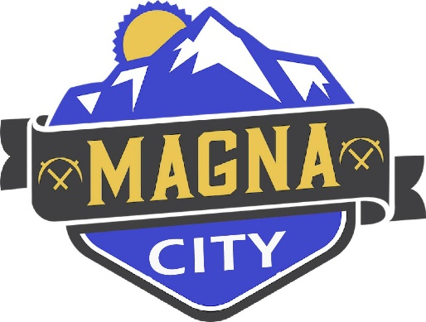
NOTICE OF CANCELLATION
The Magna Community Reinvestment Agency (CRA) meeting for April 14, 2026 has been canceled.

A copy of this notice may be viewed or obtained from the following:
- Utah Public Notice Website: https://www.utah/gov/pmn
- Webster Center
- Magna City Website: https://www.magna.utah.gov

