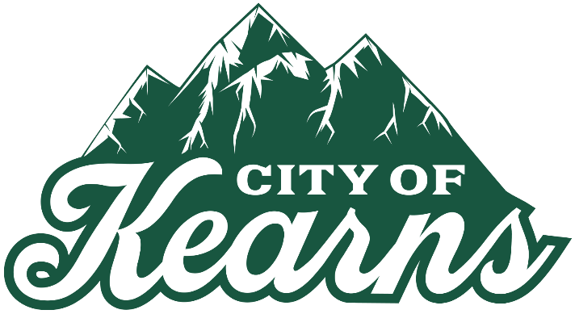
NOTICE OF CANCELLATION
The regularly scheduled Kearns Community Reinvestment Agency (CRA) meeting for April 13, 2026 has been canceled due to lack of items for the agenda.

The next CRA Meeting is planned for May 11, 2026 at 6:00 p.m., to be followed by the regular City Council Meeting

A copy of this notice may be viewed or obtained from the following:
- Utah Public Notice Website: https://www.utah/gov/pmn
- Kearns City Website: https://www.kearns.utah.gov

