MEETING MINUTES
Daggett County Conservation District
Regular Meeting, Wednesday, February 11, 2026
Daggett County Courthouse (95 North 1st West; Manila,UT 84046)
12:00 P.M.

ATTENDEES
Conservation District: Absent
Bryan Smith, Chairman
Kolby Hullinger, Supervisor
Steve Forbes, Supervisor
AJ Olsen , Supervisor
Hugh Straatman - Supervisor
Debbie Rose, Clerk
Conservation Partner Representatives: Absent
Darrell Gillman, UDAF
Cheyenne Reid, USU Cheyenne Reid
Jeremy Maycock, NRCS Jeremy Maycock
Cortney Borer,SGI-Vernal Cortney Borer
Duane Huston-UDAF Duane Huston
Sherett Bonomo– Forest Service Sherett Bonomo
Visitors
Catherine Magee NRCS
Anders Fillerup NRCS
Garrett Fish NRCS
Hans Hunt NRCS
Brandon Todd NRCS
Sean Hughes Daggett Weed

Meeting Approval and Administrative Clarifications
- Bryan Smith called the meeting to order at 12:00 PM.
- Steve Forbes motioned to approve the January meeting minutes
Kolby Hullinger seconded. Motion carried.

BOARD MEMBER REPORTS
- Visitor introduction : Catherine Magee NRCS, Anders Fillerup NRCS, Garrett Fish NRCS, Hans Hunt NRCS, Brandon Todd NRCS, Sean Hughes Daggett Weed.
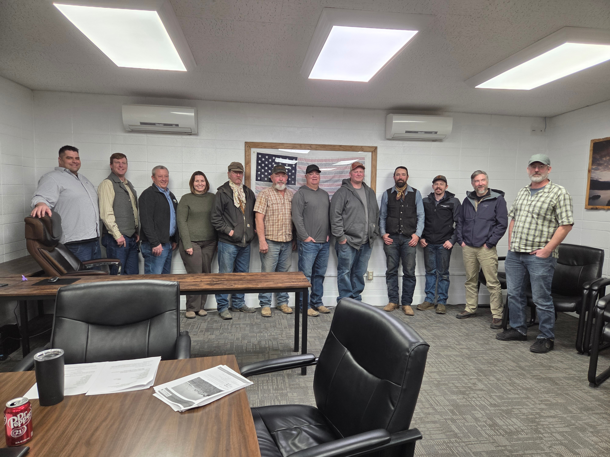

- Motion by Steve Forbes for $3000 per year. After further discussion the original motion was amended by Bryan Smith to increase the contract for secretary services to $3500.00 per year. Seconded by Kolby Hullinger. Motion carried.
- Weed board changes ( Action Item)
- Renewal of board members, Bryan Smith and Hugh Straatman will agree to renew with the Daggett conservation district. Kolby Hullinger and Steve Forbes will continue to serve on the board.
- Dni and fraud assessment are past due and need to be addressed.
- USU Crop School will be held on February 23, at the Manila High School AG. Room.
- Golden Shovel Award will be presented to Hugh Straatman at the USU Crop School.
- Need to buy a shovel . Cheyenne Reid will take care of this for us.
- March zone meeting on the 25th will be held in Vernal from 10am to 2pm @ USU Branch office.
- Next months board meeting will be held at 9:30 in Vernal prior to the zone meeting on March 25th.
GUEST BUSINESS
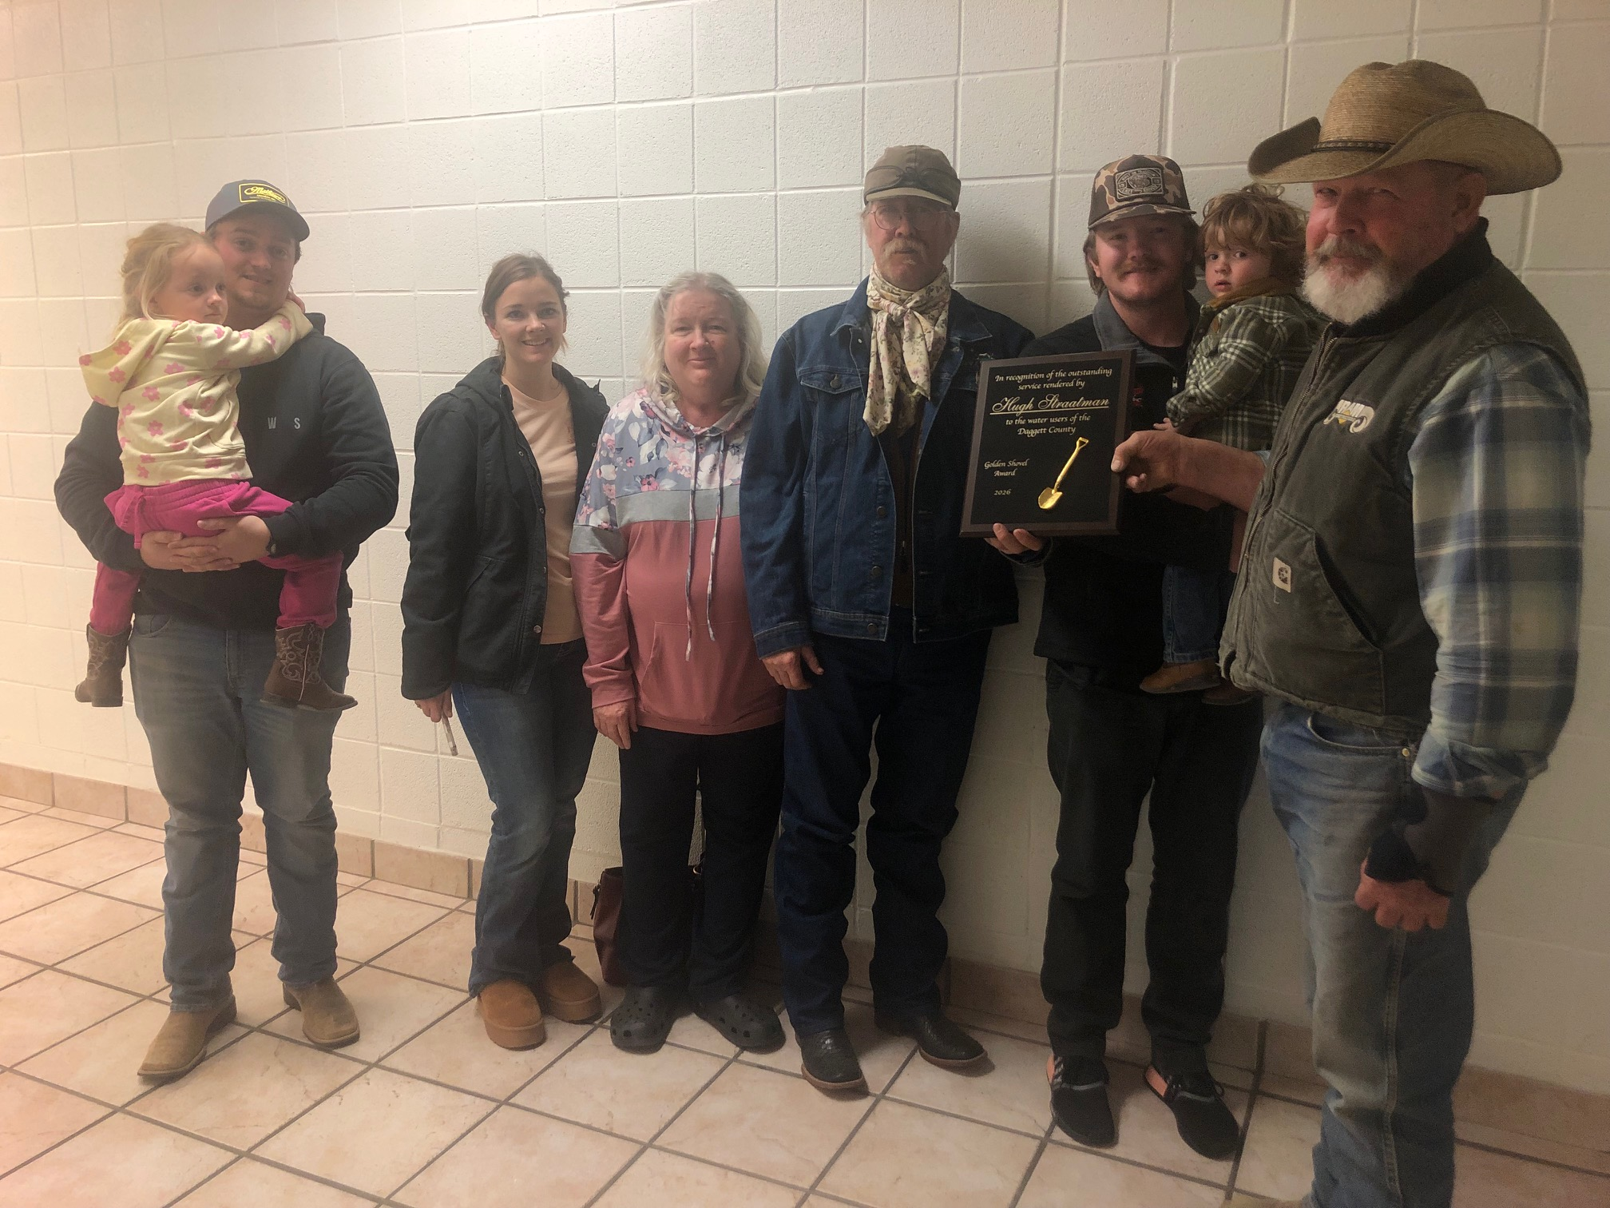
FINACIAL OVERVIEW AND ACTION

- Financial report/ bank statement

- External Hard drive purchase ( Action Item) This is included in the contract with Debbie Rose

SERA
PARTNER REPORTS
- The Daggett County Conservation District convened a meeting featuring key representatives from the Natural Resources Conservation Service (NRSC) and other local agricultural and conservation stakeholders. The session focused on current staffing challenges, program priorities, ongoing projects, and collaboration efforts involving federal agencies and local partners. The dialogue highlighted operational updates, strategic initiatives, and regional conservation concerns, particularly emphasizing the importance of regenerative agriculture, watershed management, and Interagency cooperation.

ADDITIONAL
- Signed agreement from the receiver for chemicals and an agreement from the weed department. Talk about this next meeting with the weed board.
ADJOURN
- Hugh Straatman motioned to adjourn the meeting at 1:15 Steve Forbes
Seconded the motion. Motion carried.

MEETING MINUTES
Daggett County Weed Board
Regular Meeting, Wednesday, February 11, 2026
Daggett County Courthouse (95 North 1st West, Manila, UT 84046

ATTENDEES ABSENT
Daggett County Weed Board
Matt Tippets Chairman
Bryan Smith, Supervisor
Kolby Hullinger, Supervisor
Steve Forbes, Supervisor
AJ Olsen , Supervisor
Hugh Straatman - Supervisor
Debbie Rose, Clerk
Partner Representatives:
Darrell Gillman, UDAF
Jeremy Maycock, NRCS Jeremy Maycock
Courney,SGI-Vernal
Brock Logan, County Brock Logan
Sean Hughes, County

Shereett Bonomo– Forest Service Shereett Bonomo

MEETING PROCCEEDINGS

Matt Tippetts called the meeting to order at 1:15 PM.

Minutes from last meeting were reviewed, motion to approve bystevce Hullinger second bykolby Olsen. Motion carried.

FINACIAL REPORt
370000 more money good shape new loans can start now. Smaller areas . Funding . We can put a grant in for the west side. Weed should be ok.grant cut in half last year and another 5 perent this year. Wri weed projects can apply in the fall. For federal lands
Shereett has applied for wri grants.
13 and half percent drop of water for Flaming Gorge .
OTHER
WEED BUSINESS
- Weed Spraying/Equipment Updates
- Interstate canal there will be alot of weeds.
OTHER
Minutes , talk to lanrinda
Wet land can we help . Abandoned sewer ponds
ADJOURN
Aj motioned to adjourn at 1:42:PM. Kolbybryan seconded. Motion carried.

