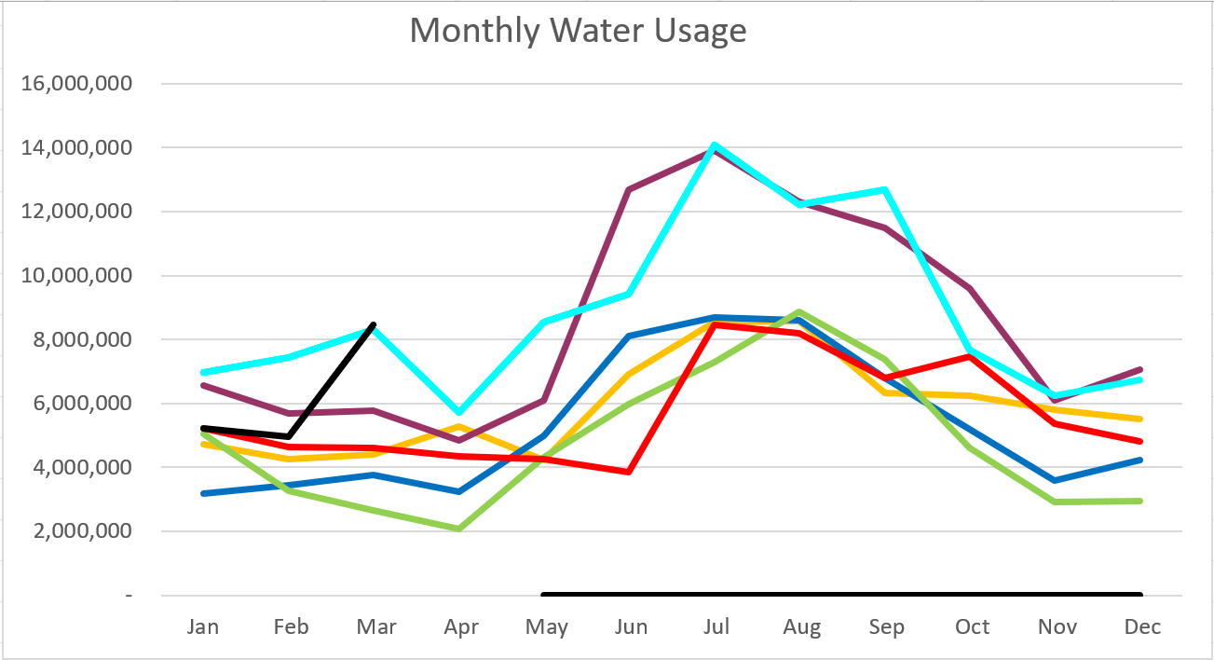
2026 - Black
2025 – Light Blue 2024 – Purple
2023 – Red 2022 – Yellow
2021 – Blue 2020 – Green

March 2026

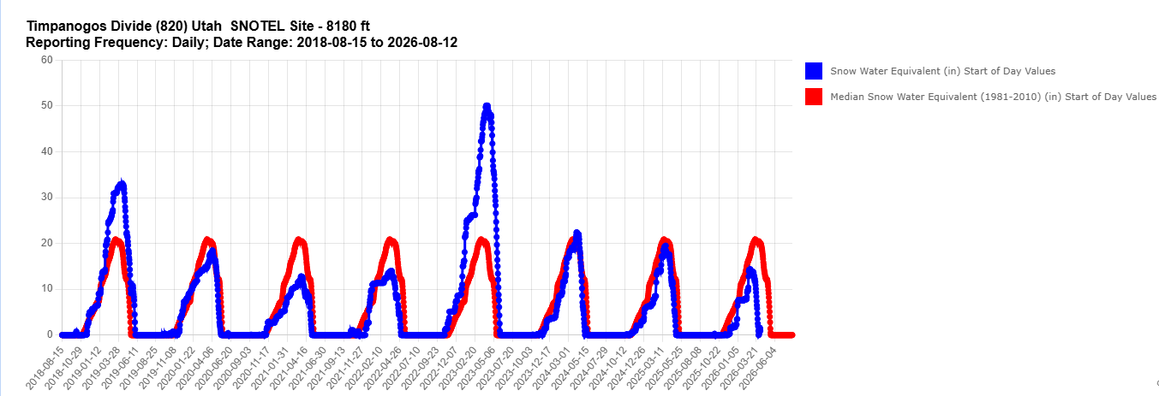

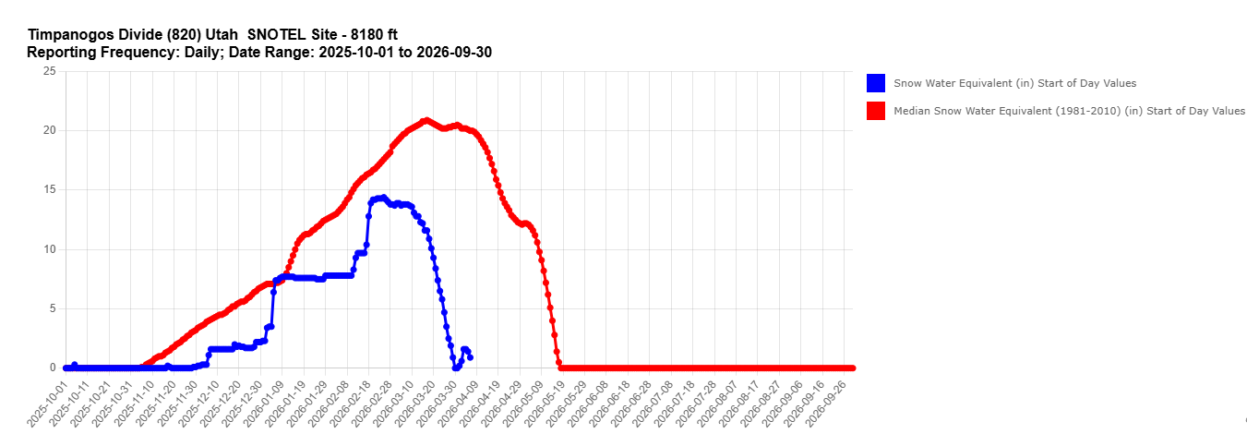

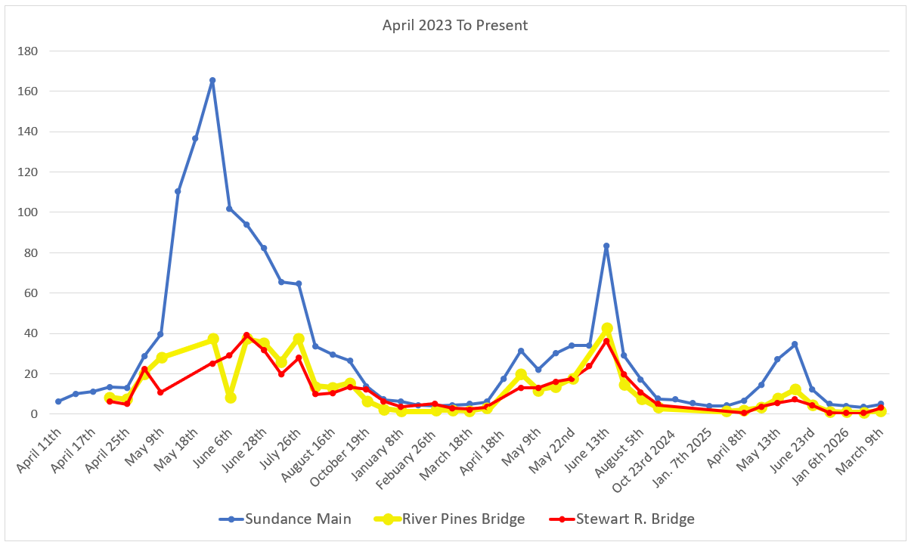
C
F
S

Water Department Information for March
- Our overall water consumption is similar to this time last year.
- Aspen Grove wet-well levels are averaging 6.37 feet for March 2026 which is higher from last month. Currently it is sitting at about 7.45 feet. This time last year, in March 2025, our average was 5.6 feet.
- Stewart Spring is averaging 46 gpm for March 2026, which is up from as last month. This time last year it was averaging 59 gpm for March 2025. We are currently sitting around 55 gpm.
- Stewart spring overflow is running 0 gpm for the month of March which is down from last month. Total Stewart Spring produced an average of 46 gpm for March 2026.
- Unaccounted water
  - Lower Pressure Zone and Stewart Zone
    - Replaced both master meters going into the tanks, Stewart meter had build up in meter lining that makes the reading less accurate. Still need to wire them into our system, waiting for the electricians.
- Construction is going on inside the building.
- We may have power going up stewart road soon.
- We have two companies coming in April to demo leak detection equipment.
- We have a leak locate company coming in April to isolate the leak on upper Stewart Rd. So we can dig it up and fix it.
- The State added more samples to our biweekly list.
- We are filing an objection to the division of water rights on the Proposed determination file.
- The fire control panel went out we are looking into options.
- Unaccounted water elimination processes:
  - We have replaced almost all the service meters including the 6-inch meters.
  - Corrected meters with wrong calculations, and mismatched register sizes.
  - We have had the spring meters heartbeat checked multiple times
  - We have had 2 leak detection companies conduct leak surveys
  - We have fixed multiple leaks
  - We have replaced 2 leaking hydrants.
  - We have inspected about 50 percent of the hydrants with a camera device.
  - We have had all the PRV’s inspected and replaced one 6 inch one 4 inch and two 2 inch PRV’s
  - We eliminated a section of old pipe on coming from the old Stewart Tank
  - We isolated Stewart tank to check for tank leaks.
  - We have two new zero meters ordered to replace the spring meters.
  - We started isolating zones in the system by transferring usage from Stewart to Aspen grove sides.

Wastewater Department Information for March
- We have one lab for March; all were within limits.
- The plant construction is moving forward. We should have wastewater flowing through the new equipment next week.
- The next phase will be demolition of the blower room and construct mbr 3 tank.
- We have seen a change in the wastewater coming in and have been making changes to accommodate the paper clogging the fine screen. Our changes seem to be working.
- We installed starlink as a backup internet system. We lost a phone line that controlled the backup call out and the fire control panal. The fire control is now on starlink and the back up call out system is now a Voip line.
- The generator control panel was having issues. We had cummins service come out. They are scheduled to come back the 19th to repair that panel and the Automatic transfer switch to the lift station.

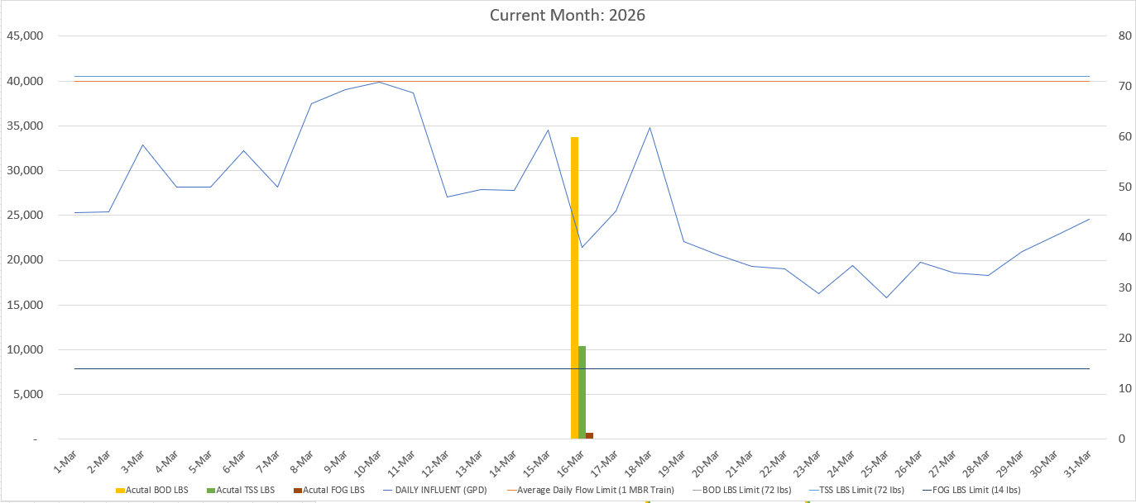

AVERAGE DAILY FLOW (GPD) | 26,184
HIGHEST DAILY FLOW (GPD) | 39,837

